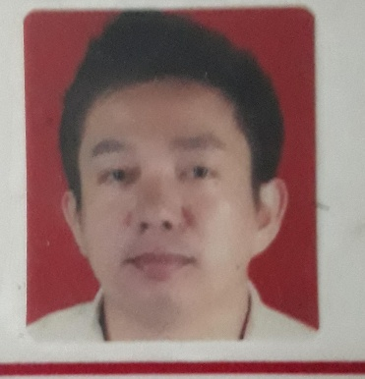
RANDY ESTRELLA MACALE

ADDRESS : B3 L8 Abraham st. Francisco Homes 2 Graceville San Jose delmonte Bulacan
CONTACT NO : (+63) 09776854860
EMAIL ADD : randymacale21@gmail.com

CAREER OBJECTIVE:
To be more effective, efficient, and progressive employee in any position that commensurate my skills and qualifications.
PERSONAL INFORMATION:
- BIRTHDATE November 21, 1983
- CIVIL STATUS : Married
- RELIGION : Iglesia ni Cristo
- FATHER : Rosendo B. Macale
- MOTHER : Ma. Salve E. Macale

EDUCATIONAL BACKGROUND
PRIMARY:
Manuel L. Quezon Elementary School
Malaria tala, caloocan city
1990 - 1996

SECONDARY:

Lagro High School
lagro. subdivision Quezon city
1996- 2000

HIGHEST EDUCATIONAL ATTAINTMENT :
B.S Nursing
Our lady Of Fatima University
Hilltop Quezon City
2000 - 2006

Skills and Proficiencies

Communications Skills:
- -Can speak Filipino and English languages.
- -Skilled in written and oral communications

Computer Skills:
- -Able to perform task using MS application
- -Proficient in using the Internet to access for common needs.
Work Experience:

Mcdonald's
Service Crew
2003 - 2004

Job Responsibilities:

- Provide excellent service to customers
- Provide clean and healthy environment
- Provide clean food

Private Nurse
Mayor Oscar Malapitan
Mayor of Caloocan City
January 2006 – 2008
Caloocan City

Job Responsibilities:

- Provide health care to patient
- Give medicine on time
- Assessing, observing, and speaking to patients. Recording details and symptoms of patient medical history and current health. Preparing patients for exams and treatment. Administering medications and treatments, then monitoring patients for side effects and reactions

Mercury Drug Corporation
Pharmacy Assistant
2008 - Present
Quezon City Philippines

Job Responsibilities:

-Mercury Drug is more than just a pharmacy - it is the country's trusted and caring health and wellness partner, providing the widest range of branded and generic medicines, as well as a complete line of healthcare and personal care products, including medical devices, and basic everyday needs.

- Providing excellent service to customer to give correct medicine that they need.

CHARACTER REFERENCE

Edmon Sandel
Pharmacy assistant
Mercury Drug Corporation

Rosendo B. Macale
Father
Retired police officer

Eleonor M. Macale
Wife

This is to certify that the above information is true and correct to the best of my
knowledge and belief.

Randy E. Macale

