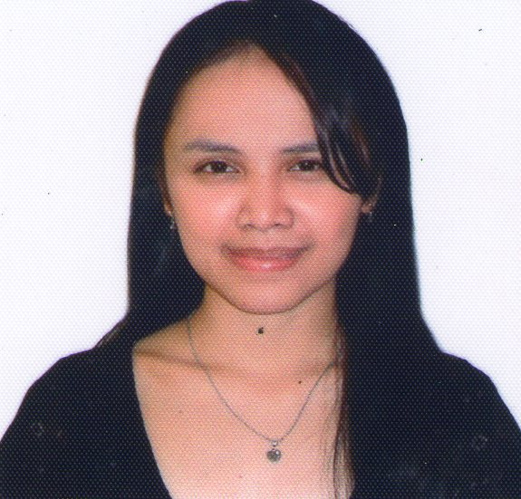
CONTACT INFORMATION
Name Monica L. Leyson, R.N.
Address Block 27-A Lot 31 Kalayaan Village, Pasay City, Philippines
Cell Phone 09683659811/09392530887
Email monicaleyson@ymail.com
PERSONAL INFORMATION
Date of Birth April 03,1990
Place of Birth Manila
Citizenship Filipino
Gender Female
EMPLOYMENT HISTORY
Hemodialysis Nurse
Taguig City Dialysis Center
North Signal Village Taguig, Metro Manila
March 16,2019-Present

IVF/General Nurse
Women Health Center
Sultan Bin King Abdulaziz St., Jeddah, Kingdom of Saudi Arabia
October 10,2016- January 26 2019

Company Nurse
Sanford Marketing Corporation
Berma Blg.Brgy Baclaran P’que City
June 02,2014-October 30,2014

Staff Nurse
Cruz-Rabe Maternity and General Hospital
Tuktukan,Taguig City
March 05,2011-March 30,2014

Duties and Responsibilities:

Emergency Room:

-Prepare the unit and admission of the patient to Emergency Room/ER
-Maintains proper supplies and appropriate medical equipments
-Performs triage, while considering both physical and psychosocial elements
-Monitor vital signs and report to the physician.
-Administer medication and treatments as prescribed by the physician (orally, subcutaneously, through an IV) and records prescribed medications,reports adverse reactions to medications or treatments
-Collection of samples,evaluate and record the results.
.-Provides IV therapy
-Cleans and bandages wounds
-Provides basic, bedside care
-Follow medical and surgical asepsis.

-Assist in various procedures like Intubation,Chest Tube Insertion, and Foley's Catheter Insertion etc.
-Prepare the patient for various investigations like X-ray,ECG,Ultrasound,MRI,CT Scan etc.
-Operates ECG machine and audiometry

-Cardio Pulmonary Resuscitation (CPR) in case of emergency situation.
-Responds to life-saving situations based upon nursing standards and protocol
-Provide psychological support to the patient and relatives.

Medical-Surgical Ward:

-Provide medications and injections as prescribed by the doctor.
-IV therapy,administer intravenous fluids and oxygen ,if required.
-Provide frequent patient evaluations including monitoring vital signs and perform essential procedures like catheterization,suctioning,blood transfusion,ABG,enema,gastric gavage/lavage, NGT insertion/feeding,wound drainage/dressing etc. and medication administration
-Prepare patients and assist with, examinations, treatments and various investigations like Ultra Sound, Echo,CT scan,MRI,Endoscopy,etc.
-Assist doctors during treatment.
-Refer any changes in patient's status or untoward reaction to the doctor.
-Collect specimens including sputum,stool,urine and send it for medical analysis to laboratory.
-Analyse test results from various departments and record it properly.
-Provide care to patients before and after surgical procedures.
-Manage care for surgical wounds and address post-surgical pain and give therapeutic medications
- Changes dressings and notifies the attending physician of any abnormalities noted in the initial healing process.
-Pre/Post operative /DC teaching.
-Provide general nursing care to all patients and give psychological support to the patient and family members.
-Educate patient and family about the disease and prognosis of the patient.

Seminars Attended:

Advanced Cardiovascular Life Support with Basic ECG Rhythm Course
HCT Academy
United St., Pasig City
November 5-6,2021
Basic Life Support
Taguig City Health Office
June 29-31, 2021
Mechanical Ventilation
Lung Center of the Philippines
Quezon Avenue,Quezon City
November 09,2012

Phlebotomy
NC-CLEX, Inc. (Nursing Center for Clinical Laboratory Experience)
Ground Floor, KB Arizona Tower 838 P.Campa Street Sampaloc, Manila
October 11,2012
Intravenous Therapy Training
Manila Adventist Medical Center
Pasay City
January 18-20,2011

Educational Attainment:

Tertiary:Dr. Carlos S. Lanting College
Bachelor of Science in Nursing
16 Tandang Sora Avenue , Sangandaan,Novaliches, Quezon City
2008-2010
Arellano University-Jose Abad Santos Campus
Bachelor of Science in Nursing
3058 Taft Avenue , Pasay City,
2006-2008
Secondary:Kalayaan National High School
Kalayaan Village , Pasay City
S.Y. - 2002-2006
Elementary:San Diego Elementary School
Luzviminda Village , Quezon City
S.Y. - 1996- 2002

Character References:

Dr.Othman Sindi
Reproductive Endocrinologist/Medical Director
Women Health Center- Jeddah, Kingdom of Saudi Arabia
Contact no.+966505611108

Dr.Nabeel Barsha
IVF/ Reproductive Endocrinologist
King Abdulaziz Medical City- Jeddah, Kingdom of Saudi Arabia
Contact no. +966562608808
Luisa Abella Mariano,R.N.
Head Nurse
Cruz-Rabe Maternity and General Hospital ,Taguig, Metro Manila, Philippines
Contact no. +639495916806

Key Qualifications

-Accepts responsibility and is self-motivated.
-Works independently with little direct supervision.
-Literate with Microsoft Office (Word, Excel, Power Point, Outlook),Microsoft Internet

I hereby certify that the above informations are true and correct to the best of my knowledge and belief.

________________________
Monica L. Leyson ,R.N.

