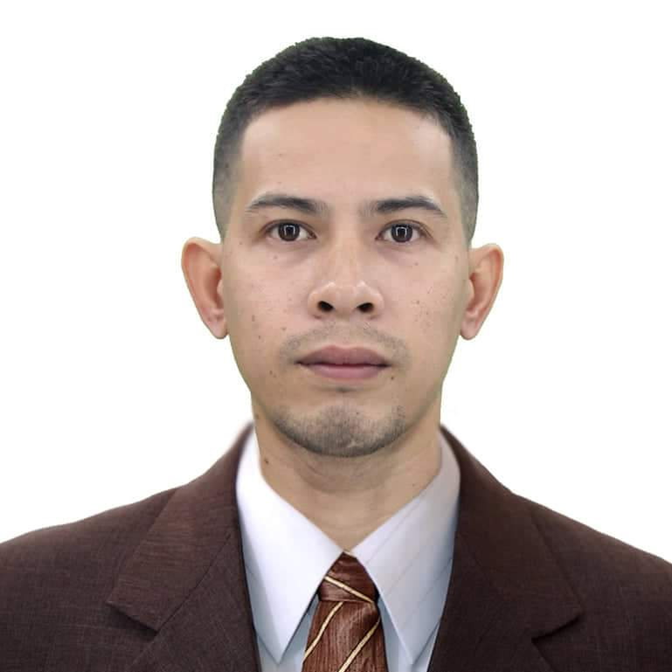

Mark Erwin Algara
Address: #249 Sitio Pook Paliparan III, Dasmariñas City, Cavite
Mobile #: 09959344196 / 09692863654
E-mail Address: mistisonghilawww@gmail.com

POSITION: Any position that will fit my capability.

OBJECTIVE: To obtain a position within my chosen field where I can utilize my skills as a hard-working, well-educated employee in exchange for a steady market-fair paycheck.

SUMMARY OF QUALIFICATIONS:

- Motivated, honest and goal oriented
- Fast learner, flexible and willing to learn
- Skilled and hardworking

PERSONAL BACKGROUND:

Age: 32 years old
Date of Birth: November 25, 1990
Place of Birth: Dasmariñas City, Cavite
Civil Status: Single
Sex: Male
Religion: Catholic
Nationality: Filipino
Height: 5’5”
Weight: 61 kg's

EDUCATIONAL BACKGROUND:

TERTIARY: NATIONAL COLLEGE OF SCIENCE AND TECHNOLOGY
Associate in Hotel Restaurant and Management
Amafel Bldg., Aguinaldo Highway, Dasmariñas city, Cavite
2009-2010 (Undergraduate)

SECONDARY: CONGRESSIONAL NATIONAL HIGH SCHOOL
Via Verde San Agustin II, Dasmariñas city,Cavite
2002-2006

WORK EXPERIENCE:

PRODUCTION OPERATOR
Magnolia Inc. | Barangay San Francisco, General Trias, Cavite (2013-2014)
JOB DESCRIPTION:
● Dairy company engaged in the marketing, manufacturing, distribution, and exporting of butter, margarine and cheese products under the brand names magnolia, Dari crème and star.
● Machine Operator

JEEPNEY DRIVER
Public Utility Jeepney | Dasmariñas City, Cavite (2016-2019)
JOB DESCRIPTION:
● Driving a public utility jeepney
● Deliver the passenger to their designated location safely.

PRODUCTION OPERATOR
Amkor Technology of the Philippines | Biñan Laguna (July2020-Dec2020)
JOB DESCRITION:
● Monitor machines that attach the wafers for processing.
● Load wafers into the equipment that creates patterns and forms the electronic circuitry.

TECHNICIAN
Wuhan Fiberhome | Dasmariñas City, Cavite (2021-2022)
JOB DESCRIPTION:
● Telecommunication Internet Provider
● Installing and Repairing Internet connection
● Driving a Company Service Vehicle

DRIVER/TECHNICIAN
Miescor Telecoms Inc. | Anonas Extension,Diliman,Quezon City (2022-present)
JOB DESCRIPTION:
● Maintaining Low Sagging Cables
● Pole Clearing Operation
● Driving a Company Service Vehicle

SKILLS :

- Computer Literate
- Driving
- Quick Learner
- Maintaining Cable Facilities
- Service Line Installation
- Internet Technician Provider

REFERENCES:

Mr. Darryl Dayao
Supervisor
+639298239552

My signature below signifies that the foregoing information is true and correct according to the best of my knowledge.

MARK ERWIIN ALGARA
Applicant

