STEVEN LUMPINAS LUBOSAN
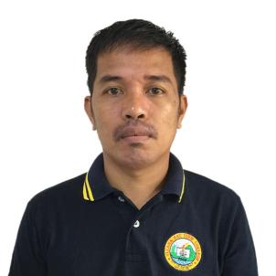
Phone No: 0946-221-5221
Email: slubosan278@gmail.com
Address: Purok 4, Datu Panas, Buug, Zamboanga Sibugay
Birthday: October 14, 1984
CAREER OBJECTIVE

To make use of my interpersonal skills to achieve goals of a company that focuses on the satisfaction and experience of the customers.
TECHNICAL SKILLS

- Microsoft Office (MS Word, Excel and PowerPoint)
- Basic skills in Electrical Wiring
- Basic skills in Carpentry
- Basic skills in Welding
PERSONAL SKILLS

- Excellent written and verbal communication skills
- Highly organized and efficient
- Ability to work independently or as part of a team
EDUCATION

Bachelor of Ministry in Pastoral Studies
Lommason Alliance Bible College
Poblacion Lapuyan Zamboanga del Sur
(2002-2007)

National Certificate II in Driving
TESDA
(July 13, 2022)
EMPLOYMENT BACKGROUND

- Site Acquisition Officer
Fiberhome Phils. Inc.
2021– Present
- Bible Translator
Wcyliffe Associates
Davao City
2015-2016
- Full Time Pastor
Buug Alliance Church
Poblacion, Buug, Zamboanga Sibugay
2009-2014
- Full Time Pastor
Kawit Alliance Church
Riverside, Kawit, Pagadian City
2007-2008
- Full Time Pastor
Napolan Alliance Church
Alta Tierra, Napolan, Pagadian City
2008-2006

REFERENCES

- Noel Manuel Ahmad
Fiberhome FiberGEN Project
Implementation Department
Project Supervisor Mindanao
09667641083

- Ryan Tan Yaeso
Fiberhome FiberGEN Project
SAQ/ROW Department
FTTBTS Assistant Project Manager
0947-545-9132
riyannahyaeso@yahoo.com

- Norhai Jane Capas Bakil
Fiberhome FiberGEN Project
SAQ/ROW Department
FTTBTS Project Coordinator
0920-514-2571
norhaijanebakil@gmail.com

