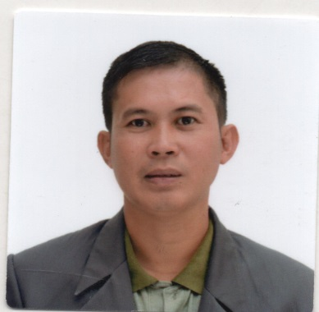
FAJARDO, RUEL FERNANDO
#297 Arboleda St. San Pedro Ili Alcala, Pangasinan
Contact Number: +639565910759/+639706432278
Email Address: fajardkristine@gmail.com
OBJECTIVE:
To develop my work related skills in the required environment by working harmoniously with my co-workers and the management, and i will give my loyalty, knowledge and time to the company i’m working with.
WORKING EXPERIENCE

FARMING (Planting Vegetables, Corn and Rice)
Duties and Responsibilities: Plants crops using hand tools and farm machines, builsd trellises for climbing vegetables and vines,operates farm machine to cultivate,fertilise,spray and harvest.
Irrigates land for crop growth.
2015– Present

SKILLS:

- Erecting trellises
- Spraying
- Driving farm machinery
- Marcotting
- Planting &maintenance in the farm
- Pruning
SEMINARS-TRAININGS-CONFERENCE
East West Seeds Philippines
Alcala, Pangasinan Philippines
June 2022

Agway Chemicals Corporation
Alcala, Pangasinan Philippines
May 2022

BASF Philippines Incorporation
Alcala, Pangasinan
December 2021

EDUCATIONAL BACKGROUND:
Tertiary: Virgen Milagrosa Unniversity Foundation
Hotel Restaurant and Management
Martin P. Posadas Ave. San Carlos City, Pangasinan
S. Y 2006-2009
Virgen Milagrosa University Foundation
Bachelor of Science in Nursing
Martin P. Posada Ave. San Carlos City, Pangasinan
S.Y 2005-2006(56 UNITS EARNED)
Secondary: Arboleda National Highschool
San Pedro ili, Alcala Pangasinan
S. Y 2000-2003
Primary: San Pedro ili Elementary School
San Pedro ili, Alcala Pangasinan
S. Y 1994-2000

PERSONAL DATA:
Nickname : Bhen
Age : 35
Date of birth : September 28, 1986
Place of birth : Dagupan City, Pangasinan
Gender : Male
Status : Married
Height : 5’5
Weight : 155lbs
Citizenship : Filipino
Religion : Roman Catholic
Father’s Name : Gabriel V. Fajardo Sr.
Mother’s Name : Florida F. Fajardo
Language Spoken : Ilocano, Tagalog, English, Arabic

CHARACTER REFERENCES:
Mrs Merly F. Lorenzana
Traders of Vegetables in Agri Pinoy Urdaneta,city
Urdaneta,City Pangasinan
+639489917897

Mr. Johnny Junio
Brgy. Captain
Bautista, Pangasinan Philippines
+639988557306

Mr. Rhem Rain Araneta
GMA Theatre Artist
MANILA, PHILIPPINES
+639150474412

I Hereby certify that the above mentioned information has been accomplished in good faith, verified by me to the best of my knowledge and beliefs as true and accurate.
RUEL F. FAJARDO
Applicant Signature

