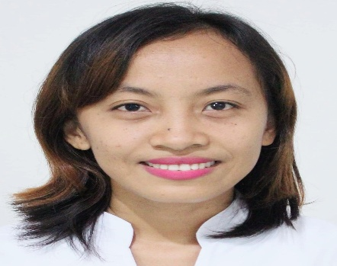
DARYL CONCORDIA BAYBADO
Light Residences Tower 2 ,
Madison Cor. Edsa, Mandaluyong City
darylconcordiabaybado@gmail.com
09069268091

OBJECTIVE: To work in an organization where I can acquire new knowledge, sharpen my skills and put my efforts on achieving organization as well as personal goals.

EDUCATIONAL BACKGROUND

Tertiary : Saint Ferdinand College Ilagan
Santa Ana St. Ilagan City, Isabela
Bachelor of Science in Nursing

Isabela Colleges Incorporation
Cauayan City, Isabela
Bachelor of Science in Secondary Education
Major in Biology
Graduate Year 2018

Secondary : Saint Ferdinand College Ilagan
Santa Ana St. Ilagan City,Isabela
School Year 2004-2005

Primary : Camp Melchor F. Dela Cruz
Elementary School
Camp Melchor F. Dela Cruz Upi,
Gamu, Isabela
School Year 2001-2002

WORK EXPERIENCE

- GoWELL Pharmaceutical Company-Baguio Branch
Santa Scholastica Baguio City
Staff Coordinator
February 20014

- Local Government Unit- Municipal Health Office
Bugallon Proper Ramon, Isabela
Contratual Nurse
November 2014

- Local Government Unit-Ramon
Municipall Health Office
Bugallon Proper Ramon, Isabela
Contratual Nurse
July 15,2015-January 15,2020

- Department of Interior of Local Government
Santiago City, Region 2
Contact Tracer
December 1,2020-December 31-2021

- Local Government Unit-Santiago City
San Andres Santiago City
Barangay Health Aide
January 3,2022-July 31,2022

Skills:

Data Encoding
Taking Vital Signs
Flexible

CHARACTER REFERENCES

Frances Marie Hernandez
639178477587
Light Residences Tower 2
Madison Cor. Edsa, Mandaluyong City

Aleth Joyce Cubacub,CPA
+639175758384
Forerunners Haggai7 Inc.
Unit 9C, The Currency,
Doña Julia Vargas Cor. F. Ortigas Rds.,
Pasig City
Philippines

I hereby certified that the above information is true and correct.

DARYL CONCORDIA BAYBADO
Applicant

