LEONER D. CAWASA
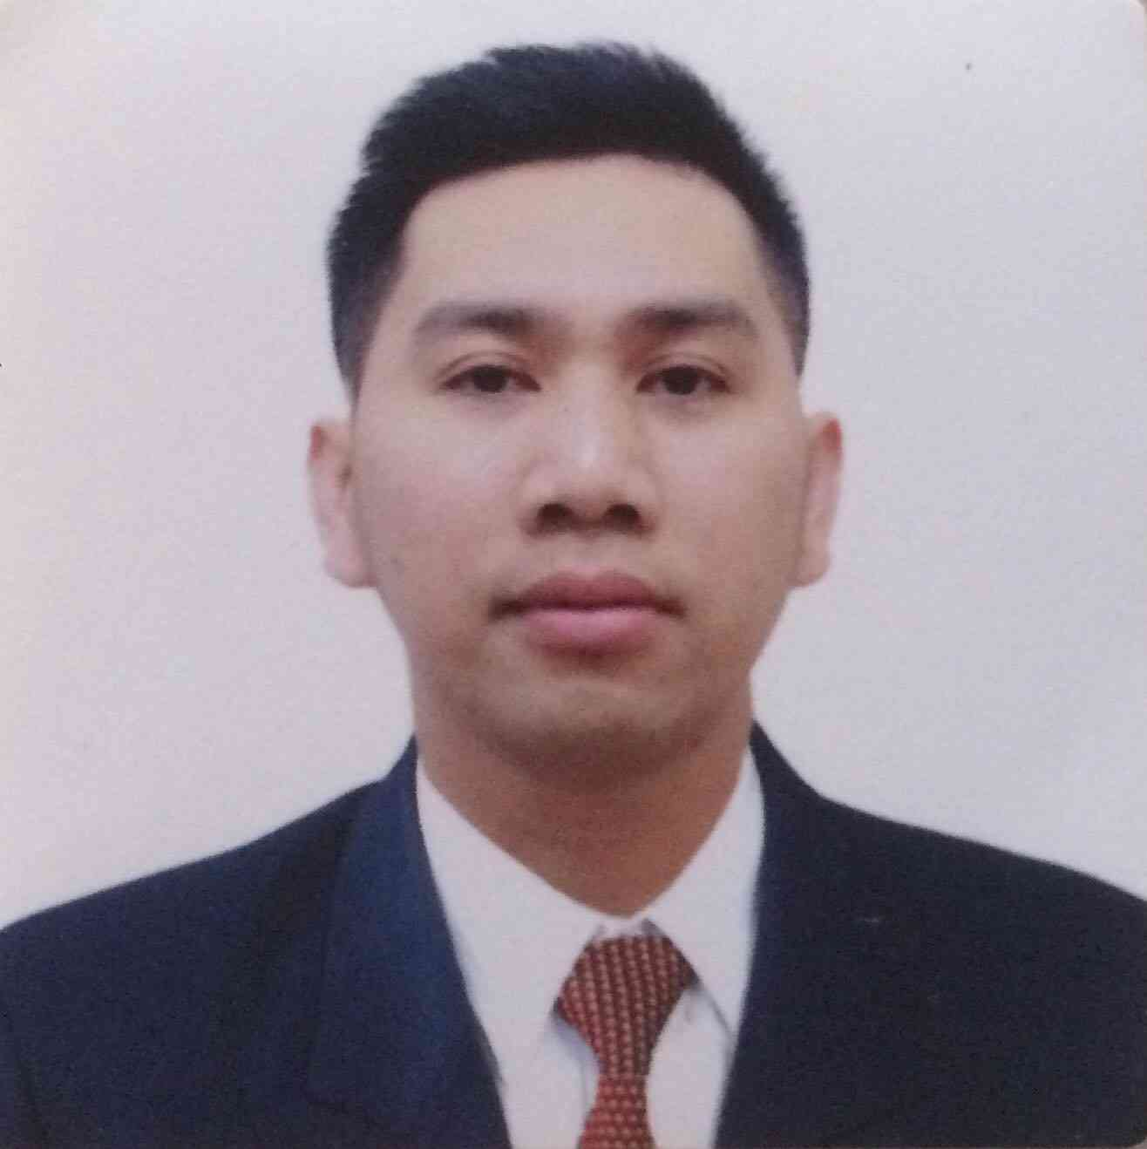
Purok 2, Leling Hagonoy
Davao del Sur, 8006
Philippines
+639815278570
leonercawasa@hotmail.com

OBJECTIVE: Innovative and accomplished chef seeking to apply my extensive culinary experience gained from working on the cruise ship in a challenging land-based role . Committed to delivering exceptional cuisine and creating memorable dinning experiences for customers while continuously improving my skills in dynamic kitchen environment .

WORKING EXPERIENCE:

ROYAL CARIBBEAN CRUISE INTERNATIONAL
1050 Caribbean Way, Miami, Florida, 33132

Chef de Partie – Buffet Station
June 3, 2022-March 11, 2023
Ovation of the Seas

JOB DESCRIPTION:

- Review and read Menu to estimate food and requirements to ensure speed and efficiency.
- Follows daily flow chart with regard to menus and any other food products that maybe required from the station of responsibility.
- Uses production sheets and meal count information to produce the correct amount of required food products.
- Conducts on the job training with commis in recipe knowledge and cooking procedures outlined in the recipe cards.
- Fully responsible for organizing work schedule and controlling over time of assigned section, ensure Time and attendance Policy followed by each member of the Team.
- Observe and evaluates employees and work procedures to ensure quality standards and level of service met.
- Ensures that food items are prepared and presented according to corporate recipe standards set by the Director, Culinary Operations.
- Conducts an inventory of the items in the work station storage.
- Determines the day’s food requirements and prepares daily requisitions in crunch time for approval by the Sous Chef
- Reviews the quality and quantity of the delivery and accepts issued product.
- Responsible for achieving the food cost budget for the assigned work station.
- Communicates on daily basis with the Executive Chef with regards to planned food cost budget for the area of responsibility.
- Conducts training with Commis in waste management to ensure useable food products are completely used and avoid over production.
- Acquire proficiency in regards to standard regulations about proper food storage, correct food preparation and safe food temperature.
- Knows and operates all equipment according to standard operating procedures.
- Conducts on the Job Training with Commis to ensure all crew members working in his/her area of responsibility know RCL and onboard Public Health Control Plan as related to preparing, holding, storing, re-heating and service food.
- Conducts training and follow up on record keeping for Blast Chiller and Cooling Logs of the Blast Chiller in their area of responsibility.

ROYAL CARIBBEAN CRUISE INTERNATIONAL
1050 Caribbean Way, Miami, Florida, 33132
Mariner of the Seas

Chef de Partie – Main Pantry
May 29, 2021-March 17, 2022

- Review and read Menu to estimate food and requirements to ensure speed and efficiency.
- Follows daily flow chart with regard to menus and any other food products that maybe required from the station of responsibility.
- Uses production sheets and meal count information to produce the correct amount of required food products.
- Conducts on the job training with commis in recipe knowledge and cooking procedures outlined in the recipe cards.
- Fully responsible for organizing work schedule and controlling over time of assigned section, ensure Time and attendance Policy followed by each member of the Team.
- Observe and evaluates employees and work procedures to ensure quality standards and level of service met.
- Ensures that food items are prepared and presented according to corporate recipe standards set by the Director, Culinary Operations.
- Conducts an inventory of the items in the work station storage.
- Determines the day’s food requirements and prepares daily requisitions in crunch time for approval by the Sous Chef
- Reviews the quality and quantity of the delivery and accepts issued product.
- Responsible for achieving the food cost budget for the assigned work station.
- Communicates on daily basis with the Executive Chef with regards to planned food cost budget for the area of responsibility.
- Conducts training with Commis in waste management to ensure useable food products are completely used and avoid over production.
- Acquire proficiency in regards to standard regulations about proper food storage, correct food preparation and safe food temperature.
- Knows and operates all equipment according to standard operating procedures.
- Conducts on the Job Training with Commis to ensure all crew members working in his/her area of responsibility know RCL and onboard Public Health Control Plan as related to preparing, holding, storing, re-heating and service food.
- Conducts training and follow up on record keeping for Blast Chiller and Cooling Logs of the Blast Chiller in their area of responsibility.

Royal Caribbean Cruise International
1050 Caribbean way, Miami Florida
Ovation of the Seas

Pantry Cook Assistant
Nov. 10, 2019 – April 17, 2020
Jan. 21,2019 – September 20, 2019
March 12, 2018 – November 14, 2018
OVATION OF THE SEAS

- Maintain station clean and sanitize daily
- Responsible for slicing all cold cuts, seared beef , marination of gravlax and platings.
- Slicing variety of cheese, cut fruits and platings
- Assist chef de partie in platings of all appetizer for dinner
- Responsible in making Station organize and make sure all items are available and serve timely
- Maintain and follow daily Food records for documentation
- Any other task requested by Chef de partie

THANANI RESTAURANT ( European Cuisine)- Pre Opening Team
Al Zora Golf Club, Ajman, UAE.

Chef de Partie – Hot kitchen
January 06, 2017 to Dec. 30, 2017

JOB DESCRIPTION:

- Prepares and properly garnishes all food orders as they are received on accordance with menu specifications , insuring properly plate presentation
- Prepares sauces and hot entrees, controls the positioning and rotation of foods and ensures proper plate presentation
- Set up for lunch and dinner by ensuring proper amounts are in place for forecasted covers, special functions and reservations
- Adheres to company standards of food quality , preparation, recipes and presentation
- Orders adequate supplies for own section , and set up Mise en place for section
- Supervises the proper set-up of each items on menus and ensures their readiness
- Follows proper safety, hygiene, sanitation practices and following the principles of HACCP
- Maintains an exact record of preparation , cooking and presentation of all dishes produced in the section in a file which is kept at all the section at all times for reference
- Confers closely with the sous chef and takes every opportunity to become familiar with all aspects of his position, in order to be ready to fill in whenever is required
- Coordinates job tasks with the staff in own section
- Helps employees to achieve optimum quality
- Any other task requested by Head chef or Sous

STARWOOD HOTELS AND RESORT WORLDWIDE, MARRIOT
THE WESTIN GOLF RESORT and SPA
Abu Dhabi Golf Club
Khalifa City A, Uae.

Demi Chef de Partie –( Bakery and Pastry)
Oct.23 2015 to Dec. 16, 2016

JOB DESCRIPTION:

- Review the daily production sheets with the chef de partie and sous chef
- Prepare the lists of mise en place and ordering
- Prepares and when required delegates the production of necessary food items in accordance with the standard in a timely and efficient fashion to ensure that there is no interruption to the guest service
- Adhere to follow standard recipes in order to maintain quality and ensure standards are met
- Keep work station clean and organize including the tables , fridge /freezers and stoves
- Ensure that the opening and closing procedures are follow base on the standard
- Keeps overproduction and food waste to its minimum, ensures proper labeling and storing of food to reduce food cost expenses
- Operates all kitchen equipments with safety in mind at all times
- Ensure all the food products are handled, stored, prepared and served safely in accordance with the hotel and government food safety guidelines of food products to chefs in time
- Actively participates in departmental training of culinary skills to all kitchen associates
- Hands on in daily kitchen section operation
- Communicate and follow directives given by the chef de partie and sous chef

STARWOOD HOTELS AND RESORT WORLDWIDE, MARRIOT
THE WESTIN GOLF RESORT and SPA
Abu Dhabi Golf Club
Khalifa City A, Uae

SACCI RESTAURANT (Italian Cuisine)- Pre Opening Team
COLD KITCHEN and PIZZA SECTION

October 23, 2014- Sept. 30, 2015

JOB DESCRIPTION:

Daily checking and production of cold kitchen mise en place
- Ensure that all the date labels of items are up to date
- Ensure that the section is well set up and ready for operation
- Observe the daily opening and closing of the kitchen
- Maintain the standard of cooking and making of salads
- Hands on in the cold section daily operation
- Check and write market and store list to be order and hand over it to chef de partie

MILLENIUM RESTAURANTS LLC.
Yas Marina Island,
Abu Dhabi, UAE

COMMI 1 (Pre Opening Team)Hot and Cold Kitchen Section
October 8 to September 30 2014

JOB DESCRIPTION :

- Daily checking of items prior to start the section operations
- Ensure that all mise en place are enough for the day
- Hands on in every order in the cold kitchen section
- Prepare desserts and platting
- Help hot Kitchen section mise en place
- Perform Grilling and actual cooking in hot kitchen
- Keeping Records on Invoice and reports for Requisition
- Responsible for Monthly inventory on Items received from the Suppliers
- Keeping Records and calculation of Daily food Cost base from the Requisition and revenue

AYAD DROUP LTD.- OPERA CAFE

Pastry staff -Baker
July 10, 2010 –Aug. 30, 2013

Summary of skills:

- Three years ( 3 ) of experience in restaurant baking
- Familiar with the procedures and recipes of preparing various bakery products
- Possess effective written and verbal communication skills
- Follow food preparation methods and baking to ensure baked goods are prepared in manner prescribed by our standards
- Ensure that the baked goods are stored and kept at proper holding temperatures, through the use of thermometers
- Perform other job related tasks as assigned
- Flexible and has the ability to perform task in a professional manner
- Attention to detail with excellent management and multitasking skills

HOTEL DE CRISBELLE

Kitchen Staff
June 1 2009- Nov. 1 2009

- Responsible for mise en place
- Ensure that all items needed for the menu is available
- Cleaning the area before to start

PHILIPPINE NATIONAL RED CROSS

Membership with Accident Assistant Benefit In-Charge
January 2007 – April 2009

- Initiates the conduct of Red Cross Activities; Organization of Red Cross Youth Councils, and promoting Membership with Accident Assistant Benefit
- Responsible for encoding members in the master list for records using computer
- Transmitting enrolled members to National Head office
- Responsible for assisting clients on their claims
- Responsible for transmitting clients documents for reimbursements and money claims
- Responsible to deposit all cash collections
- Making reports every end of the month for inventory
- Ensure to inform the clients, once money claims are ready for release
- Excellent in communication skills, maintain positive relations with staff, people in the community in high- volume with fast-paced operations

PHILIPPINE ANTIONAL RED CROSS

TRAINOR ON STANDARD FIRST AID AND BASIC LIFE SUPPORT

- Conduct Basic life Support and Standard First Aid Training on Caregivers, Nursing Student, High School, Elementary, Community and even industrial employee
- Facilitate actual demonstration on Bandaging technique and cardio Pulmonary resuscitation
- Making grades for school requirements
- Making of certificate using computer and printer

DISSIMINATOR ON INTERNATIONAL HUMANITARIAN LAW
2005-2006
- Extensive background in humanitarian works, people- oriented, service operation development including promotion of services. .
- Coordinates and facilitates the dissemination of International Humanitarian Law.
- Focal person in setting personal as well as team members’ learning, training and
- development on the actualization of service delivery

Volunteer
August 2004-2006

- Participate on relief operations for refuges during arm conflict and even disaster calamities
- Facilitate and participate the conduct of first aid station

EDUCATIONAL BACKGROUND

University of Southeastern Philippines
Bachelor of Science in Biology –
Obrero, Davao City
2003

University of Mindanao
Bachelor of Arts in English-
Digos City
2005

Carmelo delos cientos Trade School
TESDA
Culinary commercial cooking NC11

SEMINARS AND TRAININGS

- Updating course on IHL safer Access Training 2008
- Updating Course on International Humanitarian Law and Red Cross Movement for barangay 2008
- Trainers Training course on Standard First Aid and Basic Life Support 2005

- International Exchange program at Fukushima Japan 2005
- International Friendship program at Tokyo Japan 2005
- Chapter Orientation on SARS Prevention and other Public Health Emergencies 2005
- Red Cross Youth Super Camp Philippines 2004

OTHER SKILLS

- Proficient in English/ Tagalog/ Visayan

OTHER RELEVANT INFOR MATION

Date of Birth: December 20, 1987
Civil Status: Single
Religion: Protestant
Citizenship: Filipino
Provincial Address: leling, Hagonoy Davao del Sur

References are subject for request.

