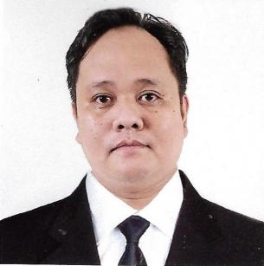
ARTCHIE I. PARAL
#2363 La Mesa St., Ugong, Valenzuela City
Mobile No.: (+63)945 768 3561
E-mail Add.: Mafimukmoya@gmail.com

Career Objectives:

To fill any vacant position in your company that suits my qualifications.

Work Experiences:

January 2020 - February 2023

Hounds and Grounds Cafe
Malvar St. Cor. EDSA Avenue Bagong Barrio West , Caloocan City
Position: Cook

September 1, 2016 – September 1, 2018

SUBWAY ARABIA
FOODWAY TRADING EST.
Riyadh, Kingdom of Saudi Arabia
Position: Sandwich Artitst

October 5, 2012 – October 5, 2014

McDonald’s (Riyadh)
RIYADH INTERNATIONAL CATERING CORPORATION
Riyadh, Kingdom of Saudi Arabia
Position: Service Crew
Promoted: Crew Trainor (Nov. 2013 – Oct. 2014)

Training Experience:

December 1, 2016

SUBWAY Manager’s Training Course
SHAMEL FOOD COMPANY, LTD.
SUBWAY, KSA

January 29 - May 10, 2009

CityState Tower Hotel (OJT)
600 Hrs. Specializing in various Hotel Operations Particularly in
Kitchen Department
#1315 A. Mabini St., Ermita, Manila

Educational Background:

College Dr. Carlos S. Lanting College (DCLC)
Hotel and Restaurant Services
#16 Tandang Sora Avenue, Quezon City
(2007-2009)

Personal Background:

Date of Birth : May 23, 1985
Place of Birth : Valenzuela City
Religion : Roman Catholic
Civil Status : Married
Gender : Male
Citizenship : Filipino
Weight : 98 kg.
Height : 5’7”

Reference will be furnished upon request.

Artchie I. Paral

