JINGBIE JHOY BONOEN
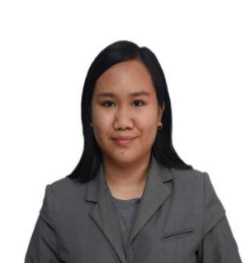
House Address: Brgy. Pancian Pagudpud, Ilocos Norte
Cell phone Number: 09687456906
Email: bonoenjingbie14@gmail.com

OBJECTIVES
- Seeking a challenging position in where my skills, knowledge, and capabilities will contribute to any aspect of the institution where I give my service to be able to improve and develop farther my talents and capabilities through continuous learning and valuable life experiences.

SKILLS AND COMPETENCE
- Computer Literate
- Patience
- Mentoring
- Flexibility and Adaptability
- Ability to work under pressure
- Friendly
- Problem-Solving
- Communicate Clearly

SUMMARY OF QUALIFICATION

- LET Passer
- NC II holder of Bread and Pastry Production
- Computer Literate

TRAINING/SEMINARS

(June 10-July 16, 2017) Hannah’s Beach Resort and Convention Center
(Brgy. Balaoi Pagudpud, Ilocos Norte)

(January 16-June 8, 2018) BergBlick Restaurant (Brgy. Burayoc Pagudpud, Ilocos Norte)

(December 2019) TESDA NCII Bread and Pastry Production

EDUCATIONAL BACKGROUND
Tertiary
2020 Mariano Marcos State University
Professional Education

College of Teacher Education
Laoag City

2019 Mariano Marcos State University
Bachelor of Science in Industrial Technology
(Major in Food Technology)
College of Industrial Technology
Laoag City
                - Commission on Higher Education Scholar

Secondary
2015 Pasaleng National High School
Pasaleng Pagudpud, Ilocos Norte

Elementary
2012 Pasaleng Elementary School
Pasaleng Pagudpud, Ilocos Norte

PERSONAL QUALIFICATION
Hardworking, patient, willing to learn, willing to be trained, fast learner, friendly, active listener.

I hereby certify that the above information is true and correct to the best of my knowledge.

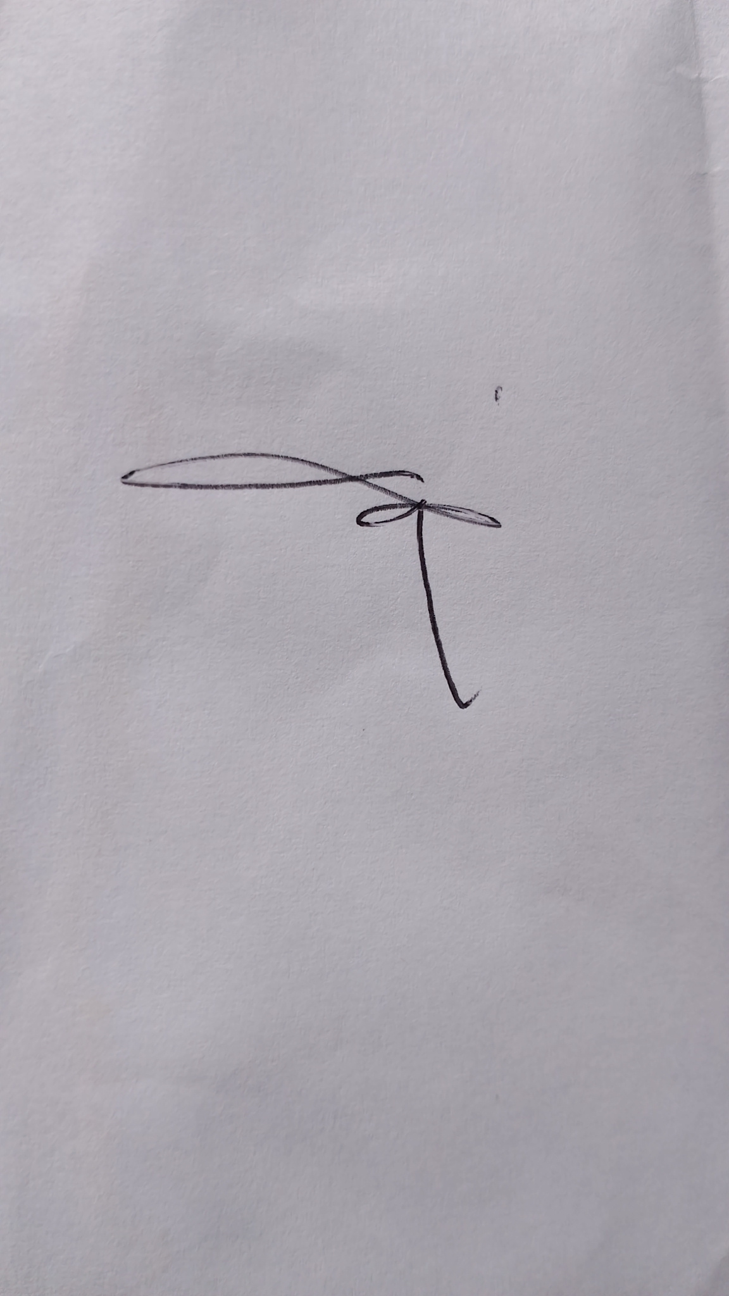

JINGBIE JHOY BONOEN
Applicant

