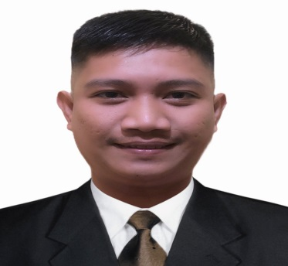
ALLAN U. CABADDU
Blk 24 Lot 73 Eastwood Residence,
Rodriguez Rizal
Mobile nos. 09774206736
Email Address: Sirallankid.cabaddu@gmail.com

OBJECTIVES

To apply for the position that suits my qualification, to gain more knowledge regarding the nature of work, to be able to work where I can fully utilize and develop my skills, experiences further for the professional fields I am in to.

SKILLS

- Ability to communicate with other
- Well organized
- Fast leaner
- Hard working and can work under pressure
- Knowledgeable in computer

EDUCATIONAL BACKGROUND
Tertiary: Polytechnic University of the Philippines
Year attended: 2009-2014
Sta. Mesa, Manila
Course: Bachelor of Science Hotel and Restaurant Management

WORK EXPERIENCE

August (2014) - September (2017) WAITER
KPOP CHICKEN RESTAURANT
Dubai (UAE)

- Greet customer and sear them according to their preferences.
- Offer welcome drinks and beverages.
- Take the orders and provide information about menu items.
- Ensure that the order is prepared according to the menu.
- Serve meals and side dishes.
- Ensure that continued service is managed during the course of the meal.
- Keep a constant eye on the table to gauge needs and fulfill them immediately.
- Accept payment in cash or credit card.
- Carry dishes and flatware to the kitchen.
- Collect menus at the end of the shift.

November (2017) – November (2019) ACCOUNTS CLERK/CASHIER
ONE AND ONLY ROYAL MIRAGE HOTEL
Dubai (UAE)

- Collect cash, checks and credit card payments from customers.
- Make change accurately and efficiently.
- Issue receipts to customers.
- Deal with returns and refunds as necessary.
- Maintain cash control over register drawer and verify amounts are correct.
- Answer customer questions as they arise.
- Calculate customer bills through cash register ringing.
- Help with other tasks as needed including managing shelves, tracking inventory and keeping the store clean.

PERSONAL DETAILS

Nickname : Allan
Birth date : May 9, 1993
Age : 29 years old
Nationality: Filipino
Height : 5’4
Weight : 55 kg.
Driver’s license : Professional 123

ALLAN U. CABADDU
Applicant

