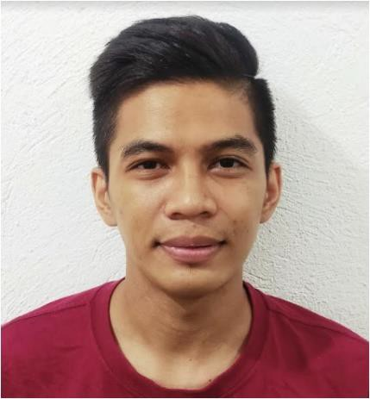
Von Jovi R. Gomez
#157 Sitio De Asis San Martin de Porres Paranaque City
Mobile No. +63 9605885343

OBJECTIVES

To be able to share my knowledge and experience for the growth of the company and to learn more about my chosen field for me to have a better background that can be a key for my success.

KEY STRENGTHS AND SKILLS

Can do multi – tasking and can work with less supervision, willing to undergo training if necessary for the job.

WORK EXPERIENCE

POSITION: Warehouse Personnel – Inventory Management
DURATION: December 2021 – May 4, 2023
COMPANY: DB Schenker Philippines INC (WILSERV Agency)
COMPANY INDUSTRY: Warehousing and Logistics
LOCATION: Unit Z1 Veterans St., Veterans Center JY & Sons Taguig City

JOB RESPONSIBILITY:
- Ensuring warehouse stocks are in order based on the system vs. actual
- Daily cycle count.

POSITION: Warehouse Personnel – Inventory Management
DURATION: September 2019 – April 2021
COMPANY: DB Schenker Philippines INC (LSERV Agency)
COMPANY INDUSTRY: Warehousing and Logistics
LOCATION: Unit Z1 Veterans St., Veterans Center JY & Sons Taguig City

JOB RESPONSIBILITY:
- Ensuring warehouse stocks are in order based on the system vs. actual
- Daily cycle count.

POSITION: Warehouse Personnel – Quality Control DURATION: March 2017 – September 2019 COMPANY: Magsaysay Shipping Logistics (ARM Agency) COMPANY INDUSTRY: Warehousing and Logistics LOCATION: C5 Road, Western Bicutan Taguig City

JOB RESPONSIBILITY:
- Picking orders based on customer requirements or special instructions
- Ensuring that the FIFO process is always observed
- Daily Inventory Arrangement

POSITION: Kitchen-Crew- Assistant Chef
DURATION: March 2015– September 2017
COMPANY: Lartizan Corporation
COMPANY INDUSTRY: Fine Dinning Restaurant
LOCATION : Serendra 2 Loading Bay Ground 26th corner McKinley Pkway, metro manila

JOB RESPONSIBILITY:
- Always ensure the serving food is presentable and clean
- Ensuring that the FIFO process is always observed
- Daily Inventory Arrangement

EDUCATION

EDUCATION LEVEL: High School Graduate
SCHOOL / UNIVERSITY: Dr, Arcadio Santos National High School
LOCATION: Paranaque City
DATE: 2012 - 2013

PERSONAL INFORMATION

Nickname : Von Jovi
Birthday : October 17, 1993
Birthplace : Paranaque City
Age : 29
Gender : Male
Nationality : Filipino
Marital Status : Single
I hereby certify that the above information is true and correct to the best of my knowledge and belief.

Von Jovi Gomez
Applicant Signature

