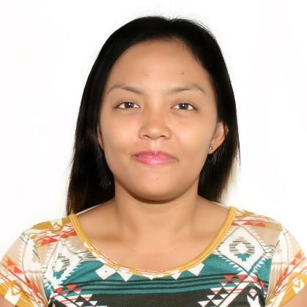
KATHLEEN JOY A. LOPOS
09264042134/09502765091 PUROK 2 ANISLAG, DARAGA, ALBAY kathleenjoyalopos@gmail.com

CAREER OBJECTIVE

- To secure a position that I can use my strong organizational skills, educational background, and ability to work well with different people to be able to contribute to your corporate goals and visions.
- To work in a company where I can share and practice my knowledge and skills to face new and exciting challenges and to develop my personality and contribute for the company's continued excellent and success.

EDUCATIONAL ATTAINMENT YEAR GRADUATED/YEAR LEVEL
GRADUATE STUDIES  Certificate of Methods of Teaching  Bicol University College of Education | 2016-2017
Daraga, Albay  TERTIARY  Bachelor of Science in Nursing | 2009-2012
Immaculate Conception College-Albay  Daraga, Albay  Bicol University Polangui Campus | 2007-2009
Polangui, Albay  SECONDARY  Saint Raphael Academy | 2003-2007
Legazpi City  PRIMARY EDUCATION  Bicol University Early and Late Childhood Opportunity Program  Daraga, Albay | 1997-2003
PERSONAL DATA

Date of Birth : May 15, 1990
Place of Birth : Daraga
Age : 32
Sex : Female
Height : 5’2”
Weight : 60 kgs
Civil Status : Married
Religion : Roman Catholic
Nationality : Filipino
Language/Dialect Spoken : Bicol, Tagalog, English
Arabic

SKILLS QUALIFICATIONS

- Computer Literate
- Can work well with different people and different schedules
- With good skills in writing and speaking in English language
- Good interpersonal and communications skills
- Can work in demanding time schedule within minimum supervisions
- Results oriented dynamic highly motivated and can be able to work independently

ELIGIBILITIES

- Nursing Licensure Examination

WORKING EXPERIENCE

Operating Room and Delivery Room,Staff Nurse
Allied Care Experts Medical Center
Legazpi City
January 3,2022-present

Dental Nurse
Almuhaidib Group of Companies
Dammam, Saudi Arabia
July 9, 2019- July 10, 2020

Dental Nurse
Dentoplast Centers Group
Dammam, Saudi Arabia
Jan. 28, 2018- July 8,2019

School Nurse
Daraga National High School
Daraga, Albay
July 1, 2015 – Dec. 31, 2016

School Nurse
Daraga Community College
Daraga Albay
June 10, 2014- June 30, 2017

TRAININGS AND SEMINARS ATTENDED

BASIC LIFE SUPPORT AND ADVANCE CARDIAC LIFE SUPPORT
LEGAZPI CITY
JANUARY 24-26, 2017

DARAGA MUNICIPAL ATHLETIC MEET 2016
DARAGA ALBAY
OCTOBER 6-7, 2016

THIRD BASIC SIGN LANGUAGE TRAINING WORKSHOP AND SEMINAR ON SPECIAL EDUCATION
DARAGA NATIONAL HIGH SCHOOL
DARAGA ALBAY
MARCH 29-30, 2016

SMOKING, ALCOHOLISM AND DRUG PREVENTION SEMINAR
DARAGA NATIONAL HIGH SCHOOL
DARAGA ALBAY
NOV. 27, 2015

I hereby certify that the above information on this record is true and correct to the best of my knowledge and belief.

KATHLEEN JOY A. LOPOS
APPLICANT

