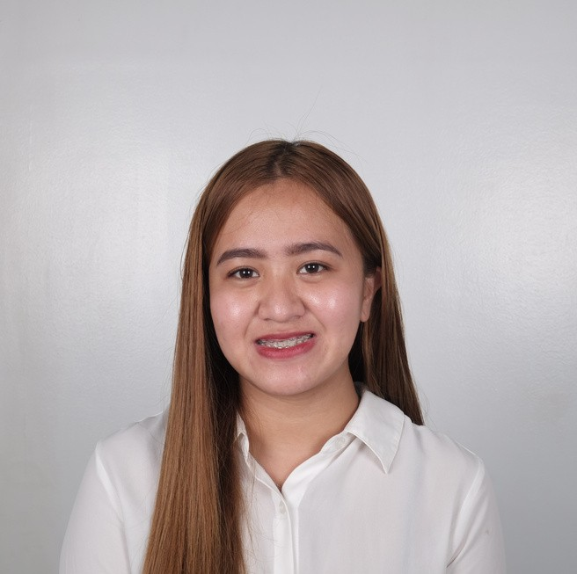
J H E R E L Y N N E M Y E T . B A L D E M O R
Organized and dependable candidate who is successful at managing multiple priorities with a great attitude. Excellent reputation for resolving problems and improving customer satisfaction. Securing a career opportunity to fully utilize my trainings and skills, while making a significant contribution to company success through hardworking.

C O N T A C T W O R K E X P E R I E N C E
+63 966 917 8092

jamyelynne1218@gmail.com Baguio City, Benguet, Philippines

P E R S O N A L D A T A
Date of Birth: December 12, 1996
Place of Birth: Baguio City, Benguet, Philippines Age: 26
Religion: Roman Catholic

S K I L L S
Willingness to take tasks and responsibility.
Success multitasking while remaining
professional and courteous in fast-paced environments.
Knowledgeable in Floral Designs, Bed Making, Table Skirting, Table Setting, Napkin Folding, Bartending and Flair tending.
Familiarity with electronic equipment, like cash register, POS and Basic Pc knowledge.

E D U C A T I O N
Bachelor Of Science
Hospitality and Tourism Management, Hotel, Resort and Restaurant Management
2013-2017
Saint Louis University, Baguio City, Benguet, Philippines

C H A R A C T E R R E F E R E N C E

Ms. Isabel M. Telio, BSHRM, HTM
Associate Prof.
Hospitality and Tourism Management Saint Louis University
09058683587
Ms. Maribelle Aguilar
Purchasing Manager
Waitress/Cashier/Florist/Bartender/Barista
Hillstation Restaurant
Resolved guest and employee complaints to maintain complete customer satisfaction and workforce effectiveness.
Shared knowledge of menu items and flavors, enabling customers to make personal decisions based on taste and interest.
Collaborated with kitchen staff to correctly update customers on unavailable dishes and wait times.
Displayed enthusiasm and promoted excellent service to customers, successfully increasing referrals, and walk-in business.
Bussed tables during busy periods to assist staff and quickly turn over tables. Greeted new customers, discussed specials, and took drink orders.
Maintained customer satisfaction with timely table check-ins to assess food and beverage needs.
Kept server areas clean and stocked to increase efficiency while working tables. Remained calm and poised when dealing with difficult customers or during busy shifts.
Trained new waitstaff on proper food handling, customer service and safety procedures.
Provided recommendations on menu items and upsold food and drinks to increase sales. 2017-Present

Waitress/Bartender

Mario's Restaurant
Strategically timed check-ins with customers to take orders and confirm satisfaction with meals after delivery, taking action to correct any problems. Helped customers with dietary restrictions, allergies and intolerances obtain safe, delicious food by working closely with kitchen staff on alternatives.
Supervised dining table set-up to prepare for diversity of event types, following strict service standards.
Maintained order efficiency and accuracy through clear communication with kitchen staff, earning numerous recommendations from satisfied customers.
Maintained thorough menu knowledge to sufficiently answer questions regarding menu item sourcing, ingredients and cooking methods.
Provided recommendations on menu items and upsold food and drinks to increase sales.
Greeted new customers, discussed specials, and took drink orders.
Maintained customer satisfaction with timely table check-ins to assess food and beverage needs.
Answered customers' questions, recommended items, and recorded order information. 2016-2017

On Call Banquet Waitress

Crown Legacy Hotel
Provide teamwork to all teammates and promote a sense of urgency for the guest and team members
Communicate with support crew and management
Complete pre‐function side‐work and Perform other duties as assigned
Monitor and maintain cleanliness, sanitation and organization of assigned work areas and Assist in preparing banquet room for function.

Hillstation, MyfoodgoddessesCorporation 09057714888
On The Job Trainee, Housekeeper
The Manor Hotel
2017-2017

Sir. Orlando Diga
Head Captain Waiter
Hillstation, MyfoodgoddessesCorporation 09166644912
Ms. Alexis Juganas
Branch Manager Bistro by Hillstation,
MyfoodgoddessesCorporation Alexisjuganas@gmail.com
09568868469
Cleans rooms, hallways, lobby, restrooms, elevators, dining areas and other function rooms
Replenish room supplies for the refrigerator, bathroom and work desk Conducts carpet cleaning activities in all required areas
Responsible for proper disposal of garbage as outlined by management Provide linens, blankets, towels, and pillows upon request by guests
Provide assistance to the elderly and young children when needed Oversee inventory of cleaning supplies and solvents
Oversee laundry of hotel linen, towels, and beddings Deliver newspapers to guests’ rooms
2017-2017

