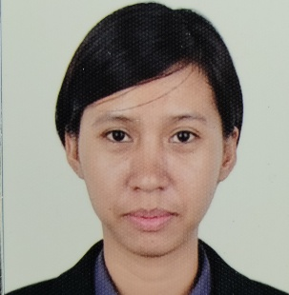
Jay-Anne I. Lim
Sabang, Danao City
Cebu City Philippines
Contact Number: +639772457875
Email: jayannelim4@gmail.com
_________________________________________________________________________________________
OBJECTIVE:
To live honest and hard life to work in a highly challenging competitive environment for the enhancement of my creative abilities and optimum profitability of the organization

PERSONAL INFORMATION
Date of Birth : December 30, 1995
Place of Birth : Cebu City
Nationality : Filipino
Hobbies/ Interests : Singing, Impersonating, Dancing and Reading

EDUCATIONAL BACKGROUND
Bachelor of Secondary Education major in English
2012- 2016
Cebu Normal University
Osmena Blvd., Cebu City
- College

Sabang National High School
Sabang, Danao City
Batch 2012

- High Shool

Bacayan Elementary School
Talamban, Cebu City
Batch 2008

- Elementary

ACADEMIC ACHIEVEMENT
  - Academic Year 2013-2014 Dean’s List
  - Licensed Professional Teacher
  - 1 month Training Certificate of Japan Work Ethics in Ibarraki Japan
SKILLS
- Friendly and open-minded; committed to client satisfaction.
- Cooperates and works well with others.
- Flexible and adaptable to changes.
- Helpful without being asked.
- Enjoy working with people- build strong relationships easily.
- Can speak, read and write in Japanese.

WORKING EXPERIENCES
- Eperformax BPO Company
March 2016-Sept 2016
Customer Service Representative

- Answer inbound calls in a timely and friendly manner.
- Evaluate problems and complaints of the callers and provide proper solutions to them.
- Respond to the needs of customers and provide personalized service.
- Provide information on the company's products or services and generate interest in the offer.

- Target Global English Academy
Sept 2016- October 2017
English Instructor

- Preparing lesson plans in accordance with students' learning needs.
- Tailoring lessons to accommodate differences in learning style and speed.
- Evaluating students' progress.
- Preparing and disseminating progress reports at regular intervals.
- Remaining knowledgeable about and respectful of cultural differences within the classroom.
- Assisting students with their technical difficulties, where possible.

- Nishiki Shokuhin Co. Ltd
August 2018-August 2021
Technical Intern Trainee in Miyagiken Japan

- Load raw ingredients into the cooking machine and measure the amount needed by following company recipes and industry standards.
- Verify that each finished item meets the quality standards of the company by observing the size, shape and luster of each snack item.
- Sanitize all materials and machinery parts at the end of each shift and clean the workspace at the worker station by following company cleanliness standards.

- Cebu Technological University
December 2021 – Present
Part-time English Instructor

- Execute lessons efficiently using different styles of teaching depending on the content.
- Engage students to ensure a lively classroom atmosphere.
- Instruct students about the structure and content of the English language.
- Teach students the spelling of words, and their meanings.

CHARACTER REFERENCE
- Welfreda Gingco
Position: School Manager
Contact number: 09275038671

