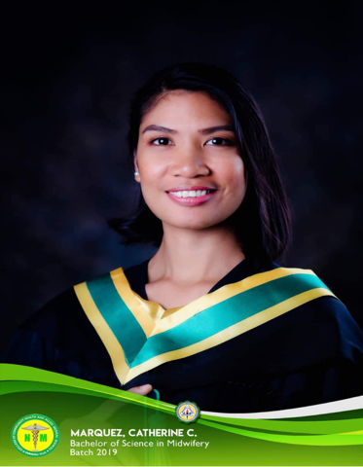
Catherine Castro, Marquez
Sta. Ana, Agoo, La Union
09569032632
Catherinemarquez456@gmail.com

OBJECTIVES

​To have a challenging job that would help me utilize my academic background, employ my knowledge and skills which may further enrich my experiences, and to significantly contribute to a respected company.

​

PERSONAL QUALIFICATION

- Good Communication Skills
- Able to follow instructions
- Take and record vital signs as well as input and output monitoring of patients
- Perform morning care routines and bathing of patients
- Educate mothers on family planning and performance of proper breast feeding practices.
- Perform bathing of infants and cord care .
- Perform kangaroo mother care
- Can work with minimum supervision

PERSONAL DETAILS

TERTIARY

August 2017 – May 2019
Don Mariano Marcos Memorial State University
​​South La Union Campos
​​Agoo, La Union

Degree Earned:​​ Bachelor of Science in Midwifery

SECONDARY

June 2001 – March 2005
​​President Elpidio Quirino Nat’l High School
​​San Agustin East, Agoo, La Union

PRIMARY
June 1995 – March 2001
​​Cubal Elementary School
​​San Pedro, Agoo, La Union

SEMINARS AND TRAINING ATTENDED

- Perinatal Sepsis
European Association of perenatal medicine
March 09, 2021

- Best Practices in Immunization for Women
Delex Pharmacy International
January 13, 2020

- Simplifying bedside stroke assessment
Delex Pharmacy International
November 23, 2020

- Traumatic Brain Injury in Children
November 18, 2020

- Module 2: Newborns : General Overview and Significance of the first 1000 days of life
0ctober 13, 2020

- Module 1: Pregnancy : General Overview and Significance of the first 1000 days of life
0ctober 13, 2020

- Womens Research During the Pandemic

- 1st Regional Midwives Conference “Midwives Moving Forward Make a Difference”
Integrated Midwives Association of the Philippines
Topic: Labor and Partograph / Newborn Resuscitation
Ariana Hotel, Paringao, Bauang La Union
May 20, 2017

- Certificate of attendance for participation in the 19th IMAP CAR Regional Convention for CAR, I, II, III.
- Theme: Achieving excellence in midwifery care amidst global challenges
- Prince Plaza Hotel Legarda Road, Baguio City.
- August 17-18, 2013

- Red Cross 143 Basic Training Course
Don Mariano Marcos Memorial State University-SLUC
September 9-16, 2013

- Basic Life Support Training– Health Care Provider and Basic First Aid Management
Don Mariano Marcos Memorial State University-SLUC
November 7-9, 2013

- Integrated Management of childhood Illness
Don Mariano Marcos Memorial State University-SLUC
November 11-20, 2013

WORK EXPERIENCE

- May 2019 - up to present. Nursing Attendant 1
Ilocos Training and Regional
MedicalCenter

- July 2017 – April 2019 Nursing Attendant 1
Baguio General Hospital
and MedicalCenter

- August 2016 – December 2016​ Nursing Assistant
Davao Doctors Hospita
Quirino Ave., Davao City

- July 01 – December 31 2015​​ Post-Graduate training
La Union Medical Center
Nazareno Agoo, La Union

- May – July 2014​​​ Volunteer Midwife
Agoo Maternity Lying-In
Sta. Barbara , Agoo La Union

JOB DESCRIPTION

PERSONAL DATA

Age​​: ​ 33
Height​​: ​ 5’5
Gender​​: ​ Female
Citizenship​​: ​ Filipino
Religion​​:​ Christian
Civil status​​: ​ Single
Date of Birth ​​: ​September 24, 1989
Place of Birth ​​:​Agoo, La Union
Address ​​: ​San Pedro, Agoo, La Union
Father’s Name​: ​Cesar A. Marquez
Mother’s Name​​: ​Verina C. Marquez
Language or Dialects​: ​Tagalog, English, and Ilocano

CHARACTER REFERENCES

Benjie Rivera​ ​ Pastor Christian Life Ministry
San Vicente Sur Agoo
09075172622

Recarla Ortega Nurse Supervisor Ilocos Training and Regional
Medical Center
09176186949

Norman Dagang Nurse Supervisor Baguio General Hospital and
Medical Center
09266271729

“I hereby certify that all above written information are true and correct, to the best of my
Knowledge and understanding.”

Catherine C. Marquez
Applicant

