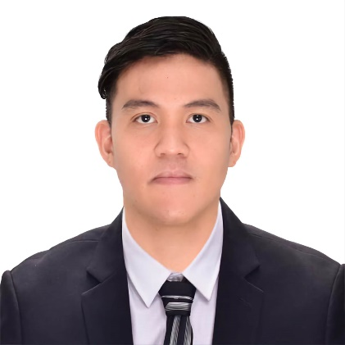
Paulino Jose L. Herrera
Email: herrerajosepaulino914@gmail.com
Contact No.: +639156550194

Objectives
- To provide outstanding food quality and service to ensure 100% guests/client satisfaction.
- To expose my expertise, efficiency, effectiveness and professionalism in a team-oriented and busy environment thus meeting company’s standards especially recipes.
- To pursue more challenging and rewarding career in the hotel and tourism industry where I can display my proficiency of developing excellent results both for the company and clients

Education
3A Prime Hospitality Training – Ships’ Catering NCIII (Ship’s Cook) 72 Escario Street, Cebu City 6000
Center for Healthcare Profession – NCII Housekeeping A.C Cortes Mandaue City, Cebu
J.H Cerilles State College – B.S in Hotel and Restaurant Management Pagadian City, Zamboanga del Sur From June 2009 – April 2013
Career Experience
- Cook at Oceania Cruises
C.F Sharp Crewing Management – Centro Maximo Bldg. D. Jakosalem St.,
Cebu City, 6000 Cebu from March 26, 2019 to Present

- Commis 3 (Hot Kitchen) at Plantation Bay Resort and Spa
Marigondon, Mactan Lapu-Lapu City, 6015 Cebu
From April 9, 2018 to February 21, 2019

- Commis 3 (Butchery) at Plantation Bay Resort and Spa
Marigondon, Mactan Lapu-Lapu City, 6015 Cebu
February 21, 2017 to April 8, 2018

- Commis 3 (Hot Kitchen) at Cebu City Marriott Hotel Cardinal Rosales Ave., Cebu City 6000
February 21, 2016 to November 2016

- P.A Attendant and Room Attendant at Cebu City Marriott
Cardinal Rosales Ave., Cebu City 6000
January 5, 2015 to February 18, 2016
Reference
Rico Bernadez Chef de Partie at Oceania Cruises Email: ricobernadez1980@gmail.com
Dindo dela Cruz Sabado Chef de Partie at Oceania Cruises Email: Dindosabado31@yahoo.com
Rodelio Dalut Contact #: +1 (649) 347-7142
Dondon Tiro Sous Chef at Plantation Bay Resort and Spa Contact #: 09153912620

I hereby certify that, to the best of my knowledge, the provided information is true and accurate.

Applicant
Paulino Jose Lanit Herrera

