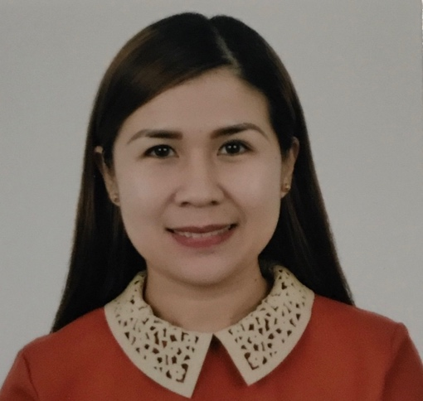
DOYEN SUBONG JOPE
Barangay Mansaya, Lapuz, Iloilo City, Philippines
Mobile No. +63 917.773.3601
Landline No. +63 (033)332.17.55
Email Address: doyenjope@yahoo.com
doyenjope1985@gmail.com

PERSONAL PROFILE

A confident and highly organized administrative professional with experience in a busy office and customer service experience, rapidly assimilation and learning processes to operations and accounting. Meticuluos in my approach to data collection and presentation, maintain records and very keen to information details. Able to work autonomously and meet deadlines throughout the (Check Runs etc.) and to be a part of a dynamic organization that maximize my competence and optimize my protection for growth and development.

WORK EXPERIENCE:

CHINA BANK SAVINGS
Centralized Operation Group
APDLG – Guimaras Branch Lite
Piazza Zemarcato Bldg., San Miguel,
Jordan, Guimaras
(033) 329-4751 / 0918-9656964

SERVICE HEAD (JULY 16, 2021 – Present)
- Responsible for the overall conduct of business and operational effectiveness and efficiency of assigned Regional Business Center as well as Service Personnel to meet established objectives
- Ensure excellent customer service according to the established corporate standards.
- Ensures daily that the loan documents of newly booked, renewed and/or extended loans such as Promissory Notes, Disclosure Statements, Amortization schedules are complete and accurately filled.
- Implements company policies and procedures within the assigned territory and sees to it that they are properly complied with.
- Acts as Approver of loan within my credit authority limit.
- Prepare a Daily End of the Day Reports and Month End Reports.

PARK INN BY RADISSON ILOILO
SM City Iloilo Complex, Benigno Aquino Jr. Avenue,
Brgy. Buhang, Mandurriao, Iloilo City 5000 Philippines
(033) 500-0000

CREDIT AND COLLECTION SUPERVISOR (APRIL 1, 2020 – JUNE 10, 2021)
- Collect outstanding debts from clients and achieve collection target to ensure positive cash flow
- Monitor slow moving accounts to identify delinquent debts and take necessary action to recover debts.
- Post clients check and ensure timely credit transfer.
- Review collection queue to perform collection activities accordingly.
- Adhere to client policies and procedures
- Close a specific number of collection accounts each month to meet assigned target
- Contact debtors and implement repayment schedules and terms.
- Assist the company to take legal action against debtors by providing necessary information.
- Maintain security and confidentiality of company
- Follow legal requirements during debt collections to avoid legal issues.
- Conduct monthly credit meeting with General Manager, Financial Controller, Director of Sales, F&B Manager & Front Office Manager.

ACCOUNTS PAYABLE ASSISTANT (FEBRUARY 26, 2019 – MARCH 31, 2020)
- Audits bills for errors, corrects as necessary.
- Ensures appropriate support documentation is obtained and attached to the invoices before payment is made.
- Researches travel agency commission checks and performs necessary follow up.
- Ensures correct charging amount by coding invoices.
- Accrues un-posted invoices for month end.
- Reconciles all statements, requests missing invoices and makes adjustments as necessary.
- Summarizes payments due and communicates cash needs to the Assistant Accountant for approval.
- Keeps file on audited food invoices and pays monthly.
- Ensure all accounts payable transactions have been approved by all necessary signatures.
- Check supporting documentation confirming the delivery of goods and services from suppliers.
- Audits bills for errors, corrects as necessary.
- Ensures proper back up is attached to expense reports.
- Authorizing and entering relevant information into the accounts payable system.
- Stamps all invoices “paid” before going to the check signers for signature.
- Run monthly accounts payable reports and reconcile to receiving records.
- Prepare monthly expenses accruals.
- Keeps immediate Supervisor promptly and fully informed of all problems or unusual matters of significance.
- Performs all duties and responsibilities in a timely and efficient manner in accordance with established company policies and procedures to achieve the overall objective of this position.

VALIANT (INC.) A RURAL BANK
41-A Mabini St., Iloilo City 5000
Philippines
Contact No. +63 (033) 336-63-96

ASSISTANT CASHIER (JULY 2009 – FEBRUARY 22, 2019)
- May act as a Cashier in case the former’s absence, be called to act as an alternate teller/ new accounts when needed
- Main tasks – register and prepares deposit slip for MCOCI and COCI to be deposited to depository banks
- Upkeep maintain and monitor post-dated check.
- Assists in preparing journal entries of Bank Deposits and other Inter-Branch transactions.
- Establishes and maintains the Bank’s fiscal record keeping system by utilizing generally accepted accounting principles;
- Provides a high level of customer relations and service
- And ensures compliance with Bank policies and procedures

BANK TELLER (JANUARY 2008 – 2009)
- Facilitates financial transactions (both Cash and Checks) made by the clients and record all
transactions accurately and efficiently.
- Provides account services to customers by receiving Deposits and Loan Payments;
- Cashing Checks, issuing savings withdrawals; answering questions in person or on telephone; referring to other bank services
- Records transactions by logging cashier’s checks, other Local Manager’s check, and other special services; preparing currency transaction reports.
- Reconciles cash drawer by proving cash transactions; counting and packaging currency and coins; reconciling loan coupons and other transactions; turing excess cash and mutilated currency to head teller.
- Maintains customer confidence and protect bank operations by keeping information confidential.

LOANS BOOKKEEPER (AUGUST 2007-DECEMBER 2007)
- Daily positing balance transactions and providing accounting entries.
- Monitors debt levels and compliance with debt covenants.
- Pay supplier invoices in a timely manner
- Ensures that receivables are collected promptly
- Encodes blotter reports for Regular Loans & Secured Loans
- Prepares bank deposits by compiling data from cashiers, verifying and balancing receipts, and
sending cash, checks or other forms of payment to the bank.
- And keep track of overdue accounts
- Updates and maintain one or more accounting records, including those which tabulate
- expenditures, receipts, accounts payable and receivable, and profit and loss
- Maintains the Petty Cash Fund

SM APPLIANCE CENTER (INC.)
Benigno Aquino Avenue, Diversion Road,
Mandurriao, Iloilo City,
5000, Philippines

SALES CASHIER (APRIL 2007 – AUGUST 12, 2017)
- Receives payment by Cash, Checks, Credit Cards, Vouchers, or Automatic Debits - Process Sales or other Transactions
- Issues Receipts, Refunds, Credits, or Change due to Customers – Issues Money, Credit or Vouchers.
- Establish or Identify Prices of Goods, Services or Admission, and Tabulate bills using calculators, cash registers, or optical price scanners – Calculate costs of goods or services.
- Process merchandise returns and exchanges
- Monitor checkout stations to ensure that they have adequate cash available and that they are staffed appropriately.
- Sort, count and wrap currency and coins
- Request information or assistance using paging systems
- Greet customers entering establishments

PRACTICUM

EQUITABLE PCI BANK - ILOILO (NOVEMBER 2005 – JANUARY 2006)
Valeria & Solis Sts., Iloilo City, 5000

CHARACTER REFERENCE:

MS. MA. DINDA TAMAYO
Provincial Director
Department of Trade and Industry - Antique
09173016694

MS. AUBREY G. MERLO
Sales Manager
Park Inn By Radisson Iloilo
SM City Iloilo Complex
Brgy. Buhang, Mandurriao, Iloilo City
09178133772

MS. CECILE FAITH B. PALACIOS
General Cashier
Park Inn by Radisson Iloilo
SM City Iloilo Complex
Brgy. Buhang, Mandurriao, Iloilo City
09771734694

~o0o~

