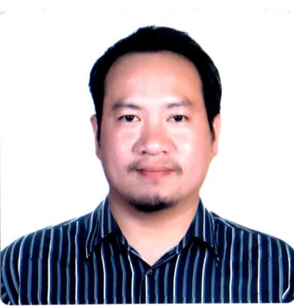
BUENDIA, RAMON Jr. SALES
ramonsummer042891@gmail.com
+639913067988
Purok 2 Barangay Tacunan Tugbok District Davao City

Personal Profile
As a butcher, I believe that I am capable enough to do this job physically and mentally. I’m a hardworking person with enough knowledge and skill in meat industry. I can work under pressure, individually or as a team. A reliable employee who will abide by the rules given by the company.

Personal Information
Date of Birth: April 28, 1991
Age: 31
Place of Birth: Davao City
Civil Status: Married
Number of Children: 2
Age of Children: 3 years old and 6 months old
Beneficiaries:
Terry Vic A. Buendia
Yrrebelle Summer A. Buendia
Yrremon Autumn A. Buendia
Nationality: Filipino
Weight: 71
Height: 5’4’’
Skills
- Deboning
- Slicing
- Trimming
- Packing
- Operating Band Saw and Slicer
- Cleaning Equipment
- Good Costumer Service
- Health and Safety Knowledge
- Forklift Operator
Educational Attainment
- Primary Level: Good shepherd Baptist School
- Secondary Level: Maryknoll High School of Panabo, inc. (2003-2004)
- Tertiary Level: DMMA College of Southern Philippines Undergraduate (2012-2013)
Seminars/Trainings:
- Forklift Operator (August 16, 2017 to September 29, 2017)
Training Center: DPWH Training Center (Km. 48, Canocotan, Tagum City Davao Del Norte)

Employment History
Position: Industrial Meat Cutter, Butcher, Deboner
Date Employed: August 21, 2019 to November 19, 2022
Company Name: Jolisa Agribusiness Corporation (Lisa’s Tender Lean Meats)
Location: Laverna Hills Diversion Road Buhangin Davao City
Contact Number: (082) 233-1757
Job Description:
- Deboning primal cuts pork and beef
- Slicing, trimming, operating Band Saw and Slicer
- Cleaning equipment

Position: Forklift Operator
Date Employed: August 21,2018 up to January 20, 2019
Company name: Davao Packaging Corporation (DPC)
Location: Bo. A.O. Floirendo Panabo City Davao Del norte
Contact Number: (082) 234-2281
Job Description:
- Loading, unloading, and receiving warehouse items.
- Transporting materials to different locations within the facility.

Position: Forklift Operator
Date Employed: January 20, 2018 up to August 16, 2018
Company Name: Master Port Services (MPSI), Inc.
Location: Bo. Ilang Davao City
Contact Number: (082) 238-0597
Job Description:
- Loading, unloading, shipping, and receiving warehouse items.
- Transporting materials to different locations within the facility.
- Securing loads to the machine before transportation

Position: Stevedore
Date Employed: September 2014 up to February 2015
Company Name: Davao International Container Terminal
Location: Panabo City Davao Del Norte
Job Description:
- Loading, unloading Banana for export

Position: Service Crew
Date Employed: January 2013 up to March 2013
Company Name: Freemont Foods Corp.
Location: Buhangin Davao City
Job Description:
- The focus of a service crew member is to tend to the needs of customers.
- providing help and assistance in the kitchen when such is needed.

Work References:
Full Name: Edwin A. Laga
Job Position: Assistant Supervisor
Company Name: Jolisa Agribusiness Corporation (Lisa’s Tender Lean Meats)
Contact Number: +63929-899-9489

Full Name: Monaliza Carinosa Salomeri
Job Position: Head Quality Assurance
Company Name: Jolisa Agribusiness Corporation (Lisa’s Tender Lean Meats)
Contact Number: +63917-425-4802

Full Name: Norie M. Bansali
Job Position: Human Resource
Company Name: Jolisa Agribusiness Corporation (Lisa’s Tender Lean Meats)
Contact Number: +63919-067-2916

Buendia, Ramon Jr. Sales
Applicant

