


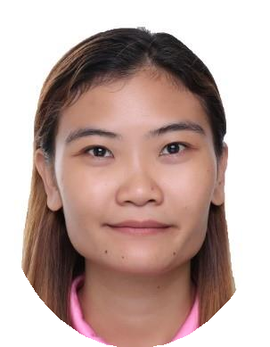

CATHARINE CORTEZ PAHANG
CONTACT

+63 908 8924 775

EMAIL

catharinecortezpahang@gm ail.com

ADDRESS
Parañaque City, Philippines, 1700
OBJECTIVE
- To seek and maintain full-time position that offers professional challenges utilizing interpersonal skills, time management and problem-solving skills.
- Organized and dependable candidate successful at managing multiple priorities with a positive attitude.
1

WORK HISTORY

DEPORTES INC.
1
Parañaque City, Philippines
February 22, 2023 - Current

Retail Store and Operations Manager
- Plans and develop strategies to hit monthly target and prepare monthly sales report.
- Offering excellent customer service and maintain positive customer relationship by handling customer complain and aftersales feedback.
- Ensure completeness of stocks and facilitate allocations and replenishment, recommend stock transfer.
- Promote team communication and hands on to training and orientation of Company rules and regulations to Store's Retail Supervisor, Sales and Cashier.
- Utilized upselling techniques to promote additional products and increase sales.

JAPAN SOUTH AUCTION INC.
Parañaque City, Philippines
May 02, 2017- December 15, 2022

Manager
- Oversee all marketing campaigns and channels to promote business and product through short message and social networking services.
- Developed and maintained relationships with customers and suppliers through account development.
- Responsible for developing marketing plans and strategy to increase number of customer and to generate higher sales every auction day.
- Projecting target sales per auction based on number of containers display at auction hall.
- Coordinate with all staff to implement sales strategies depending on the volume of containers per auction.

ST. AUGUSTINE & REALTY DEVELOPMENT INC.
Quezon City, Philippines
January 13, 2016 - April 4, 2017

Marketing Staff
- Maintained complete database of files, contacts, and project materials.
- Collaborated with design team to create visuals for various marketing campaigns.
- Coordinated with sales and operational teams to verify alignment of marketing initiatives with company goals.
- Created and implemented customer loyalty programs to increase customer retention and loyalty.
- Responded to customer inquiries promptly and professionally to increase customer satisfaction.
- Generated reports to support development and implementation of marketing plans.

SECURITY BANK & CAPITAL INVESTMENT CORP.
Makati City, Philippines
April 27, 2015 - September 25, 2015

Administrative Staff
- Assisted coworkers and staff members with special tasks on daily basis. Managed filing system, entered data and completed other clerical tasks.
- Updated spreadsheets and databases to track, analyze, and report on performance and sales data.
- Managed phone and email correspondence and handled incoming and outgoing mail and faxes.
- Managed paper and electronic filing systems by routing various documents, taking messages and managing incoming and outgoing mail.

EDUCATION

MARIE-BERNARDE COLLEGE INC.
Formerly: Saint Bernadette College of Health and Sciences, Inc.
Quezon City, Philippines

B.S. Business Administration Major in Marketing Management
Graduate
S.Y. 2011 – 2015

QUEZON CITY HIGH SCHOOL
Quezon City, Philippines
S.Y. 2006 – 2010

