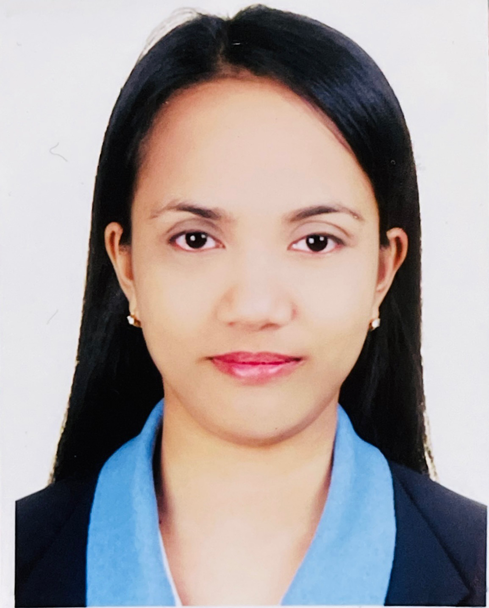
CANAY , JENNEFER
#02 Galguerra Compound., Jacinto Ext. St. Marulas, Valenzuela City
Contact Number : +63 921 170 2721 /+63 992 417 2870
Email Address : jmski_chute08@yahoo.com
Passport Number : P6659121B
Driving License : N25-09-020237

OBJECTIVES

To aquire a position within the company that offers a challenging and stimulating environment that is willing to give an opportunity to explore and enhance the best of my knowledge, skills and expertise.

SPECIAL SKILL
- WITH GOOD COMMUNICATION SKILL
- TEACHABLE AND WILLING TO LEARN FUTHER
- READY TO FACE CHALLENGES
- DESCRIPTION AND UNDERSTANDING THE NEED FOR CONFIDENTIALITY
- SINCERE, TRUSTWORTHY AND HARD WORKING

CAREER PROFILE/WORKING EXPERIENCES
➢Technical Intern Trainee (Fish Processing)
September 9, 2016 to November 11, 2021
FUKUI KE NMIN SEIKATSU KYOUDOU KUMIAI
Fukui-Ken Japan

Duties and Responsibilities:

- Set up and operate machines that process fish and seafood products.
- Check products and packaging for irregularities.
- Ensure compliance with company standards.
- Make the necessary adjustments to machines, Record production information.
- Cut, clean, and trim (remove skin, bones, head, etc.) fish and seafood before sale or packaging.
- Scale the fish, cut it, gut it, and separate the fillets.
- Cut pieces according to specifications and weigh them.
- we make sure that everything is good and clean in orderly that our customer is satisfy and prevent food poisoning and safety.

➢ MACHINE OPERATOR
June 9, 2013 to November 29, 2015
Innulox Corp (Chi Mei OptoElectronic)
Tainan Taiwan

Duties and Responsibilities:
- Inspecting some of LCD/LED Monitor, TV, Notebook, Tablet etc. to be excellent to our customer specially the defect that I have seen in panel.
- Do manual inspection to avoid computer error in terms of the particles, line defect, abnormal display and broken panel.

➢ MACHINE OPERATOR
June 9, 2010 – May 17, 2012
Opto Technology Inc.
Science Based Hsinchu Taiwan

Duties and Responsibilities:

- Look over work orders, instructions, and processing charts to determine a work schedule.
- Monitor machines that slice silicon crystals into wafers for processing.
- Load wafers into the equipment that creates patterns and forms the electronic circuitry.
- Set and adjust controls to regulate the manufacturing equipment’s power level, temperature, and other process parameters.
- Adjust the process equipment and repair as needed during the manufacturing process.
- Test completed microchips to ensure they work properly.
- We also meet quotas to finish our respective products.

➢ ENCODER / RESEACHER
Jan 30,’09 – May 2010
IQUEST INSIGHT INC.
50 Brgy. Llano Road Caloocan City

Duties and Responsibilities

- Preparing and sorting data for computer entry, Reviewing data to make sure it's accurate before entering it in the system.
- Entering data from paper to a computer data entry system.
- Maintaining the data system and ensuring all information is correctly recorded.
- Completing data backups, Filing and making paper copies.
- Checking your work for errors or duplicate entries.
- Keeping records of data entry and database informations.

➢ SERVICE CREW
Feb 10, ’07 – July 21, ’07
Jollibee Foods Corporation
Valenzuela Branch Philippines
Duties and Responsibilities

- Sets up food service, kitchen, or salad area facilities, equipment and utensils, under detailed instruction and, in accordance with specific area needs; checks food temperatures and/or prepares areas for daily operations; equipment as assigned.
- Conveys food and supplies from the main kitchen, and/or salad preparation area to the serving site either by carrying or by utilizing a motorized cart.
- Follows prescribed procedures in setting up hot and cold food lines; ice cream, yogurt, and/or ice machines; chooses proper utensils and sets steam line to appropriate temperature for menu items.
- Prepares or assists in the preparation of hot and cold meat and vegetable dishes, beverages, salads, sandwiches, salad dressings, and/or other similar food items, as appropriate to the position.
- Serves food items to customers from counters and/or steam tables, in accordance with specific instructions, ensuring that appropriate portions are served, and adds relishes and garnishes according to instructions.
- Replenishes foods, silverware, glassware, dishes, and trays at serving stations; may order and replenish condiments.
- May clean, wash and maintain work areas, including floors, facilities, pots, pans, service ware, utensils, and equipment; collects and places garbage and trash in designated containers; as appropriate to the area of operation.
- May perform cashiering duties, as required.
- May provide guidance and training to other employees performing related work.
Performs miscellaneous job-related duties as assigned.

Educational Attainment

TERTIARY​​​
Bachelor of Science in Information Technology
​AMA Computer College (AMA UNIVERSITY)
​Caloocan City Philippines
​2004 – 2008

SECONDARY
Valenzuela National High School
​Marulas Valenzuela City
​1998-2002

PRIMARY​​​​​
Marulas Central School
​Marulas Valenzuela City
​1992-1998

CHARACTER REFERENCE

Name: Arnold Sanchez
Company: Water Refilling
Contact: (0995) 918 6742

Name: Michelle Siega
Company: Realpage Philippines., Inc
Contact: (0923) 834 7882

Name: Seza Odonzo
Company: Telford Services Philippines., Inc
Contact: (0945) 739 4452

