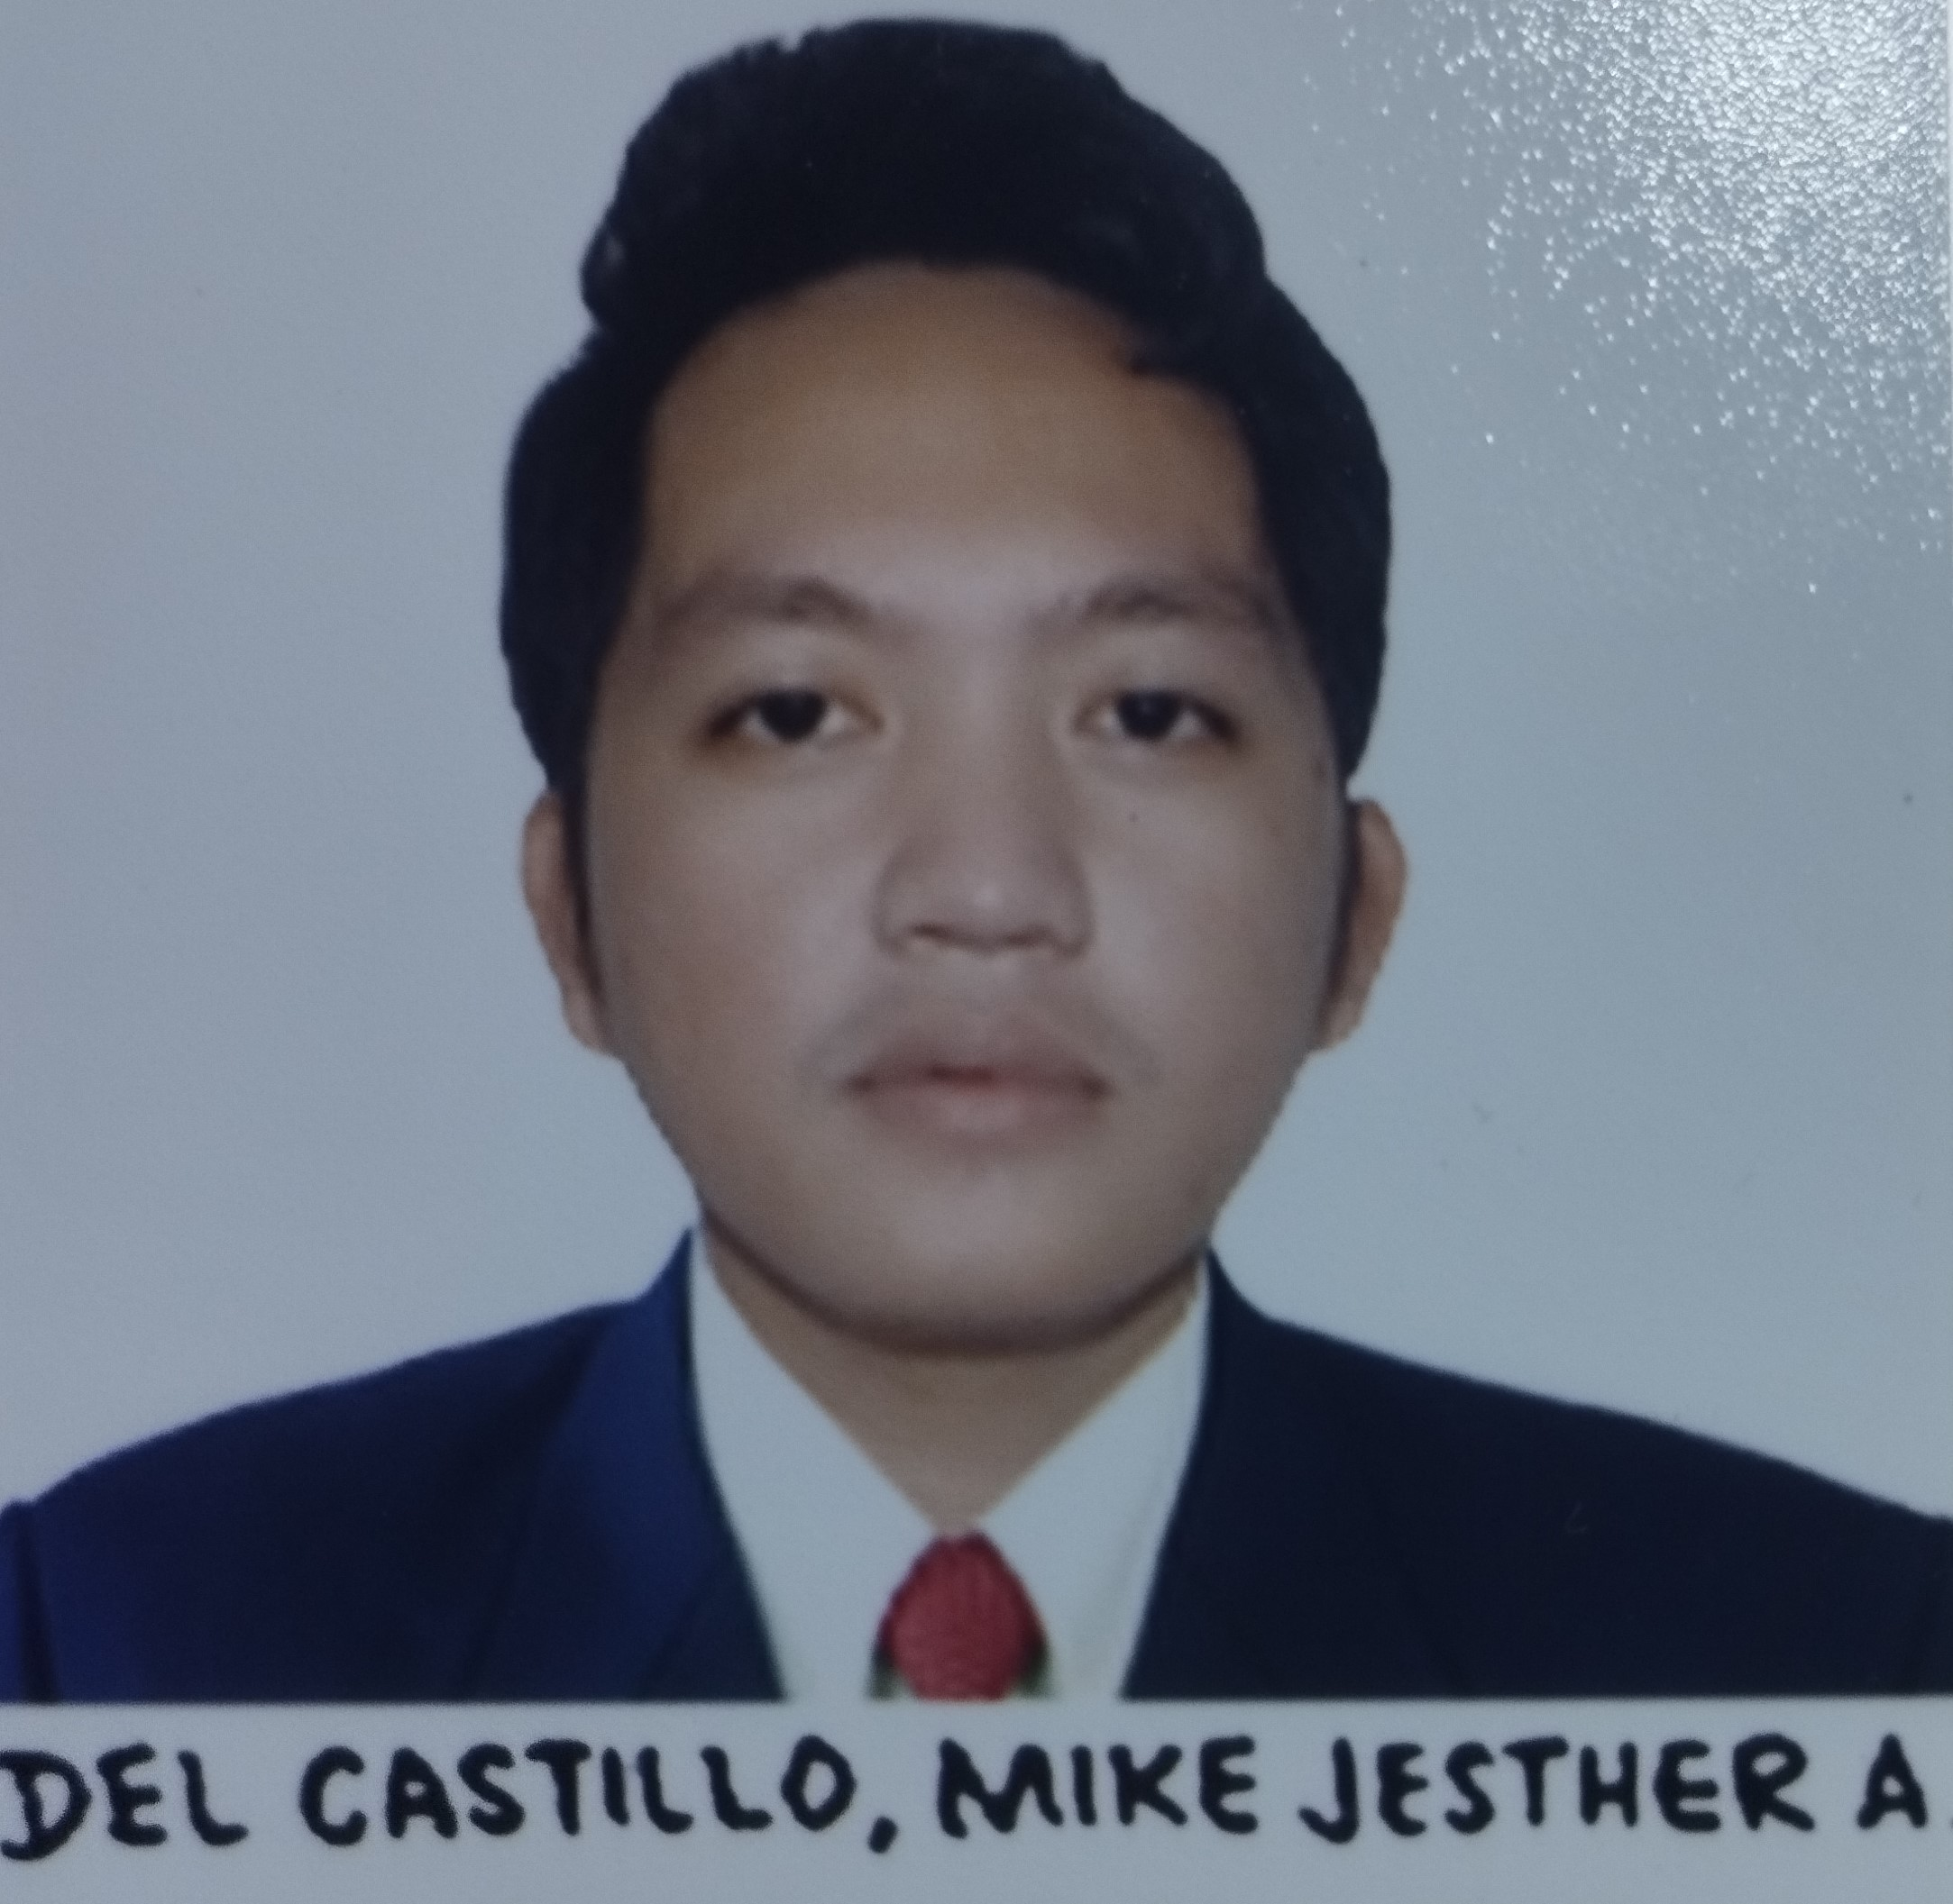
RESUME

Name:ENGR. MIKE JESTHER A. DEL CASTILLO
Profession: Mechanical Engineer
Age: 25 years old
Address: Brgy. Baresbes, Dingras, Ilocos Norte 2913 Philippines
Email Address: mjdelcastillo6@gmail.com

EDUCATIONAL BACKGROUND

Tertiary: NORTHWESTERN UNIVERSITY
Bachelor of Science in Mechanical Engineering
#50 Buttong Laoag City, Ilocos Norte

Secondary: SAN MARCELINO NATIONAL HIH SCHOOL
Brgy San Marcelino, Dingras, Ilocos Norte

Primary: BARESBES ELEMENTARY SCHOOL
Brgy. Baresbes, Dingras, Ilocos Norte

CHARACTER REFERENCES

ELMER B. TOLENTINO Punong Barangay
Brgy. Baresbes, Dingras, Ilocos Norte

MAXIMA O. ROSQUETA Former Head Teacher
Baresbes Elementary School

I hereby certify that the above-mentioned are true and correct.

MIKE JESTHER A. DEL CASTILLO
Applicant

