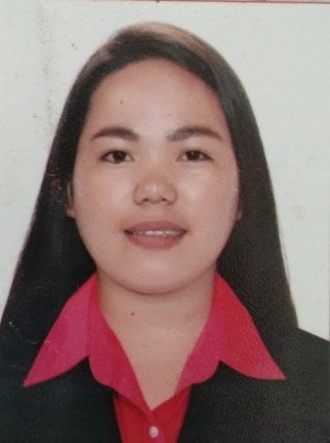
ROSELLE JOVITO MAKINANO
Caregiver / Housekeeper
30 Mercury Road Pilar Village Las Piñas * makinanoroselle10@gmail.com * +63977 640 1282
Caregiver with 5+ years of experience in geriatric care within homes and assisted living environments. Recognized for ability to monitor and provide emotional and physical support to patients and staff. Possess exceptional communication abilities, as well as cultural sensitivity to care for diverse populations.
Housekeeper with 3+ years of experience in home and hotel inn. Keeping it clean and organized things all the time.

PROFESSIONAL EXPERIENCE
February 2019 –December 2022
PRIVATE FAMILY /Makati Philippines
Private Caregiver – Elderly Care
- Care for 2 patient aged 93 & 94 in a rotational schedule
- Managed their daily needs including personal hygiene, dressing, being turned and being transferred from chairs to bed to toilet, vise versa
- Monitored changes in patients’ breathing rate, body temperature, blood pressure, glucose levels and emotional wellbeing.
- Monitored changes of using straight catheter, NGT feeding, nebulizing and suctioning
- Monitored general healthcare, overseeing medication and prescription usage, appointment reminders and administering medicines.

March 2016-January 2018
GMAOZ NURSING AGENCY LTD., / Tel Aviv Israel
PRIVATE CAREGIVER – Elderly Care
- Care for patient aged 87 years old
- Managed her daily needs including personal hygiene, bathing and grooming, dressing, toileting and exercising
- Monitored changes in patients’ breathing rate, body temperature, blood pressure, glucose levels and emotional wellbeing
- Monitored general healthcare, overseeing medication and prescription usage, appointment reminders and administering medicines
- Monitored basic food preparation, preparing meals, shopping, housekeeping, laundry and other errands.

December 2014-December 2015
HEAVENLY BED n BREAKFAST INN / Parañaque Philippines
RECEPTIONIST / ROOM ATTENDANT
- Monitored arrival and departure of guests
- Proficient in all functions including reservation while staying abreast of housekeeping and laundry standards
- Recording in and out guests
- Monitored and responds to all guests comment and suggestions, complaints and request while ensuring ultimate guests satisfactions
- Managed and develop, support front desk and reservation while encouraging and executing excellent service to all guests

November 2012-December 2014
GOLDEN LEGACY JOBMOVERS CORP. / Manila Philippines
HOUSEHOLD SERVICE WORKER / NANNY
- Monitored and taking care of the whole family including 5 children and Parents
- Managed housekeeping including laundry, cooking, marketing, gardening, washing and ironing clothes
- Monitor and managed kids in their daily activities including, daily homework, exercising, playing and safety
- Preparing delicious and healthy foods for the whole family

January 2011-January 2012
ASIA SUMMIT CORPORATION / Taguig Philippines
PURCHASING & MERCHANDISING STAFF
- Managed and received request of quotation from sales department, understanding and give the required value or price
- Managed outsourcing and finding the best and cheapest pricing of the products needed
- Managed and familiarizing products inside the stockroom
- Managed and giving best ideas for the company success

June 2008-June 2012
DEMO POWER CORPORATION / Quezon City Philippines
SALES REPRESENTATIVE
- Managed and familiarizing the benefits of the products needed to sell
- Monitored sales and promoting products, giving best to give big sales to company

CERTIFICATIONS
2019
HOUSEKEEPING NCII
Technical Education and Skills Development Authority

2018
CAREGIVING – Newborn & Elderly Care
Aide and ACHEALTH Company

2015
CAREGIVING NCII
Technical Education and Skills Development Authority

2012
HOUSEHOLD SERVICE WORKER
Technical Education and Skills Development Authority
EDUCATION
2005-2007
DIPLOMA IN COMPUTER STUDIES
STI COLLEGE

ADDITIONAL SKILLS
- Independent
- Detail-oriented
- Dependable
- Compassionate
- Written-communication
- CPR certified
- First Aid certified
- Able to lift up to 200 pounds
- Proficient cook and baker
- Experienced with managing records
- Patient, Lovable and Friendly
- Knowledgeable in Microsoft Office
- Strong multitasker

______________________________________________________________________________
30 Mercury Road Pilar Village Las Piñas City Philippines * makinanoroselle10@gmail.com * (+63) 9776401282

