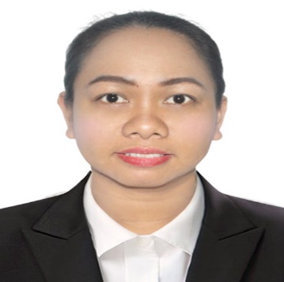
CLARIFEL B. ANDRADE
Caregiver
To make use of my good personality, capacity for working with the elderly and young, and solid medical education. To obtain the position of Caregiver and advance the organization's standing via my abilities and expertise.
 |  | Address  1754 Maunlad Street, CAA BF International, Las Piñas City, Philippines, 1740  Phone  +639973659221  E-mail  clarifelandrade@gmail.com  LinkedIn  Skype Account: +639973659221  First Aid Certified  Able to lift up to 200 pounds  Proficient cook  Experienced with managing records  Patient and friendly  Expert in Microsoft Office  Strong multitasker
   | Work History
  11/2022  12/2022 |  | ON-THE-JOB TRAINING  PERPETUAL HELP MEDICAL CENTER, Las Piñas, Philippines  - Recognized for ability to monitor and provide emotional and physical support to patients and staff. Possess exceptional communication abilities, as well as cultural sensitivity to care for diverse populations.
  01/2013 - Present |  | KINDERGARTEN TEACHER  DOÑA MANUELA ELEMENTARY, Las Piñas, Philippines  - Delivered lesson plans, implemented school curriculum and used data to create, monitor and establish personalized learning plan for each student.
  09/2011 – 03/2012 |  | ELEMENTARY TEACHER  DON CARLO CAVINA SCHOOL, Las Piñas ,  Philippines  - Used learning stations to incorporate colors,  shapes and textures to help students develop communication skills and build relationships.
   | Education
  07 2022 –  03 2023 |  | Vocational Course  UNIVERSITY OF PERPETUAL HELP SYSTEM DALTA - Las Piñas City  Caregiver Graduate 2023
  06/2016 –04/2022 |  | Master of Arts: Educational Management  CITY UNIVERSITY OF PASAY – Pasay City  36 Units
  06/ 2007 – 03/ 2011 |  | Bachelor in Elementary Education, Early Childhood  SAINT FRANCIS of ASSISI COLLEGE  Dean's Lister 2nd Semester
   | Certifications
  03/23/2023  09/11/2020  10/5/2016  07/2021  01/28 to 29/2023  02/4 to 5/2023 |  | NATIONAL CERTIFICATE II IN CAREGIVING  PHILIPPINE RED CROSS IN STANDARD FIRST AID BASIC LIFE SUPPORT-CPR WITH AED TRAINING  KINDERGARTEN MODULE VALIDATOR  KINDERGARTEN WRITER  CANDIDATE IN OUTSTANDING TEACHER
   |  | Personal Data
   | Contact
   | Skills
Date of Birth September 26, 1990
Place of Birth Villa Verde, Nueva Vizcaya
Age 32
Sex Female
Height 5’2 ft.
Weight 75kg.
Nationality Filipino
Civil Status Married
Religion Catholic
Father’s Name Crispin Gamiao Barbado Jr.
Occupation Retired Teacher
Mother’s Maiden Name Ofelia Almazan Villalobos
Occupation House Wife

