EUFE MARIE EBALLE VILLEJO
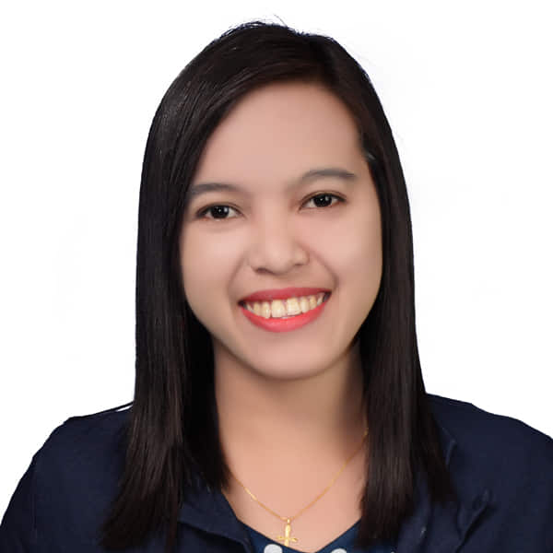
Barangay 5, Tangub City, Misamis Occidental
+639 486768520
villejoeufe@gmail.com
To acquire valuable knowledge and skills to complement those that I have learned from school and work in an actual job environment. In return, I offer my service and determination to be an asset to your company throughout the duration of my training period.

Personal information
Civil Status: Single
Religion: Iglesia Filipina Independiente (IFI)
Birth Date: June 5, 1997
Birth Place: Tangub City, Misamis Occidental

EXPERIENCE

APRIL 2020 – To CURRENT

Home based Online esl teacher, 51 talk
- Customized small group and individual classroom activities based on differentiated learning needs.
- Provided one-on-one instruction for non-English speaking students within classroom settings.
- Tracked class attendance and student progress.
- Employed kinesthetic, visual and auditory approaches to make lessons interesting and interactive.

May 2019 – TO current

branch cashier, rhean motor center inc.
- Issued and redeemed money orders, cashier checks, traveler's checks and savings bonds.
- Cash handling and counting for customer payment.
- Basic Mathematics.
- Responsible for balance cash draw at close.
- Built and maintained client relationships through quality, personalized interactions.
- Greeted customers promptly and responded to questions.
- Answered and directed incoming calls using multi-line telephone system.
- Scheduled and confirmed appointments.
- Sorted incoming mail and directed to correct personnel each day.
- Served as company concierge to employees requiring assistance help with travel arrangements.
- Screened and verified visitors for identification credentials and purpose of visit to maintain security of personnel and office environment.

Education

october 2020

bachelor of science in secondary education, medina college

may 2018

bachelor of science in office administration, la salle university

Skills
- Computer Proficiency  - Self-Motivation  - Work Ethic | - Creativity  - Multi-tasking  - Time Management

certification

tesol/teyl

tesol Certificate from tech international

REFERENCES

Mr. Herjane Mie Villadores
Teacher 1
Clarin National High School
+639309768526

Ms. Melody Canete
Branch Receptionist
+63938 685 2691

Mr. George S. Benitez
Barangay Kagawad/Point Person
+639092713985

