
OBJECTIVE

To Seek and develop my knowledge, abilities for the success of the company and strengthen my education and professional skills at the same time for brighter future.
WORK EXPERIENCE
August 01 2016 to January 18 2021. as I.T Staff / Sys Admin
Cashmate Credit Corporation

JOB DESCRIPTION
*Installing and configuring computer hardware, software, systems,
Networks, printers, and scanners
*Monitoring and maintaining computer/server/systems and networks
*Responding in a timely manner to service issues and requests
*Providing technical support across the company (this may be in person,
Over the phone and remote app)
*Setting up accounts for new users
*Repairing and replacing equipment as necessary
*Troubleshooting hardware, software and networking
*Photoshop
*implement and manage windows server's infrastructures,
Active directory, Group policies, users and permissions
*reset user/password
*maintain windows servers, data backup and recovery
*install, upgrade and monitor software and hardware
*inventory computers and other peripherals
*visit other branches for solving any encountered issues if needed.

March 15 2021 to January 30 2023. as Freelance – Wordpress Developer
Castle Jackson

JOB DESCRIPTION
* Design and code WordPress CMS responsive and Crossover Website
* PSD to WordPress slicing, convert into responsive functional CMS website
* Fixing Technical SEO issue's using Semrush
* WordPress Speed Optimization
* Designing FLyers, Banner, Book Cover and other marketing materials.
* Securing and Optimize WordPress Website
* Design WordPress Website using Divi & Elementor

EDUCATION
2011 - 2015 BACHELOR OF SCIENCE in INFORMATION and TECHNOLOGY
Panpacific University North Philippines Urdaneta City, Pangasinan

CERTIFICATION
2015 – NCll Computer Hardware & Servicing

Personal Information
Phone:
+639913129066

E-mail:
laureajonathan@gmail.com

Address:
Tabuyoc Binalonan, Pangasinan 2436 Philippines

Skills:

•Knowledgeable in Web Development (HTML, CSS, PHP, & MySql) & WordPress Development
•Knowledgeable in Photoshop and Video Editing
•Computer Hardware/Software/Network/Cabling & Trouble Shooting
•Computer literate (MS Word, Excel, PowerPoint)

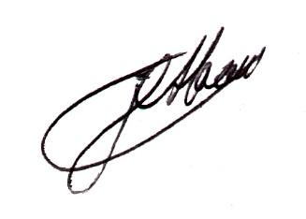
I hereby certify that all information above is true and correct to my knowledge.

Jonathan L. Abao

