

NAMFREL P. MIRA
jhongbrion@gmail.com
jhong_brion@@yahoo.com
Skype: jhongbrion
Mobile No. +639635365379
+639369543860
ADDRESS:
Phase 4, Block 4, Lot 6, Camella
Homes, Villa Kananga, Butuan City,
Philippines
PERSONAL DETAILS:
Age : 45yrs old
Gender : Male
Height : 5’6”
Weight : 130 lbs.
Civil Status : Married
Birth Date : December 12, 1977
Birth Place : Tubay,
Agusan del Norte
Nationality : Filipino
Passport no. : P7568398A
Valid Until : June 17, 2028

nglish& Tagalog

SCHOOLING:

Primary
Little Lambs Learning Center
Pasig City
1994 – 1990

Secondary
Little Lambs Learning Center
Pasig City
1990 – 1994

College:
Pasig Catholic College
Pasig City
Bachelor of Science in Business
Administration Computer
Management (BSBA)
1994 -2002

CAREER OBJECTIVES: To enhance my knowledge in the field of my study in any procedure, maximize my ability and productivity in my chosen career, and to accept more opportunities for career growth and development.
SUMMARY OF QUALIFICATION:
- Work efficiently in a team setting.
- Able to multi-task and maintain accurate service to customers.
- Able to perform consistent quality standard services of the company.
- Able to handle any problem/issues with my co-worker.
- Flexible, hardworking, and smart-working individual

WORK EXPERIENCE:
Position : 3rd cook sushi
Company : Celebrity Cruises
Start Date : July 31, 2022
Finish Date : Present

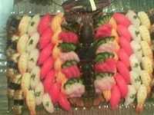




Duties Responsibilities:
- Following the USPH standard
- Making daily mise in place for the daily operation.
- Following the company standards and recipe
- Maintaining the cleanliness of the kitchen and the kitchen equipment

WORK EXPERIENCE:
Position : SUSHI CHEF
Company : CLUB SUSHI
Company Industry : Sushi and Steak Restaurant
Location : English Harbour, Antigua, and Barbuda
Start Date : November 01, 2014
Finish Date : May 15, 2019

Duties Responsibilities:
- To have full responsibility for my sushi station with regard to the
planning, preparation, set up, and execution of food items.
- To determine how the food should be presented and create decorative food
display.
- To keep the working area in excellent hygienic condition at all times according
to the rules set by the restaurant.
- To perform monthly inventory at the kitchen, utilizing food supplies,
portion control, and proper wastage monitoring.
- To be familiar with local food hygiene and HACCP guidelines as established per Antigua and Barbuda Public Health Office
- To implement and enforce all policies, procedures and standards set by
restaurant office including but not limited to kitchen standards.

WORK EXPERIENCE:
Position : COMMIS 1 SUSHI,HOT and WOK
Company : BENIHANA Amwaj Rotana Hotel
Company Industry : Japanese American Steak Restaurant
Location : Jumeira Beach Residence Dubai U.A.E.
Start Date : May 01, 2010
Finish Date : October 20, 2014

Duties Responsibilities:
- Determine how food should be presented, and create, decorative food
displays.
- To support directly the chef de partie and demi chef in the daily operation
and work.
- To keep working area at all times in Hygienic conditional according to
the rules and standard set by the hotel.
- To take the full responsibility of my Sushi section when my immediate
supervisor is not around.

WORK EXPERIENCE:
Seaman ‘s Book no. : A0067076
Valid Until : April 22, 2032
Language : English & Filipino
SCHOOLING:
Primary:
Tubay Central Elem. School
Tubay, Agusan del Norte
S.Y. 1990 – 1991
Secondary:
Rizal High School
Pasig City
S.Y. 1995 – 1996

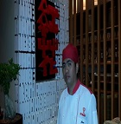

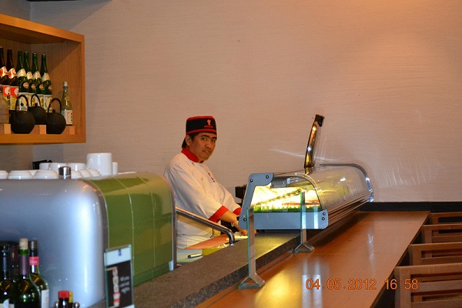


Position : Kitchen Steward
Company : Al MuroojRotana
Company Industry : Hotel
Location : ShiekZayed Road, Dubai U.A.E
Start Date ; February 09, 2009
Finish Date : April 30, 2010

Duties Responsibilities:
Ensure that the kitchen and all surfaces are kept clean and all utensils
are clean and in their appropriate place.
- Refuse is securely bagged/packed and recyclable materials are properly segregated.
- Maintaining and correctly operating the dishwashing machine.

WORK EXPERIENCE:
Position : Kitchen Steward
Company : Amwaj Rotana
Location : Jumeira Beach Residence, Dubai, U.A.E.
Start Date : January 19, 2008
Finish Date : February 08, 2009

Duties Responsibilities:
- Ensure that the kitchen and all surfaces are kept clean and all utensils
are clean and in their appropriate places.
- Refuse is securely bagged and packed recyclable materials are properly segregated.
- Maintaining and correctly operating the dishwashing machine.

WORK EXPERENCE:
Position : Assistant Cook
Company : City Garden Suites
Location : Malate, Manila Phils.
Start Date : February 2004
Finish Date : January 2005

Duties Responsibilities:
- Assisted in the preparation of cooking menu items.
- Checked all items to ensure adequacy and quality of the foods offered
- Prepared salads, dressings and desserts.

WORK EXPERIENCE:
Position : Kitchen Helper
Company : Carl Patrick
Company Industry : Restaurant
Location : Butuan City, Phils.

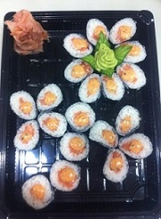
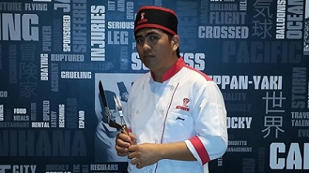
Start Date : December 2001
Finish Date : July 2003

Duties Responsibilities:
- Assisted the chef in preparing the foods.

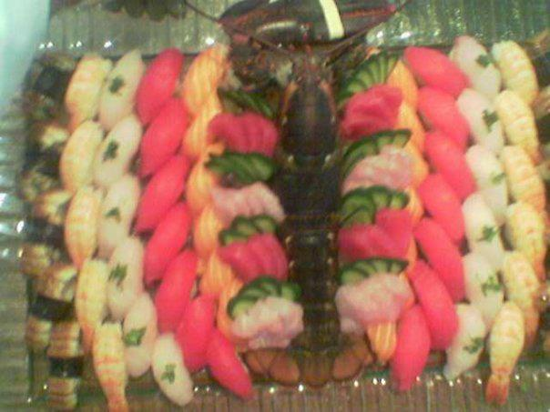
- Cleaned kitchen, utensils and equipment.
- Ensure the smooth operation and outstanding quality of the food.

WORK EXPERIENCE:
Position : Kitchen Helper
Company : Dan Michael
Company Industry : Restaurant
Location : Butuan City, Phils.
Start Date : December 2000
Finish Date : November 2001

Duties Responsibilities:
- Assisted the chef in preparing the foods.
- Cleaned the kitchen, utensils and equipment.

- Ensure the smooth operation and outstanding quality of the food.

WORK EXPERIENCE:
Position : Messenger/Clerk
Company : Carlota & Ass., Law Office
Company Industry : Law Office
Location : Quezon City, Phils.
Start Date : October 1998
Finish Date : August 2000

Duties Responsibilities:
- Delivering the letters.

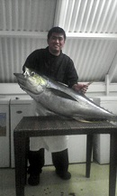

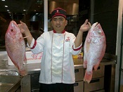

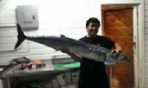

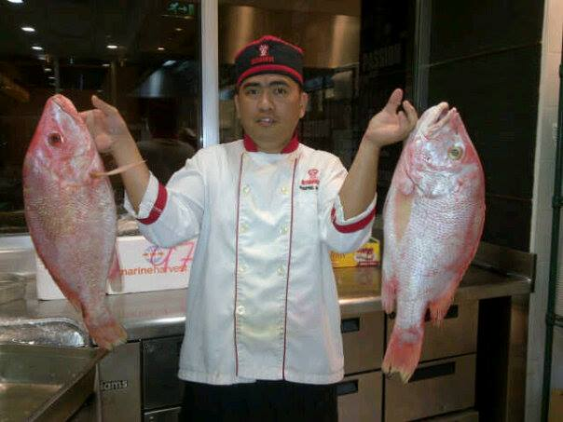
- Answering the phone calls, operating fax machine, photocopy machine.
- Paying and collecting bills.

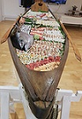



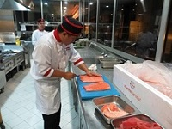



WORK-RELATED TRAINING
ELEMENTARY FOOD HYGIENE
Al BustanRotana
Diera, Dubai, U.A.E.
Certificate No. 1012483
May 23 2010

FIRE TRAINING LEVEL 1
AmwajRotana, Jumeira Beach Residence, Dubai U.A.E.
May 03, 2010

FIRST AID FOR APPOINTED PERSON
First Security Group Health and Safety Division
PO Box 9677, Dubai, U.A.E.
May 18, 2010

LEVEL 2 AWARD IN EMERGENCY FIRST AID AT WORK
HIGHFIELD AWARDING BODY FOR COMPLIANCE
CERTIFICATE NUMBER: FA155250
OCTOBER 01, 2013

