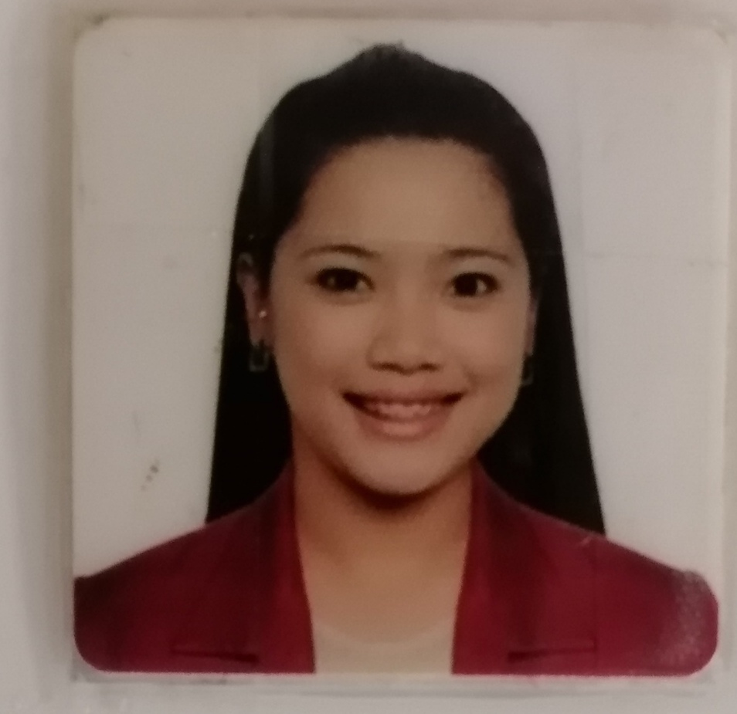

LARISA V. BALISI
289 Cablong Pozorrubio, Pangasinan 2435
Mobile phone: ₆₃₉₄₈₉₉₅₇₇₈₁
Email Address: larisabalisi@gmail.com

I am highly motivated and conscientious individual who works equally well as a part of a team or on my own initiative. I am outgoing and interact confidently with others. I am a full qualified nurse and I got a professional regulation commission in nursing.

WORKING EXPERIENCE
July 17,2017 to present- Financial Advisor : Sunlife of Canada Phils.

January 6,2016 to March 3,2017
Pozorrubio Rural Health Unit Clinic
Medical Transcriptionist
> Assist in Transcribing ng Medical Requests from the Doctor
> Folloe up with the health care provider to ensure the accuracy of reports.
> Transcribe and interpret the dictation into diagnostic tests with results, operative reports, referral letters and other documents
> Identify inconsistencies, errors, and missing information within a report that could compromise patient care
- November 19, 2013 to November 3, 2015: Staff Nurse: Saba Medical Polyclinic Jeddah Saudi Arabia
- Staff Nurse assigned in areas Like Emergency Room, Dental, Ob Gyne and Surgery Area
- Applies proper technique (aseptic, sterile and isolation) as required in the performance
- Participates in planning implementation and evaluation of nursing care in general and in the individual patient
- Assist in all the procedures with the guidance of the doctor

- March 15, 2012- June 2, 2013: Staff Nurse: Urgent Surgical and Medical Care Hospital Agoo, La Union
- Observe and record vital signs, symptoms and condition of the patient, report to charge or physician
- Daily monitoring every shift of vital signs and all pertinent data about the patient
- Hear reports and receive assignments; perform duties under the supervision of the charge nurse

- February 23, 2009- February 2012- OPD Clinic Assistant;Saudi German Hospital Jeddah Saudi Arabia
- Assist the doctor in Rheumatology Clinic assigned in taking the vital signs
- Under the supervision of the doctor when performing activities for the rehabilitation of the patient
- Assigned in Orthopedic, Dental, Surgery and Psychiatry if there is lacking of nurse
- April 10, 2007- December 5, 2008: Clinic Nurse: Dr. Carlos Gramata M.D. Clinic Pozorrubio Pangasinan
- Assist the doctor in the clinic; taking vital signs
- Maintain confidentiality of patients information and privacy and complies with established communication code
- Assist in minor suturing and some minor operations that can be done in the clinic before referral

SUMMARY OF QUALIFICATION

- Computer literate
- Basic life support provider
- Able to speak Arabic
- Self-motivated, initiative, maintains a high level of energy
- Tolerant and flexible and adjusts to different situation
- Ability to organize and work under pressure
- Strong communication and customer service skill
- Demonstrated ability to work in dynamic and fast paced environment
- Flexible schedule: Willing to work overtime and weekends
- Able to follow guidelines accurately
- Track record of working efficiently while unsupervised

EDUCATIONAL BACKGROUND

IELTS certification November 2015
May 3, 2013- Nurse Technician: Prometric Exam by Saudi Commission for Health Specialties
2012- Licensed Nurse by the Professional Regulation Commission
2007-2003- Pines City Colleges: Bachelor Of Science In Nursing
2003-1999- Benigno V. Aldana National High School
1999-1993- Pozorrubio Central School

PERSONAL DETAILS
Birth date : August 6, 1986
Age : 36years old
Sex : Female
Civil Status : Married
Nationality : Filipino
Height : 5’6”
Interests: Reading magazines, surfing the internet, traveling, watching movies, learning and discovering new things, listening to music and interacting with different kinds of people

REFERENCES

- Mrs. Nina Castillo
Clinical instructor- Pines City Colleges
+639167732728

- Lester Bermudez
Brgy Captain Cablong Pozorrubio Pangasinan
+639162896733
- Dr. Hany Moharram
Medical Director- Saba Medical
h.moharram@sabamedical.com
+966505689288

I hereby certify that the information mention are true and correct to the best of my knowledge and belief.

_________________________
LARISA V. BALISI

