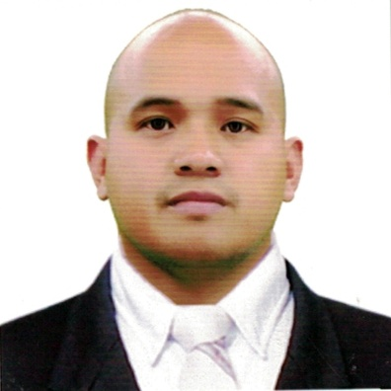

Name: Patricio L. Cariño Jr.
Address: #32 Batangcaoa Urbiztondo,Pangasinan
Contact No. +63967-350-6794
Email add: jrpatcarino45@gmail.com

OBJECTIVE:

I am currently looking for a job, for any position where I can share and develop my knowledge and skills.

RESUME SUMMARY:

Machine Operator with 8 years of experience monitoring and operating machines in a manufacturing settings. Proficient at determining faults and conducting repairs. Have excellent communication skills and can operate CNC grinding machines. Maintain a 100% safety record throughout my career.

EDUCATIONAL ATTAINMENT:

College/University: AMA Computer College
Bachelor of Science in Computer Engineering (2000-2006)
Dagupan City,Pangasinan

Secondary: Urbiztondo National High School (1996-2000)
Urbiztondo Pangasinan

Primary: Duplac Elementary School (1990-1996)
Urbiztondo Pangasinan

PERSONAL INFORMATION:

Date of Birth : June 05 1983
Place of Birth : Urbiztondo Pangasinan
Age : 39 years old
Weight : 80 kgs.
Language/ Dialect : Tagalog, English
Religion : Roman Catholic
Civil Status : married
Citizenship : Filipino
Father’s name : Patricio Cariño Sr.
Occupation : Deceased
Mother’s Name : Rufina Cariño
Occupation : House keeper
In case of Emergency: Ofelia Cariño

WORK EXPERIENCES:

Hiwin Technologies Corp.
October 2, 2014-September 20, 2017
Machine Operator
Taichung City,Taiwan ROC

Hiwin Technologies Corp.
July 19,2011-July 9,2014
Machine Operator
Taichung City,Taiwan ROC

Unimicron Technologies Inc.
2008-2010
Machine Operator

RELEVANT SKILLS:

•Experience as a machine operator
•Knowledge of production procedures
•Attention to detail
•Teamwork
•Physical stamina and strength
•Work independently
•Multitasking ability
•Good verbal communication skills
•Active listening ability
•Can mentor and teach colleagues with less experience

DUTIES and RESPONSIBILITIES:

•Responsible for the setup and offsets as required.
•Ability to accurately read blue prints.
•Must be able to inspect machines for defects using quality control tools.
•Responsible for accurate programming and Machine operation.
•Communicates quality issues to programmers and/or General Managers.
•Pull materials for upcoming jobs.
•Consistently evaluates the quality of the finished products coming off the machine through visual inspection and the use of measurement tools.
•Checks machinery on a daily basis to ensure proper functionality outputs.

