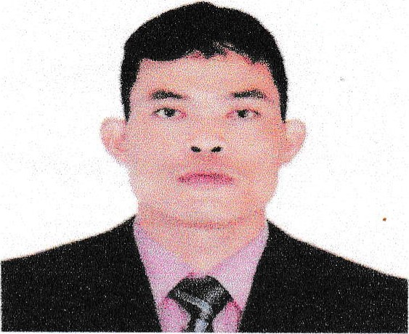
ARNOLD L. ORIZAL
Address: Purok 3A Brgy. Catalanacan
Science City of Muñoz, Nueva Ecija
Mobile No.: 09457883362/09610886411 Email
+358465259775
Address: arnoldorizal@gmail.com
PERSONAL DATA:

Birthdate | April 05, 1985
Place of Birth | Purok 3A Brgy. Catalanacan Science City of Muñoz, Nueva Ecija
Age | 38 years old
Sex | Male
Civil Status Height | Single
Weight | 68kg
Languages | Tagalog / English
Religion | Catholic
Passport Number | P8497443B
Date Issued | December 18 2021
Placelssued | Manila Philippines
SSS Number | 02-2534977-3
TIN Number | 425-450-016-000
Philhealth | 020261348110
Pag-ibig MID | 121109971495
EDUCATIONAL BACKGROUND:

ELEMENTARY | Muñoz Central School 1996-1997
HIGH SCHOOL | Muñoz Elementary School 2000-2001
EMPLOYMENT RECORD:
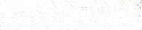
Company | AL Qayed International
Address | Industrial Area Sta, 44, Doha Qatar
Position | Welder SMAW/GMAW
Inclusive Date | December 25, 2013 -g December 25, 2015
Job Description | Installer / Fabricate Tents in Doha Qatar Industrial Area St., 44, Doha, Qatar
Company | G.T.I Armored Car Inc.
Address | Balut, Tondo Manila
Position | Welder and Fabricator
Inclusive Date | December 15, 2016 - May 16, 2017
Job Description | MIG/MAG Full Weld and Fabricator Welder
Company | JEPPAMAN BUILDERS CORPORATION
Address | Sampaloc II, Bucal Dasmarinas City Cavite
Position | Full Welder MIG/MAG
Inclusive Date | May 16, 2018 – August 16, 2019
Job Description | Instructional Builders Corporation and Installer Welder
Company | YAPI MERKEZI
Address | Jeddah Saudi Arabia
Position | Ducting Fitter Helper and Welder
Inclusive Date | September 28, 2018 – April 30, 2019
Job Description | Constructing Haramain High Speed Railway Project Certifies
Company | ISKRA SHIPYARDS
Address | Sebinek Croatia Europe
Position | Aluminum Welder, MIG/MAG welder
Inclusive Date | February 05, 2020 – March 31, 2023
Job Description | Welding Aluminum of Fishing Boat and Passenger Boat

JOB DESCRIPTION:

- Operate Welding Equipment to weld structural metal component.
- Operate manual or semi-automatic welding equipment to fuse metal segment using processes such as Shield Metal Arc Welding (SMAW) or Gas Metal Arc Welding (GMAW).(MIG/MAG)
- Welding spare parts in various direction, flat, horizontal, vertical.
- Being in charge of preparing and setting up necessary tools and equipment for welding job such as shield metal arc.

CHARACTER REFERENCES

Edgardo Cristobal Foreman
Fabricator Instructor Welder, Doha Qatar

Oliver Bacani Foreman
Fabricator Instructor Welder, Doha Qatar

Ruben Bautista Architect
Isabela

I hereby certify that the above information is true and corrects to best of my knowledge and belief.

ARNOLD L. ORIZAL
Applicant

