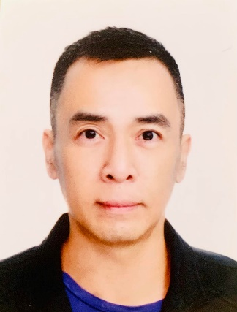

C O N T A C T
+853 6593 6569
 (Macau contact number)

 liujoseph7@gmail.com
RUA DA GRUTA, 59 EDIFICIO JARDIM DE LUIS CAMOES, 5 ANDAR J MACAU

E D U C A T I O N
TERTIARY
National College of
Business & Arts
Graduate of Computer Science
Taytay, Rizal
1995 - 2001

SECONDARY
National College of
Business & Arts
Taytay, Rizal
1991 - 1995

PRIMARY
Siena College of Taytay
Taytay, Rizal
1985 - 1991

S K I L L S

- Cleaning Experience (6years)
- Cash handling (10+ years)
- Computer skills
- Food Service (1 year)
- Cashiering (10+ years)
JOSEPH BARETTO LIU

O B J E C T I V E
Self-motivated team player with strong attention to detail. Maintains a high level of professionalism while providing consistent and quality service. Dependable janitor with a comprehensive background in cleaning services and grounds maintenance.

W O R K E X P E R I E N C E S

Cleaner (Pre-Opening Team)
City of Dreams Macau (Morpheus) – Cotai
January 29, 2018 to Present

- Empty, clean all waste containers
- Hand dust and wipe clean all workplace
- Remove waste paper and garbage from the building to the designated area
- Empty and clean ashtrays
- Clean and buff tile floor services
- Remove all finger marks and stains from vertical surfaces
- Clean all casino area, including sweeping, picking up trash, vacuuming carpets, and wiping surfaces
- Clean restrooms, including scrubbing toilets, sinks, sweeping and mopping floors.
- Deep cleaning of slot machines and stools and wiping surfaces
- Able to use and operate vacuum cleaners, floor cleaning equipment, dustpan, and brooms.


Cleaner (Pre-Opening Team)
Studio City Macau - Cotai
September 7, 2015 – February 22, 2017

- Empty, clean all waste containers
- Hand dust and wipe clean all workplace
- Remove waste paper and garbage from the building to the designated area
- Empty and clean ashtrays
- Clean and buff tile floor services
- Remove all finger marks and stains from vertical surfaces
- Clean all casino area, including sweeping, picking up trash, vacuuming carpets, and wiping surfaces
- Clean restrooms, including scrubbing toilets, sinks, sweeping and mopping floors.
- Deep cleaning of slot machines and stools and wiping surfaces
- Able to use and operate vacuum cleaners, floor cleaning equipment, dustpan, and brooms.
A W A R D S / S E M I N A R S

- MCE Excellence Award for 2nd Quarter of 2016
June 2016
Model Employee for Cleaner
(Studio City Macau)

- Model employee for Cage, Count & Credit Dept.
July 2015

- Service Excellence Award
July 2015
Model Employee for
Count Cashier
(City of Dreams Manila)

- Fire Fighting Seminar
August 2006

- Model Employee of the Month
April 2006 – Count

- Service Excellence Award
April 2006
Model Employee for
Count Team
(Thunderbird Resort & Casino)
Philippines

- Service Expert
Pizza Hut SM Megamall-B
2003

- Cashiering Expert
Pizza Hut SM Megamall-B
2003

CERTIFICATION & LICENSES

Counterfeit Detection
September 2007 – Present

R E F E R E N C E
Tristan Santiago
Asstant Count Manager
Nustar Resort & Casino
Cebu City
+639263454623
Tristan.santiago@nustar.com.ph

Jemar Mendoza
EVS Supervisor
City of Dreams Macau
Cotai, Macau
+85366109026
Jyruzkean11@gmail.com

Count Cashier (Pre-Opening Team)
City of Dreams Manila - Parañaque
September 15, 2014 – September 6, 2015

- Pull bill validator boxes from slot machines
- Run currency through a computerized currency counter
- Accurately count and record money totals
- Transport money
- Run reports on the computer
- Follow rules and regulations set up by the company
- Communicate between all key people
- Keep work area clean
- Must be safety conscious, and adhere to all company rules at all times

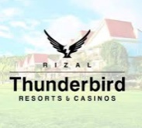
Count Team (Pre-Opening Team)
Thunderbird Resort - Binangonan
April 11 , 2005 – September 15, 2014

- Pull bill validator boxes from slot machines
- Run currency through a computerized currency counter
- Accurately count and record money totals
- Transport money
- Run reports on the computer
- Follow rules and regulations set up by the company
- Communicate between all key people
- Keep work area clean
- Must be safety conscious, and adhere to all company rules at all times


Cashier & Team Member
MegaMall B – Quezon City
March 3, 2003 – January 5, 2004

- Greet and seat customers, take food orders, and take care of any special needs of the customer. As expected, Pizza Hut Team Member positions require exceptional communication skills and a good relationship with the public.
- Pizza Hut team members mostly serve customers or prepare food in the kitchen. Customer service duties include taking orders, answering questions, and ringing out customers on the cash register. Kitchen duties include preparing dough, portioning toppings, and cooking pizzas.
- Responsible for all production processes within the restaurant, including food preparation, customer care and cleaning. * Maintains cleanliness of restaurant (empties trash, sweeps and mops floors, cleans restrooms, picks up parking lot, etc.)

