Arlene cometa oriat
Address: Bistek ville 2 BLK 25 lot 20 kaligayahan novaliches Quezon city Philippines
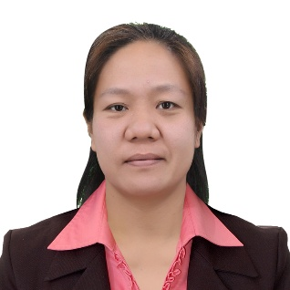
phone number 09954674392
email ad arleneoriat0917@gmail.com
zoom I’d Arlene oriat
Marital status:merraid
Number of children:1
Ages of children:4
Birthdate:09-17-1986

POSITION SOUGHT:
Kitchen helper

SUMMARY OF QUALIFICATIONS

- Over 10 years of experience in … (highlight experiences related to your job offer in Canada)
- Strong background in hospitality management food and beverage department
- Proven skills in cooking
- Demonstrated ability to work
- Professional communication skills include fluency in English and …

WORK HISTORY

Line cook 08-2022 to Present
Company Name bites TO Go cloud eats
City, Country Quezon city metro manila Philippines
• prepared meats and vegetables make sure it is clean and fresh..
•Chop according the Standard operating procedure of company
•check all ingredients needed if it is out of stock or available before start cooking also check if it is have already expired date
- Start cooking according the SOP of company
- Employed strong communication skills to “co worker”
Company Name Ang bigas inc. Quezon city metro manila Philippines
•position Food handler and line cook
- Prepare all needed like meat vegetables and fruits make it cleaned and fresh
- The one assigned for garnish of food and last touch before serve the guest.
- As a food handler I’m also assign all stocks of kitchen check the expired date check the materials it is out stock or still available..
• the one assigned for inventory of all stock in kitchen.. and the one assigned for chopping of meat and veggies and fruits according to SOP.

EDUCATION HISTORY
BS hospitality management graduate 2004to 2008
Innovative college of science and technology Malitbog bongabong Oriental Mindoro Philippines
Secondary Masaguisi national high school bongabong Oriental Mindoro 2000-2004

TRAINING
ON The Job Training
Boracay ocean club Beach resorts Boracay Philippines

REFERENCES
- Jessel palma

- Boracay paradise bay resort manager Contact number+639088163703.

