Name: JULIE ANN MARIE A. MASANGKAY  Permanent Address: Luta Sur, Malvar Batangas  Current Address: Foundation of St. Joseph the Workers  Brgy. Rosario, Ortigas Avenue Pasig City  Contact Number: 09975744427  CONTACT No. IN CASE OF EMERGENCY: 09662287091  Skype ID: cid.5194b7babe2c1e23  Email Address:joulesjulie2919@gmail.com |  | 
POSITION APPLYING FOR: | STAFF NURSE
YEARS OF EXPERIENCE | 2 YEARS
Nursing Area/s of Interest: | HEMODIALYSIS UNIT

CAREER OBJECTIVES
To be in a health care profession that will give me opportunities in exploring my potential and imparting my knowledge, and skills. To make a difference that will change and give the quality health care patient needs, provide professional commitment and compassion to serve the health care institution.

PERSONAL DATA
Age : | 30
Date of Birth : | May, 19 1992
Birth Place: | Mamburao, Occidental Mindoro
Gender : | FEMALE
Civil Status : | SINGLE
Nationality : | FILIPINO
Religion: | Roman Catholic
Language Speaking | English/ Tagalog

EDUCATION & QUALIFICATION
Education Level | Course | School / University | Year Graduated  (From-To) mm/dd/year
COLLEGE GRADUATE | Bachelor Of Science In Nursing | National University Manila  University of Batangas | June 2008- August 2010  August 2018- August 2020

LICENSE / REGISTRATION | Year Obtained (mm/dd/year)
REGISTERED NURSE | 09-10-2021

WORK EXPERIENCE (LIST OF EXPERIENCE BEGINNING WITH MOST RECENT)
Employment 1
Position : | HEMODIALYSIS STAFF NURSE
Duration (From-To): | SEPTEMBER 2021- PRESENT
Company/Hospital: | B/ Braun Avitum Philippines Inc.
Address : | 5th Avenue Corner Rizal Drive 15/F Sunlife Centre, Taguig City, Bonifacio Global City Philippines
Description: | Hospital-Level: SECONDARY LEVEL/ SPECIALIZED UNIT  Bed Capacity: 10 HEMODIALYSIS MACHINE
Department : | HEMODIALYSIS 1 and 11 MONTHS
Patient Census per day: | HEMODIALYSIS MAXIMUM OF 30 PATIENTS PER DAY
Types of Patient Handled: | PATIENTS WITH RENAL DISEASES
DUTIES AND RESPONSIBILITIES ( HD STAFF NURSE) :

- Catered and understand patients with kidney diseases/ impairment to correlate it with the dialysis process especially, hemodialysis.
- Management of intravenous infusion from insertion to infusion of IV fluids as necessary and to understand how to manage complications in IV therapy.
- Machine HD set-up such as bloodlines priming, machine parameters set-up, operating HD machine, and reprocessing machine.
- Conduct machine troubleshooting and warnings that needs to attend to prevent such HD complications.
- Input of patient hemodialysis Ultra filtration goal to minimize water retention and prevent complications such as edema, difficulty of breathing, and disequilibrium syndrome.
- Assess the patient and triage before proceeding to the HD process.
- Getting and checking of patient v/s (vital signs), GCS. Also need to check the patient’s pre and post-HD weight, this is to achieve the prescribed goal weight needed by the patient as per the doctor’s order.
- Cleansed the CVC (Central Venous Catheter ), Intra-jugular catheter, and Arteriovenous fistula aseptically before patient hooking and HD start up.
- Arteriovenous Fistula cannulation and decannulation. Identify different cannulation approaches, know their advantages and disadvantages and give the appropriate nursing responsibilities needed.
- Motivating and giving patients a safe environment, quality care, and assurance that the HD process will be well monitored, all concerns will be immediately assisted.
- Vital signs monitoring every 30mins conducted. To prevent and immediately catered to any complications that may occur to the patient such as hypotension, hypoglycemia, and other disequilibrium syndromes that might happen as the HD process is ongoing.
- Identifying dialysis adverse reactions, different causes, signs, and symptoms of complications encountered during hemodialysis and to be able to manage intervention for patient and technical complications and describe appropriate responses for emergencies.
- Provides and prepares medication needed as per doctor’s order, knows my nursing responsibilities, and makes sure to monitor patient improvement
- Maintain emergency cart updated with needed medication on the stock. Strictly monitor medication inventory and checking of the expiration date to prevent medication error that may possibly occur.
- Health education will improve patients’ awareness and help them to improve and still cope with daily living stress-free and with a positive outlook on life.
- Understand the importance of nutrition management, make the patient understand their nutrition needs, and cite the right diet for HD patients.
- Strict implementation of infection control, and hand hygiene and make patients adapt to the principles and techniques of infection control.
- Understand and monitor the used and consumables of the unit.
- Conduct charting, documentation, and data input of the handled patients related to the HD process.

Cases Handled:

Hemodialysis
* Diabetes Mellitus
* Hypertension
* Hypertensive Nephrosclerosis
* Diabetic Nephropathy
*Polycythemia Vera
*Anemia
* Urolithiasis
* Recurrent UTI
*Hepatitis-B reactive patient
* Chronic Renal Failure
* Nephrotic Syndrome
* Acute Kidney Injury
* End Stage Renal Disease
* High Creatinine Level

Equipment/Machines Operated:
Hemodialysis

* Dialysis Machine
* Laryngoscope set
* Bag Valve Mask ( AMBUBAG)
* Cardiac Monitor
* Oxygen Tank
* Pulse oximeter
*Glucometer
* Digital Thermometer
* Cardiac monitor
* Sphygmomanometer
* Suction machine
* Syringe pump (single/ dual syringe pump)
*Automated External Defibrillator
* Reverse Osmosis Water System Machine

WORK EXPERIENCE
Employment 2
Position : | Nursing Assistant
Duration (From-To): | October 13, 2020- July 2021
Company/Hospital: | St. Dominic Medical Center, Inc.
Address : | B/ Braun Avitum Philippines Inc.
Description: | 5th Avenue Corner Rizal Drive 15/F Sunlife Centre, Taguig City, Bonifacio Global City Philippines
Department : | Hemodialysis, 10months
Patient Census per day: | HEMODIALYSIS MAXIMUM OF 30 PATIENTS PER DAY
Types of Patients Handled: | PATIENTS WITH RENAL DISEASES
DUTIES AND RESPONSIBILITIES (NURSING ASSISTANT)
- Machine HD set-up such as bloodlines priming, and machine parameters set-up.
- Do patient triage, conduct vital signs checking, and assess patients with flu-like symptoms related to COVID.
- Assist patient in weighing pre and post-HD. Lead them and help them go to their seats and have them feel comfortable, relaxed, and safe before the HD process start.
- Helps nurses in monitoring vital signs such as blood pressure, oxygen saturation, pulse/ heart rate, respiratory rate, and other complaints related to a possible disequilibrium syndrome.
- Report observations of patients’ behavior, complaints, or physical symptoms to nurses.
- Keeping patient safety with all needs attended. Assisting patient whenever a patient needs to urinate and attending to the patient on cleaning and changing diapers when defecation occurs.
- Helps patients in hygiene activities such as hand and AFV(fistula) before proceeding to their seats
- Assist patients with meal serving and feeding them as necessary. Helping patients in ambulating, turning, and positioning of patients.
- Listen to and record patients’ health concerns and report the information to nurses.
- Help nurses with machine troubleshooting, HD set-up such as bloodlines priming, machine parameters set-up, operating HD machine, and reprocessing machine.
- Provide to nurses the needed consumables of the patient. Prepare it before the HD process starts.
- Helps in consumables inventory to prevent wastage and loss of stocks. Also, to monitor the first in and first out of-stock consumables.
- Helps technician in the cleaning of patient seats, changing of linen and maintaining unit cleanliness.

Cases Handled:

Hemodialysis
* Diabetes Mellitus
* Hypertension
* Hypertensive Nephrosclerosis
* Diabetic Nephropathy
*Polycythemia Vera
*Anemia
* Urolithiasis
* Recurrent UTI
*Hepatitis-B reactive patient
* Chronic Renal Failure
* Nephrotic Syndrome
* Acute Kidney Injury
* End Stage Renal Disease
* High Creatinine Level

Equipment/Machines Operated:
Hemodialysis

* Dialysis Machine
* Laryngoscope set
* Bag Valve Mask ( AMBUBAG)
* Cardiac Monitor
* Oxygen Tank
* Pulse oximeter
*Glucometer
* Digital Thermometer
* Cardiac monitor
* Sphygmomanometer
* Suction machine
* Syringe pump (single/ dual syringe pump)
*Automated External Defibrillator
* Reverse Osmosis Water System Machine

WORK EXPERIENCE
Employment 3
Position: | PRIVATE NURSE (HOME-BASED)
Duration (From-To): | January 2021-July 2022
Company/Hospital: | HOME BASED
Address : | Brgy. Rosario, Ortigas Avenue Pasig City
Description: | Hospital Level: Private Nursing/ Caregiving  One Patient- GERIATRIC PATIENT
Types of Patient Handled: | Geriatric Patient with Mild Dementia, 84y/o
DUTIES AND RESPONSIBILITIES

- Assist the patients in activities of daily living. Try to keep patient routines such as bathing, dressing, and eating each day.
- Assist patient in the use of comfort rooms, especially at the time of urination and defecation.
- Choosing and monitoring healthy meals for the patient which will boost her immune system.
- Monitor patient vital signs with the use of blood pressure apparatus, use of pulse oximeter to check patient SPO2 or Oxygen saturation level as well as heart/pulse rate, also monitor patient respiratory rate, and document any abnormalities related to the breathing process.
- Provide oxygen support as necessary with 2-3lpm via nasal cannula in case of difficulty of breathing and if low oxygen saturation has been documented as per doctor’s advice.
- Monitor and provide patient daily routine schedule such as daily exercise and accompany patient on walking to breath some fresh air and get its daily dose of sunshine vitamins as what patient used to say and imply as we are outside for our daily walking routine.
- Consider a system of reminders and help the patient to take prescribed maintenance medication.
- Provide a safe environment for the patient, remove and avoid areas that are hazardous and take caution on using comfort rooms as these are slippery and accident-prone areas for the patient.
- Understanding the patient and keep on reminding the patient with regards to some details that need to be reminded. Taking good care of patient sensitivity and forgetfulness, I make sure to be always respectful with my actions and patient communication.
- Remind significant others to also be part of the continuous care, be patient, and be a great support system that will help patients improve.
- Document all patient improvements as well as patient difficulties to improve more of the needed care of the patient.
- Used to have a great conversation with the patient about the things she tends to remember. Remind the patient of the things that seem to forget.

Case Handled:

Mild Cognitive Impairment (Mild Dementia)

Equipment/Machines Operated:
* Oxygen Tank
* Pulse oximeter
* Cardiac monitor
*Sphygmomanometer
*Digital Thermometer

WORK EXPERIENCE
Employment 3
Position: | CAREGIVER (HOME-BASED)
Duration (From-To): | May 2019-March 2020
Company/Hospital: | HOME-BASED
Address : | Brgy. Kumintang, Batangas City
Description: | Hospital-Level: Caregiver /Private/Primary Care  Patient: 1 patient  Case: Diabetes Mellitus and Hypertension  One Patient- GERIATRIC PATIENT
Types of Patient Handled: | Geriatric- 72 y/o Female
DUTIES AND RESPONSIBILITIES ( CAREGIVER/ PRIVATE NURSE)
- Help patient on doing activities of daily living such as assisting patient with the use of comfort room, bathing, and eating.
- Assist patient with her daily meal and monitor patient food intake. Assuring strict implementation of DM diet and maintaining of normal sugar level. Remind and inform the patient about avoiding foods rich in sugar, carbohydrates, and rich in cholesterol.
- Help patient on monitoring of sugar levels 30mins to 1 hour before food intake buys the use of a glucometer, CBG(capillary blood glucose ) is well monitored.
- Provided maintenance medication as prescribed.
- Make a daily routine care plan with regards to v/s monitoring, medication intake, CBG monitoring, and food intake or diet.
- Monitor vital signs of patient regularly with the use of a sphygmomanometer for blood pressure monitoring, pulse oximeter on pulse/ heart rate and oxygen saturation, and monitoring of respiratory rate.
- Assist and accompany the patient on daily walking routine and exercise.
- Communicate with the significant others about the needed intervention that should be provided for patient care and improvement.
- Monitor and apply medication on patient wounds. Make sure to educate patients and significant others on proper wound care to improve the healing process.
- Assist patients with the use of equipment and tools that are sharp and hazardous that could cause cuts and wounds.
- Accompany the patient on her monthly check-up and needed laboratory/ diagnostic procedures that need to be done.
- Document improvement and some other complications that may possibly occur to the patient.
- Communicate to her doctors with regards to patients’ condition, improvement and if ever such complications occur. Also understand the need for a maintenance medication, its purpose and contraindication to patients disease process.

Cases Handled:

Diabetes Mellitus
Equipment/Machines Operated:
* Oxygen Tank
* Pulse oximeter
* Cardiac monitor
*Sphygmomanometer
*Digital Thermometer
* Glucometer

Key Proficiencies:
- Patient Oriented.
- Good interpersonal skills
- Positive outlook and attitude that provides patient rapport and influences patient’s view through positive leadership.
- Finishing tasks within allotted time and schedule
- Can work under pressure and with minimal supervision
- Willing to work in shifting schedules and render service even on holidays and weekends
- Skills in operating machinery (specifically a dialysis machine).

Manila Affiliation
- San Lazaro Hospital Student Nurse, July 2018
- Philippine Orthopedic Center Student Nurse, July 2018
- National Center for Mental Health Student Nurse May, 2019
- Panganlungan Rehabilitation Center Student Nurse May, 2019

TRAININGS AND SEMINARS:

Red Cross Disaster Training and Prevention
Student Nurse Trainee, November 2019

Distressing is an Option: Attaining Emotional Balance the Millennial Way
University of Batangas
College of Nursing and Midwifery
2019

2019 Novel Corona Virus Seminar
University of Batangas
College of Nursing and Midwifery
March 03, 2020

Grand Case Study Competition: Chronic Kidney Disease Secondary to Diabetic Nephropathy
Batangas Medical Center
November 26, 2019

Nurse Leaders: Leading Patient Safety through Quality Improvement
Wesleyan University- Online Seminar
July 24, 2021

Certifications:

Hemodialysis Training for Nurses
B/Braun Avitum Philippines
Aesculap Academy
November 2021

ACLS (Advance Cardiac Life Support)
Certified ACLS Provider in accordance with the curriculum of the American Heart Association
Fe Del Mundo Hospital
January 2022-2024

BLS (Basic Life Support )
Certified BLS Provider in accordance with the curriculum of the American Heart Association
Fe Del Mundo Hospital
January 2022-2022

Character References:
1. Cathleen Baldonadi RN,
Head Nurse
Bbraun Avitum Philippines
Email: cathleenbaldonad @gmai.com
09176281522
2. Marielle Yomo, RN
Charge Nurse
BbraunAvitum Philippines
Email: yomomarielle@gmail.com
09176281522

3. Jayhadz Sajor
Operations Supervisor
Bbraun Avitum Philippines
Email: Jay.sajor@bbraun.com
0977777895
- Cristina Duenas
Pasig City
09064731025

- Michelle Sacarre
Batangas City
Email:Sacarremichelle@gmail.com
00966556387526

I hereby affirm to the best of my knowledge that all information stated above are true and correct.
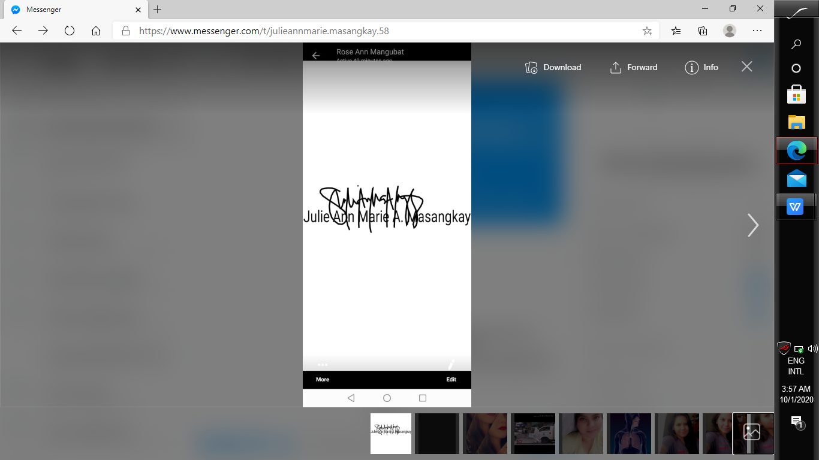

Applicant

