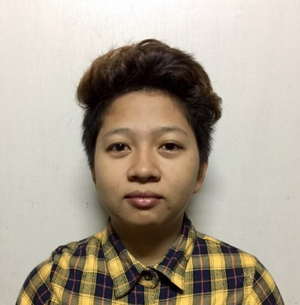
Marie Fren M. Corpuz
Barangay Mandaloque
Dingras, Ilocos Norte
+639156951407
corpuzmhong@gmail.com

CAREER OBJECTIVE
To perform as a competent individual, be able to use knowledge and skills needed to produce the best of myself, to obtain a position that would best fit my qualifications and develop further my talents and skills.

PROFESSIONAL SKILLS
- Ability to resolve complex technical errors and deliver quality customer service
- Proficient in different computer applications used in a call center environment
- Comfortable to work in day shifts and overtime if required
- Ability to deliver the best results even during the most stressed situations at work

EDUCATION:

2012 TESDA – MAIS ( Marcos Agro Industrial School )
Computer Hardware Servicing NC II
2004 – 2008 Dingras National High School ( San Marcos Campus )

SKILLS:
Computer literate, flexible
Printing personalized T-shirt
Speaks English, Tagalog and Ilocano

WORK EXPERIENCE:

RVB Firenze Hot Beverages Oct. 2013 – Dec. 2013
Barista

Caregiver Overseas Filipino Worker ( OFW ) Taiwan
Feb. 2015 – May. 2015

Harte Hanks Inc. Oct. 2015 – Dec. 2015
Customer Service Representative
Barnes and Noble Account

Harte Hanks Inc. Dec. 2015 – Jan. 2017
Technical Support Representative
Samsung Electronics Account

PERSONAL PARTICULARS:
Date of birth : Oct. 04, 1991
Gender : Female
Religion : Roman Catholic
Nationality : Filipino
Marital Status : Single
Height : 4’9
Weight : 52 kg

CHARACTER REFERENCE:

Karen B. Baay Arjay Canquin
Billing and Collection Sr. Associate Team Captain ( Harte Hanks Inc. )
+639956158509 +639273469671

Marie Fren M. Corpuz
Applicant

