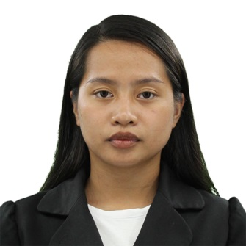
PIA HAEL C. MADIAM
San Jose, Sudipen, La Union
0956-481-4592
piahaelcmadiam@gmail.com

CAREER OBJECTIVE
To pursue a challenging career with dedication and provide my efficiency to the fullest wherever I serve my duties that will discover the potential in me. Snappy in accepting all challenges and work hard in achieving goals.

PERSONAL DATA
Birthdate: October 10, 2000
Home Address: San Jose, Sudipen, La Union
Age: 22 years old
Sex: Female

SKILLS
Have strong organizational skills, educational background and good communication skills. Able to work under pressure responsibly in all work assigned. Effective in working independently and in cooperation with others.

EDUCATIONAL BACKGROUND
College:
Don Mariano Marcos Memorial State University 2018-2022
San Fernando City, La Union, Philippines
Bachelor of Elementary Education

Secondary:
San Francisco National High School 2012-2018
San Francisco, Sudipen, La Union, Philippines

Elementary:
San Jose Elementary School 2006-2012
San Jose, Sudipen, La Union, Philippines

SEMINARS AND TRAININGS ATTENDED
On the Job Training
DMMMSU-MLUC Laboratory School
September 13, 2021 December 6, 2021
February 21, 2022 – April 18, 2022

Inset Training Program
September 6, 2021 – September 10, 2021

Pre-service Teacher’s Congress 2021:
Teacher Educations Facing and Exploring
The Challenges of the New Normal
November 29, 2021

EXPERIENCES

Sunday School Teacher
San Jose Wesleyan Church
2015 – Present

Private Tutor
October 2020 – October 2021

Teacher Assistant
La Union Cultural Institute
School Year 2022-2023

