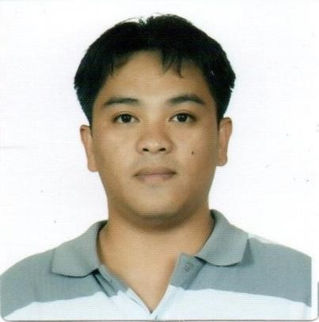

Greg Dilem De Guzman, R.N.
168 Purok I Happy Hallow Baguio City, 2600 Philippines
Email Address: reggguzmande@gmail.com
Contact #: +639517068737

Objective:
To get hold to a position that will benefit from nursing experience and driving work ethic, and seeking a challenging career with a progressive organization that provides an opportunity to capitalize my skills and abilities.
Qualifications:
- Registered nurse with 2 years of hospital experience.
- Skilled in surgical ward circulation
- Skilled in endoscopy ward settings
- Possess good interpersonal and communication skill and managed a multi-tasking effectively.
- High stress tolerance and willing to be trained.
- Team player, flexible, fast learner and alert.
Work Experience:
NURSE VACCINATOR
July 1, 2022- present
Baguio City HSO
Scout Barrio Health Center

Duties and responsibilities:
- Covid 19- vaccinator
- Maintaining protocols
- Administering scheduled medicine to patients.
- Assisting and helping in controlling communicable diseases
- Acting as the first point of contact for patient and listening to their concerns
- Monitoring of vital signs of covid patients

ISOLATION NURSE

December 1, 2020 – June 30, 2022
Baguio Teachers Camp Isolation Unit
Cabinet Hill Teachers Camp Baguio City

Duties and responsibilities:
- Providing direct care covid patients
- Maintaining isolation protocols
- Administering scheduled medicine to patients.
- Assisting and helping in controlling communicable diseases
- Acting as the first point of contact for patient and listening to their concerns
- Monitoring of vital signs of covid patients

STAFF NURSE (endoscopy room nurse)

August 1, 2018- August 15, 2019
Pines City Doctors Hospital
Magsaysay Avenue Baguio City, Philippines Duties and responsibilities:
- Providing direct care
- Assisting in controlling communicable diseases
- Assess and monitor patients
- Providing direct assistance to the anesthesiologist and endoscopist
- Maintaining sterility and safety of endoscopy instruments.

STAFF NURSE (operating room nurse)

June 1, 2017 – July 31, 2018
Pines City Doctors Hospital
Magsaysay Avenue Baguio City, Philippines

Duties and responsibilities:
- Administering scheduled medicine to patients.
- Assisting and helping in controlling communicable diseases
- Acting as the first point of contact for patient and listening to their concerns
- Promoting and safeguarding the well-being and interest of patients.
- Providing excellent patient care in a nurturing and supportive environment
- Maintaining aseptic technique.
- Maintaining sterility of instruments.

VOLUNTEER NURSE

October 2016 – December 2016
Pines City Doctors Hospital
Magsaysay Avenue Baguio City, Philippines
Duties and responsibilities:
- Assisting and helping in controlling communicable diseases
• Promoting and safeguarding the well-being and interest of patients.
• Responsible in patient’s medication.

PRIVATE DUTY NURSE

December 2015 - May 2016
John Tarnate Sr. (elder patient with history of stroke) Brookside Baguio City, Philippines
Duties and responsibilities:
- Provide direct care to patient 24/7.
- Assist in daily living.
- Administer daily medication, monitor patient response to the medication.
- Monitoring of vital signs.
- Provided mental and emotional support.
- Food feeding via peg tube.

Educational Qualifications:
Bachelor of Science in Nursing 2007-2011
Pines City Colleges Baguio City, Philippines

Bachelor of Science in Marine Transportation 2005-2007
Lingsat San Fernando La Union, Philippines

Competencies:
- Computer Literate (Microsoft word, Excel, and PowerPoint)
- Good written and verbal communication skills.
- Observing hygiene codes and demonstrates good infection control and hand hygiene.
- Ability to follow instructions and feedback.
- Using resources efficiently.
- Respect and understand other religious beliefs.

Trainings and Seminar
- I.M. on the job seminar.
- Basic life support training for health care provider.
- Lactation management training.
- Basic intravenous IV training program.
- The health workers as advocates and trend setters Seminar
- The enhanced recovery after surgery (ERAS) seminar
- Patient bandaging, packaging, rescue and transport, mass casualty incident workshop.

