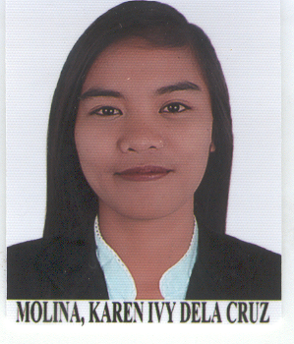

KAREN IVY DELA CRUZ MOLINA
karenivymolina65@gmail.com

CAREER OBJECTIVE:
An Accountant/Bookkeeper looking to join the team in your institution, bringing five years of professional accounting experience across various industries to help in effectively and accurately analyzing income statements, balance sheets, and other financial reports.

EDUCATIONAL HIGHLIGHTS

- Urdaneta City University
Bachelor of Science in Accountancy
San Vicente, Urdaneta City, Pangasinan, Philippines
2013 -2016

- Saint Louis University
Bachelor of Science in Accountancy
Baguio City,Benguet, Philippines
2011-2013

SIGNIFICANT EXPERIENCE

- Hi-Precision Diagnostics, Inc.
Deputy Supervisor - Bookkeeping
August 2022 – present
- Consolidated Internal Financial Statements reports
- Consolidated bank and balances for the month
- Record daily passbook transactions
- Compute and recheck Payroll, last pays, Alphalist, 2316 and 1601C
- Do monthly funding/budgeting across all branches
- Lead the team (Accountants) and decide on what the team should do ~ decision making

- Hi-Precision Diagnostics, Inc.
Senior Accountant/Bookkeeper
August 2021 – July 2022
- Check and tally monthly bank and book balances
- Record daily passbook transactions
- Compute and recheck Payroll, last pays, Alphalist, 2316 and 1601C
- Able to provide accurate Financial Statement reports
- Do monthly funding/budgeting across all branches
- Lead the team and decide on what the team should do

- Hi-Precision Diagnostics, Inc.
Accountant/Bookkeeper
June 2017 – July 2021
- Check and tally monthly bank and book balances
- Record daily passbook transactions
- Compute and recheck Payroll, last pays, Alphalist, 2316 and 1601C
- Able to provide accurate Financial Statement reports
- Do monthly funding/budgeting across all branches

SKILLS/QUALIFICATION

- Hardworking and determined to produce a good quality of work
- Details oriented with administrative skills commonly needed in an office environment
- An articulate communicator; skilled in quickly engaging team building, establishing rapport and developing strong relationship
- A highly oriented individual; able to improve critical analysis and problem solving.

LICENSES & CERTIFICATIONS

- Career Service Examination (Professional) Passer
Rating: 84.24%
April 17, 2016

SEMINARS/TRAININGS ATTENTED

- Australian Bookkeeping, Payroll and Taxation
online via zoom
April 30 - May 1, 2022

- Building Plans and Teams: EDSODAWE 2020
Z Square Mall Banawe St. cor Del Monte Ave, Quezon City
February 8 & 22, 2020

- Problem Solving and Decision Making
Z Square Mall Banawe St. cor Del Monte Ave, Quezon City
August 31, Sept. 7 & Sept 14, 2019

KAREN IVY D. MOLINA
APPLICANT’S SIGNATURE

