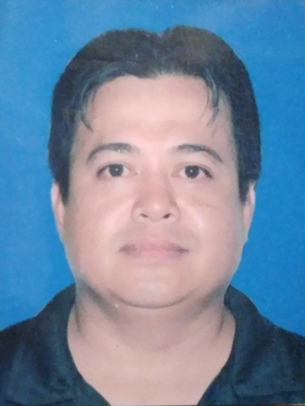
LEVIE R. PATULIN
DAIRY FARM WORKER

Gulod, Maguinao, San Rafael, Bulacan
Contact No.: 09661587793
Email Address: patulinlevie@gmail.com

WORK HISTORY:

Working Experience

Company Almarai Aldanah Dairy Farm
Location Alkarj, Riyadh, Kingdom of Saudi Arabia
Date May 04, 2013 – May 03, 2015
Position Skilled Operator II
JOB DESCRIPTION:

Milker
- Check all milking equipment before start milking.
- Lead Milker is responsible for checking foremilk to detect
abnormal milk.
-After foremilk check is done we start attached milking cluster.
-After milking we sanitize foremilk by use of iodine.
- Hose off dirt milking cluster and flatform.
- We maintain housekeeping.
- We apply CIP.

Tractor Operator/ Feeding Team

-Lifting of feeding materials.
- Covering of hay grass.
- Covering of silage.
- Catstring.
- Tractor operator/ grass pusher, harrow and scrapper.

On call job:
Accden Enterprises
Address: Caingin, San Rafael, Bulacan
Position: Driver, Helper
Year: 2016-2018
EEI Corporation
Address: 12 Manggahan St, Bagumbayan, Quezon City
Position: Warehouseman /Construction Division
Year: April 08 2011- October 20 2012
Project: Thpal Taganito
Location: Taganito, Claver, Surigao Del Norte

TRAINING CERTIFICATION :

Executive Technical Consultants
Trade Test
Dairy Farm Worker
January 22, 2010

PERSONAL QUALITIES:

- Hardworking.
- Fast Learner.
- Can work under pressure.
- Can cook.
- With good inter-personal skills, can write and speak English.
- With knowledge in using computer

Personal Background:

Age 42 years old
Date of Birth Janruary 28, 1980
Place of Birth Poblacion, San Ildefonso, Bulacan
Gender Male
Height 5’8”
Weight 90 kgs
Civil Status Single
Religion Christian
Citizenship Filipino
Father’s Name Domingo B. Patulin
Mother’s Name Teresita R. Patulin

Educational Background:

Tertiary Polytechnic University of the Philippines
Course Bachelor of Hotel Restaurant and Management
2000-2002 (Undergraduate)
Address Sta. Mesa Manila

Secondary Buenavista High School
Address Poblacion, San Ildefonso, Bulacan
1993-2000

Primary San Ildefonso North Central
Address Poblacion, San Ildefonso, Bulacan
1987-1993

CHARACTER REFERENCE:

Precious S. Catchilliar
Unit manager
Breeding Department/ ALMARAI/ ALDANAH FARM
Contact No.- 0565226078

Emerson Maniaual
Assistant Farm Manager
Feeding Department/ ALMARAI/ ALDANAH FARM
Contact No.- 0502792723

I hereby certify that the above information is true and correct to the best of my knowledge and belief.

LEVIE R. PATULIN
Applicant’s Signature

