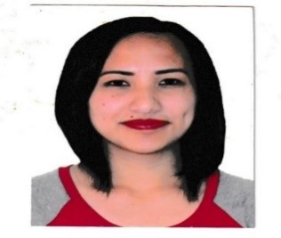

Weblyn Kibak Dogcio
Na 072, Shilan La Trinidad, Benguet
09186438989
Mixhagailmariano18@yahoo.com
February 24, 1991
2601

Objective:
Pursuing opportunity which will allow me to grow professionally.
Improve and enhance my skills and talents. Qualifications:
Extremely motivated and passionate in whatever I choose to do.
Strong interpersonal and communication skills and know how to handle and deal with different kinds of people and circumstances.
Effective working independently and in cooperation with others. Educational Back ground:
Primary:
Tacdian Elementary School 1997-2003
Secondary:
Tublay school of Home Industry 2003-2007
College:
University of Cordilleras 2007-2013
MMS Development Training Center Corporation 2022
Caregiving NCII
Household Services NCII 2015
Training:
Red Cross 2022
*Cardio Pulmonary Resuscitation
*Basic Life Skills
Nursing Skills  *suctioning  *NGT feeding  *inserting catheter | 2022
Rippling Nursing Home  *suctioning with tracheostomy | 2022
*putting and changing colostomy bag | 2022
Certificates:
*National Certificate II in CAREGIVING 22141102984963
*Basic Nursing Skills 201614111200110
*Standard First Aid Training and Basic Life Support with Automated External
Defibrillator PRC-014-04082
*Rippling River Nursing Home
Experience:
Sales lady and Book Keeper at Twin Cris Flower Shop 2013-2014
Domestic helper:
China (November 30,2015-February 28,2016) Employer: Mr. Yuan Hua
Hong Kong (March 08,2016-October 24,2018) Employer: Mr. Cheung, Suet Wai
Private caregiver : July 20,2020-August 18,2022
Ms. Regina Bayeng
2019-2023 Self-Employed Sari-sari store
Reference:
Ms.Margie Contada 09466884853
Slu nurse
Ms. Abegail Fernando 09694347311
Slu nurse
Ms. Hazel Fayangcao 09273641361
Slu nurse

