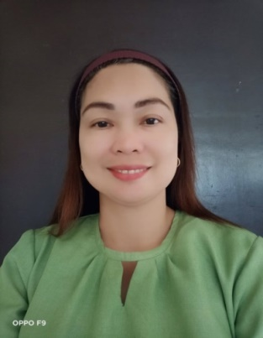
MARIE PAZ B. QUINTO
Special Education Teacher I
Address: 520 Sitio Sacbit, Malacanang, San Carlos City, Pangasinan, Philippines 2420
Phone No: +63 927-596-5727
Email: mariepaz.quinto@deped.gov.ph

SUMMARY
Special Education Teacher with 11+ years of experience in teaching diverse student populations in emotionally impaired and general education classroom settings. Skilled in delivering effective educational programs for special students with serious emotional, mental, and learning disabilities. Received awards as the Most Outstanding Special Education Teacher in the District and the Most Structured SPED Classroom in the Division. Given Certificate of Recognition for being a Coach in the Regional Athletic Competition. Passed the 2017 Principal Test or the National Qualifying Examinations for School Heads.
EXPERIENCE
MALACANANG ELEMENTARY SCHOOL-PHILIPPINES
SPECIAL EDUCATION TEACHER- June 6, 2011- PRESENT

- Develop special education curriculum, tailor individualized education plans (IEPs) based on student assessment data, and identify appropriate learning techniques
- Work with general education teachers to plan and implement instructions while ensuring 100% compliance with IEP standards
- Formulate and implement rules for behavior and procedures for maintaining a well-disciplined learning environment
- Assess students’ skills to determine their needs and develop effective teaching plans particular to each student’s abilities
- Establish a positive, structured, achievement-focused learning environment
- Establish and maintain open lines of communication with students and parents concerning student’s academic, social and behavioral progress
- Create and adapts lesson plans according to students’ academic needs
- Mentor and coach students on self-regulation and organizational skills
- Monitor and evaluates child’s progress and assessment data
- Provide support to students, parents and general education staff and support student learning
- Integrate technology in teaching and uses manipulative materials and gadgets to make the learning fun and enjoyable

EDUCATION

- VIRGEN MILAGROSA UNIVERSITY FOUNDATION- 2001
Bachelor of Elementary Education – General Education (Graduated)
- PANGASINAN STATE UNIVERSITY-SCHOOL OF ADVANCED STUDY- 2014
Master in Development Management –Major in Public Management (Graduated)
With 18 Units in Special Education
- VIRGEN MILAGROSA UNIVERSITY FOUNDATION-2023
Master of Science in Teaching- Major in Special Education- 24 units earned –Academic Requirements Completed
- PANGASINAN STATE UNIVERSITY-SCHOOL OF ADVANCED STUDY- 2015
Doctor of Education- Major in Educational Management (Academic Requirement-
Completed)

ADDITIONAL SKILLS
- Team Leadership
- Proficient in MS Office (Word, Excel, and PowerPoint)

