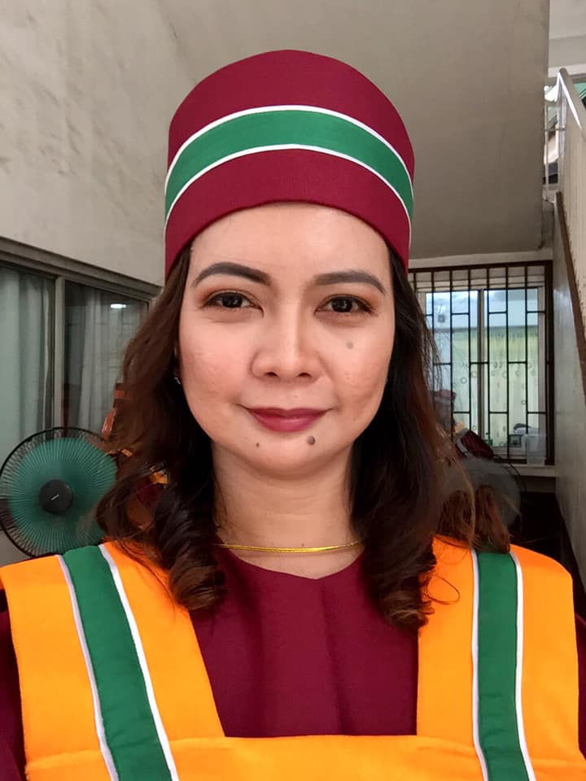
LIZA JANE BIASON-BASUEL, R.N., MAN
San Jacinto, Pangasinan, Philippines
Mobile No.: +639666452423
Email Add: lbbasuel.85@gmail.com

PROFESSIONAL STATEMENT

A transcultural nurse equipped with ten years’ experience in quality patient care, more than two years in nurse education, and masters in nursing administration. To work in a healthcare institution where I can provide quality support to other healthcare professionals while giving comprehensive and effective medical attention to the public.

PERSONAL DATA
Age: | 37
Date of Birth: | Nov 25, 1985
Gender: | Female
Civil Status:  Religion: | Married  Christian
Height: | 165.14 cm
Weight: | 50 kg
Nationality: | Filipino
Permanent Address: | Lobong, San Jacinto  Pangasinan, Philippines

WORK EXPERIENCES

Nurse Instructor
November 2018 – January 31, 2021
PHINMA University of Pangasinan
Arellano Street, Dagupan City, Pangasinan, Philippines

NICU Level II Charge Nurse
July 12, 2013 – October 24, 2017
King Saud Medical City
Riyadh, Kingdom of Saudi Arabia

NICU Level II Staff Nurse
August 21, 2009 – July 11, 2013
King Saud Medical City
Riyadh, Kingdom of Saudi Arabia

Junior Nurse (NICU)
August 2007 – August 2009
Medical Centrum Dagupan
Tambac District, Dagupan City Pangasinan

EDUCATIONAL BACKGROUND

Post-baccalaureate Education
Master of Arts in Nursing major in Nursing Administration
University of Luzon
Dagupan City, Pangasinan, Philippines
January 2018 – March 2020

Tertiary Education
Bachelor of Science in Nursing
Colegio De Dagupan
Dagupan City, Pangasinan, Philippines
June 2003 - April 2007

Secondary Education
Pangasinan School of Arts and Trades
Alvear Street, Lingayen, Pangasinan
June 1998 – March 2002

LICENSES/CERTIFICATIONS
 | License/  Certification | License/  Certification No. | Date
1. | Nurse Technician  (Saudi Commission for Health Specialties) | 10-R-N-0320113 | October 2010
2. | Registered Nurse  (Professional Regulation  Commission) | 0462833 | January 4, 2008
3. IV Therapist 08-015081 December 29, 2011
(Association of Nursing Service
Administrators of the Philippines)

SKILLS

1. Licensed IV Therapist
2. Neonatal Resuscitation Program (NRP) Provider
3. Basic Life Support (BLS) Provider
3. Infection Control Link Nurse
4. Management & Leading Skills

SEMINARS and TRAININGS

MCNAP Chapter Convention 2019
“Innovations and Advancements towards Excellence in Maternal and Child Nursing Practice and Attainment of the Sustainable Development Goals”
November 23, 2019
University of Luzon, Dagupan City

PNA Regional Convention 2019
“Region 1 Nurses: Voices to Lead Achieving Universal Health Care”
November 16, 2019
Hotel Ariana, Bauang, La Union

2nd Breastfeeding Summit
“Making a Lifetime of Difference”
August 1-2, 2019
Grand Xing Imperial Hotel, Iloilo City

BUNTIS CONGRESS 2019
“Busog-Lusog si Baby sa Gatas at Aruga ni Mommy”
July 29, 2019
Dagupan City Health Office, Dagupan City

Curriculum Development for the College of Nursing
PHINMA University of Pangasinan
November 8-9, 2018
Dagupan Village Hotel, Dagupan City

MCNAP Chapter Convention 2018
“Maternal and Child Nursing to Attain Best Practices”
September 29, 2018
University of Luzon, Dagupan City

Infection Prevention & Control Link Nurse Course
October 2016
King Saud Medical City
Cardiopulmonary Resuscitation (BLS)
Saudi Heart Association
October 27, 2016
King Saud Medical City
Riyadh, KSA

Wound Management
March 16-17, 2016
National College Hospital
Jeddah, Kingdom of Saudi Arabia

Neonatal Resuscitation Program Provider Course
Saudi Neonatology Society
February 19, 2016
King Saud Medical City
Riyadh, KSA

Emergency Medication & Intravenous Medication Safety
November 18, 2013
King Saud Medical City
Riyadh, KSA

Intravenous Therapy Course
October 1-2, 2013
King Saud Medical City
Riyadh, KSA

S.T.A.B.L.E Program & Neonatal Cardiac Module Course
April 28-30, 2013
King Saud Medical City
Riyadh, KSA

CHARACTER REFERENCES

Ms. Rita Van Wyk
Director of Nursing, Pediatric Hospital
King Saud Medical City
Tel.# 1435-6666 ext. 507

Ms. Dolores Taga Aliling
NICU Level II, Head Nurse
King Saud Medical City
Tel# +966593883431

Ms. Cindy Jaramillo
Dean, College of Health Sciences
PHINMA-University of Pangasinan
Tel# +63927533669

