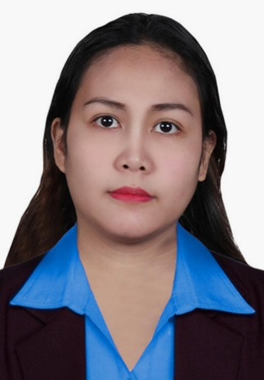
MICHELLE L. YACAS
# 61-A Dizon Subdivision,
Baguio City 2600, Philippines
Email: yacaselle11121729@gmail.com ; sundaymiss8@gmail.com
Phone: (+639) 9754686359 | 9517219336
Tel: 074-620-1154
__________________________________________________________
__________________________________________________________
I am an experienced Customer Service Representative with more than 8 years in the Industry.

Work Experiences:

TELEPERFORMANCE PHILIPPINES SERVICES
CSR | Live Captioning Associate
October 14, 2019 – Present
(3 years 4 months)
- We help people with hearing loss communicate over the phone.
- Transcribes real-time telephone conversation so the person with hearing loss can read what their caller is saying using a voice captioning tool.
- Exceeded goals through effective task prioritization and great work ethic.
- Performed duties in accordance with all applicable standards, policies and regulatory guidelines to promote safe working environment.

Concentrix Corporation
Customer Service Representative | Billing | Sales
(Financial Account)
June 14, 2018 – October 07, 2019
(1 year and 4 months)
- Identified, researched and resolved billing variances to maintain system accuracy and currency.
- Generated and submitted invoices based upon established accounts receivable schedules and terms.
- Achieved and consistently exceeded revenue quota through product and service promotion during routine calls.
- Enhanced productivity by staying on top of call scripts and maintaining control over direction of conversations.

LINGUO ONLINE PHILIPPINES INC.
ESL Trainer | English Teacher (Full Time On-site)
January 07, 2017 – August 15, 2018
(1 year and 7 months)
- Plan and prepare lesson plans that meet core objectives and principles and are in line with the curriculum goals.
- Prepare instructional aids and supplemental teaching materials and resources consistent with learning objectives and student needs.
- Select and requisition appropriate books, instructional aids and school supplies as needed.
- Deliver lessons using a variety of differentiated instructional techniques that are appropriate to the academic level and meet the diverse needs of students.
- Maximize the appropriate use of technology in the classroom as an instructional tool.

Convergys Philippines Services Corporation
Customer Service Representative | Billing | Sales
(Telco and Retail Accounts)
September 14, 2015 – October 15, 2016
(1 year and 1 month)
- Answers and listens to members' call.
- Evaluate a member's account and situation to provide accurate information to their specific problem or concern.
- Assists members' on the how tos of their accounts.
- Reliably follow up with customers on issues that were not able to be resolved during a single contact.
- Help members get the best experience by upgrading their accounts.
- Be empathetic to customer concerns and display a sincere desire to serve.

Convergys Philippines Services Corporation
Customer Service Representative | Billing | Sales
(Telco Account)
May 21, 2014 – November 17, 2014
(6 months)
- Answered customers’ queries and be able to provide information about their concerns.
- Providing tech support about their equipment if needed.
- Help customers to Upgrade their channels to get the best TV experience.
- Providing steps on how to order PPVs on their devices.
- Helping customers to lower down their bills.

Sitel Philippines Inc.
Customer Service Representative | Billing (Financial and Retail Accounts)
June 17 2013 – May 4, 2014
(11 months)
- Assisted customers with setting up or closing accounts,
- Answered telephone inquiries on banking products such as savings.
- Identified sales opportunities and referred customers to branch partners in financial services.
- Educated customers on use of banking website and mobile apps.
- Recognized needs and referred to appropriate representative or line of business for cross-sell or service opportunities.
- Exceeded goals through effective task prioritization and great work ethic.
- Actively listened to customers' requests, confirming full understanding before addressing concerns.

Educational Attainment:
Don Mariano Marcos Memorial State University
B. S. Business Administration (Major in Management)
San Fernando City, La Union, Philippines
2010-2013
Certificates:
TEFL Professional Development Institute
120-Hour Teach English as a Foreign Language (TEFL) Certificate

TESDA Certificate Of Competence in Bookkeeping NCIII
(October 2012)

JRMMM CENTER FOR LEARNING AND ASSISTANCE SERVICES | CLAS LEARNING CENTER
120-Hour Korean Language Certificate of Completion
(April 29, 2022)

