Full Name KRYSTAL DEE MATURA MARANGA
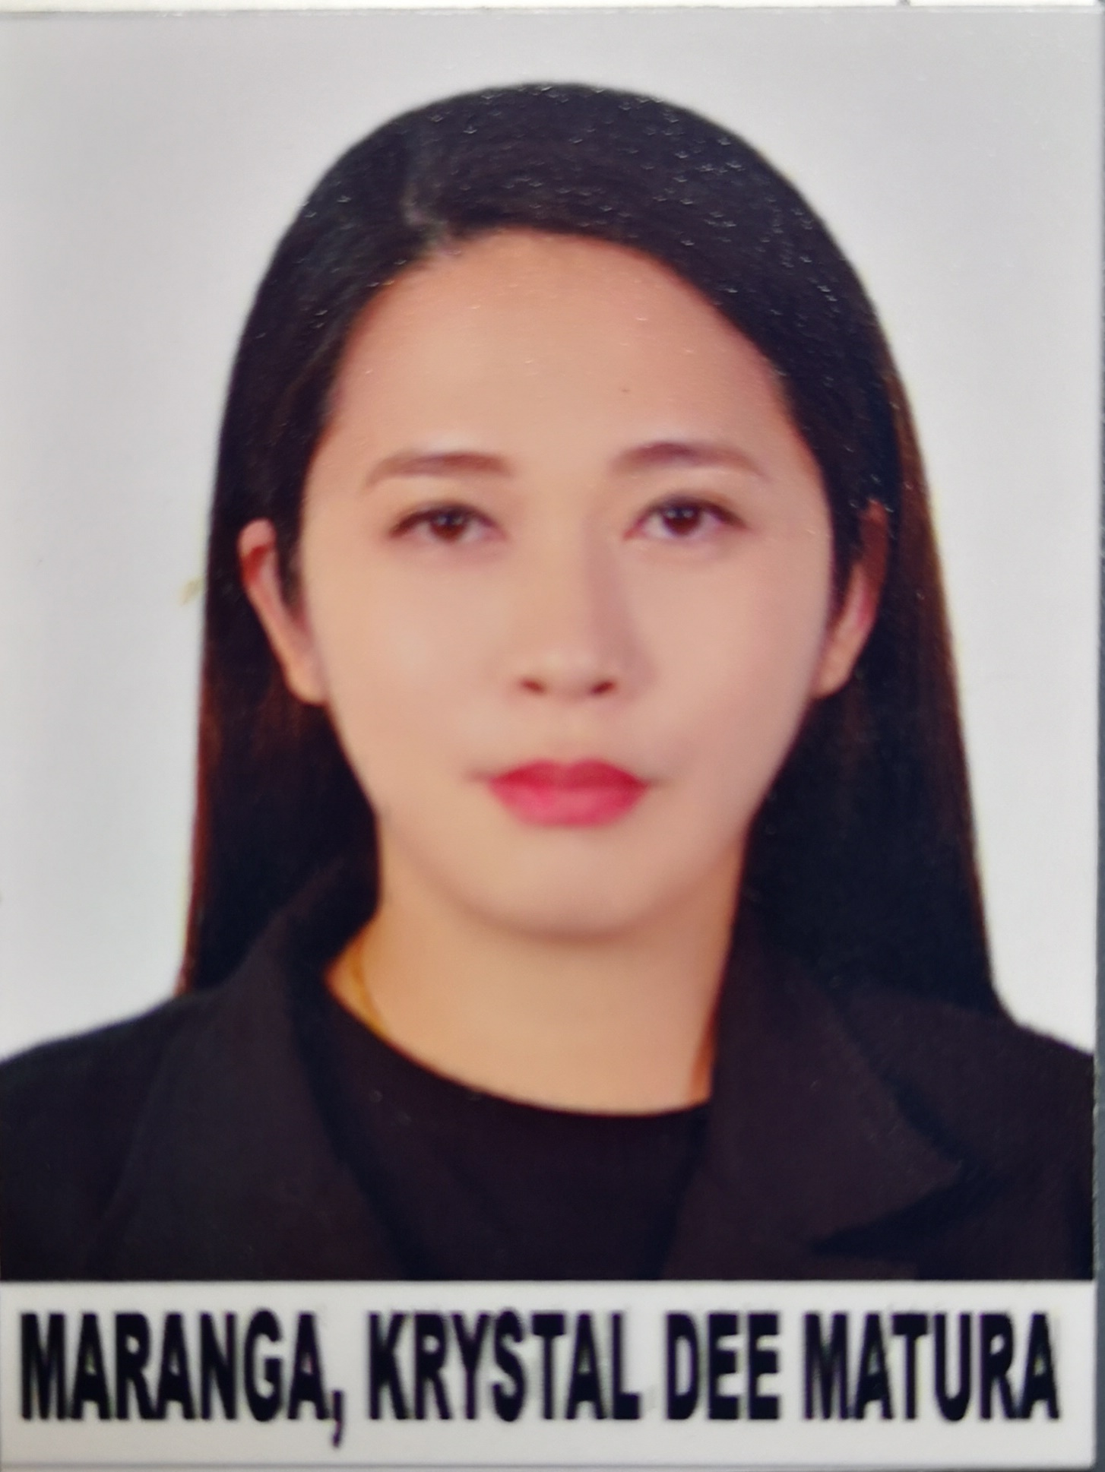

PHOTO
(At least 6 months old)
Mobile No.: +63921-447-0341
Current Address: 0694, Purok Bolinao,
Barangay Dawis, Digos City, Davao del Sur, Philippines
Email Add: krystaldee_matura28@yahoo.com

PROFESSIONAL SUMMARY
I am a dedicated and patient-focused Registered Nurse with 13 years of experience. I worked with emergency care team and other professional health care. I have gained experience with the common procedures required. I have proven expertise in acute care and family advocacy. I have acquired knowledge of the new devices, medical terminology and legal implications.

SKILLS

- Has exceptional capacity to multitask.
- I am able to remain calm under pressure, perform necessary tasks quickly and correctly and make difficult decisions swiftly in emergency situations.
- Hard-working, reliable, service-oriented health professional who loves to learn and to take up a challenge while providing highest quality care
- Compassionate caregiver with strong interpersonal communication and active listening skills for establishing and maintaining rapport with clients and their families
- Proven experience in daily implementation of care plan with solid observational and problem solving skills for the general well-being of clients.

EXPERIENCE (From Present to 2013)

Position: EMERGENCY STAFF NURSE
Date: JULY 1, 2019- PRESENT
Company: GONZALES MARANAN MEDICAL CENTER INC
Address: QUEZON AVENUE, BARANGAY ZONE 1, DIGOS CITYM DAVAO DEL SUR PHILLINES

Job Description / Duties and Responsibilities:
- Carry out administrative procedures in conformity with hospital admission policies;
- Administer medications and carry out treatments and procedures to patients as ordered by the physician;
- Prioritize immediate nursing interventions in all emergency situations;
- Operate life-saving devices intelligently;
- See to it that emergency cart is always ready for use;
- Ensure proper endorsement of patients’ condition to the staff nurse in the unit;
- Supervise the duties of the ER ward man especially in transporting patients to their respective room of choice;
- Initiate implementation of medical management like request for blood examinations, X-rays, medicine and treatment;
- Do the following intelligently as specified:
  - Assessment of patient
  - Admitting the patient
  - Taking initial vital signs for baseline purposes
  - Intravenous fluid insertion in accordance with the doctor’s order
  - Administering oxygen inhalation per nasal cannula or mask as needed
  - Preparing equipment and instruments for minor surgery cases
  - Executing resuscitation in certain situation needed
  - Administering stat medicines through the proper route
- Do proper handling of life-saving devices like suction machine, defibrillator, ambubag, etc.
- Document procedure done through charting or making the nurses notes.

Position: ACCIDENT AND EMERGENCY STAFF NURSE II
Date: JUNE 15, 2014- JUNE 14, 2019
Company: PRINCE SULTAN MILITARY MEDICAL CITY
Address: SULEIMANYA STREET, RIYADH, KINGDOM OF SAUDI ARABIA

Job Description / Duties and Responsibilities:
- Carry out administrative procedures in conformity with hospital admission policies;
- Administer medications and carry out treatments and procedures to patients as ordered by the physician;
- Prioritize immediate nursing interventions in all emergency situations;
- Operate life-saving devices intelligently;
- See to it that emergency cart is always ready for use;
- Ensure proper endorsement of patients’ condition to the staff nurse in the unit;
- Supervise the duties of the ER ward man especially in transporting patients to their respective room of choice;
- Initiate implementation of medical management like request for blood examinations, X-rays, medicine and treatment;
- Do the following intelligently as specified:
  - Assessment of patient
  - Admitting the patient
  - Taking initial vital signs for baseline purposes
  - Intravenous fluid insertion in accordance with the doctor’s order
  - Administering oxygen inhalation per nasal cannula or mask as needed
  - Preparing equipment and instruments for minor surgery cases
  - Executing resuscitation in certain situation needed
  - Administering stat medicines through the proper route
- Do proper handling of life-saving devices like suction machine, defibrillator, ambubag, etc.
- Document procedure done through charting or making the nurses notes.

Position: EMERGENCY STAFF NURSE
Date: JUNE 03, 2010-APRIL 15, 2014
Company: GONZALES MARANAN MEDICAL CENTER INC
Address: QUEZON AVENUE, BARANGAY ZONE 1, DIGOS CITYM DAVAO DEL SUR PHILLINES

Job Description / Duties and Responsibilities:
- Carry out administrative procedures in conformity with hospital admission policies;
- Administer medications and carry out treatments and procedures to patients as ordered by the physician;
- Prioritize immediate nursing interventions in all emergency situations;
- Operate life-saving devices intelligently;
- See to it that emergency cart is always ready for use;
- Ensure proper endorsement of patients’ condition to the staff nurse in the unit;
- Supervise the duties of the ER ward man especially in transporting patients to their respective room of choice;
- Initiate implementation of medical management like request for blood examinations, X-rays, medicine and treatment;
- Do the following intelligently as specified:
  - Assessment of patient
  - Admitting the patient
  - Taking initial vital signs for baseline purposes
  - Intravenous fluid insertion in accordance with the doctor’s order
  - Administering oxygen inhalation per nasal cannula or mask as needed
  - Preparing equipment and instruments for minor surgery cases
  - Executing resuscitation in certain situation needed
  - Administering stat medicines through the proper route
- Do proper handling of life-saving devices like suction machine, defibrillator, ambubag, etc.
- Document procedure done through charting or making the nurses notes.

EDUCATION

College/University: BROKENSHIRE COLLEGE
Year: June 2005-March 2009
Course: Bachelor of Science in Nursing
School / Address: Madapo Hills, Davao City, Philippines

Secondary: HOLY CROSS OF BANSALAN COLLEGE
Year: June 2001-March 2005
School / Address: Mother Ignacia Street, Bansalan Davao del Sur, Philippines

PERSONAL INFORMATION

Date of Birth : AUGUST 28, 1989
Civil Status : MARRIED
No. of Children : 1 LIVING AND 1 DECEASED
Relatives in Canada : YES
Nationality : FILIPINO
Passport Number : P0552155C

SEMINAR AND WORKSHOP

Advanced Cardiac Life Support
Conducted by: Prince Sultan Military Medical City
July 13, 2017

Basic cardiac Life Support
Conducted by: Prince Sultan Military Medical City
November 2, 2016

Environmental Health and Safety Lecture
Conducted by: Prince Sultan Military Medical City
February 25, 2015

EKG Reading, Pharmacology & Endotracheal Intubation Course
Conducted by: Institute for Nursing Enrichment Training Center
(iNET Center)
July 9, 2013

CPR Pro for the Professional Rescuer
Conducted by: Institute for Nursing Enrichment Training Center
(iNET Center)
July 8, 2013

Regular IV Training Program- Certificate of Training
Conducted by: Association of Nursing Service Administrators of the Philippines
(ANSAP)- Davao City Chapter
September 10-12, 2010

Basic IV Therapy Training for Nurses
Conducted by: Association of Nursing Service Administrators of the Philippines
(ANSAP)- Davao City Chapter
September 10-12, 2010

Disaster of Nursing
Conducted by: The Philippine National Red Cross
(PNRC)-Davao City Chapter
March 5, 2010

REFERENCES

Name: Rezzel Enerio
Position: Chief Nurse
Company / Address: Gonzales Maranan Medical Center Inc. / Quezon Avenue, Barangay Zone 1, Digos City, Davao del Sur
Contact No: (082) 553-2474

Name: Manuel K. Gonzales
Position: Medical Director
Company / Address: Gonzales Maranan Medical Center Inc. / Quezon Avenue, Barangay Zone 1, Digos City, Davao del Sur
Contact No: (082) 553-2474

Name: Edwin Perez
Position: Head Nurse
Company / Address: Prince Sultan Military Medical City / Riyadh, Kingdom of Saudi Arabia
Contact No: 1-4777714 Ext. 27304

Name: Rossario Mactao
Position: Charge Nurse
Company / Address: Prince Sultan Military Medical City / Riyadh, Kingdom of Saudi Arabia
Contact No: 1-4777714 Ext. 27304

