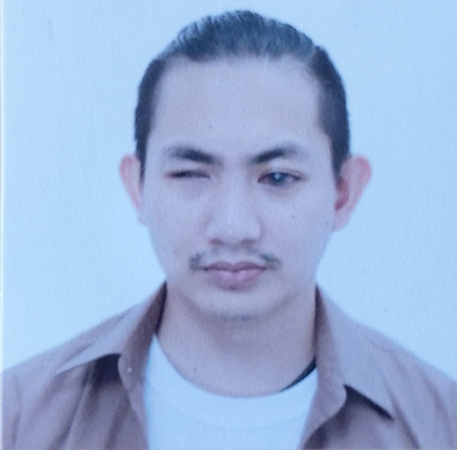
JETHRO L. VERGARA
Purok 16, Irisan, Baguio City
09288686032
Jethrovergara9311@gmail.com

CAREER OBJECTIVE:
To build a career in a growing organization where I can get the opportunities to prove and improve my skills by accepting challenges and fulfilling the organization’s goal.

PERSONAL INFORMATION:
Date of Birth : November 11, 1993
Place of Birth : Baguio City
Gender : Male
Age : 29
Civil Status : Single

EDUCATIONAL BACKGROUND:

Tertiary : University of Baguio
Bachelor in Elementary Education major in Special Education
SY: 2009 - 2015
Secondary : Irisan National High School
SY: 2006 - 2009
Primary : Mount Zion Training Center
SY: 2000 - 2005

SEMINARS AND CERTIFICATES:

- Institute on Disability and Public Policy Training
Cyberjaya, Malaysia
August 1 - 15, 2015

LICENSE:

- Department of Health Massage Licensure Examination
Top 5
October 07, 2016

NCII Passer – Massage Therapist
August 2011

WORK EXPERIENCE:

- Massage Therapist
North Luzon School for the Visually Impaired
Veterans Compound, Camp Allen, Baguio City
2020 - present

- Massage Therapist
VITAL Massage Clinic
Jose Miguel Bldg., Labsan Street, Baguio City
2019 – 2020

- Massage Therapist
North Luzon School for the Visually Impaired
Veterans Compound, Camp Allen, Baguio City
2016 - 2018

QUALIFICATIONS:

- Hardworking
- Fast Learner and willing to be trained
- Can work under pressure
- Flexible

CHARACTER REFERENCES:

- Alpha L. Consolacion
State Auditor
09778010379
- Joefer C. Masaoay
Project – in Charge Engineer
09465317662
- Miguel James Abad
Corporate Trainer
Peak Support Global Enterprise
09236303336
I hereby certify that the above information is true and correct to the best of my knowledge and belief.

Jethro L. Vergara(sgd)

