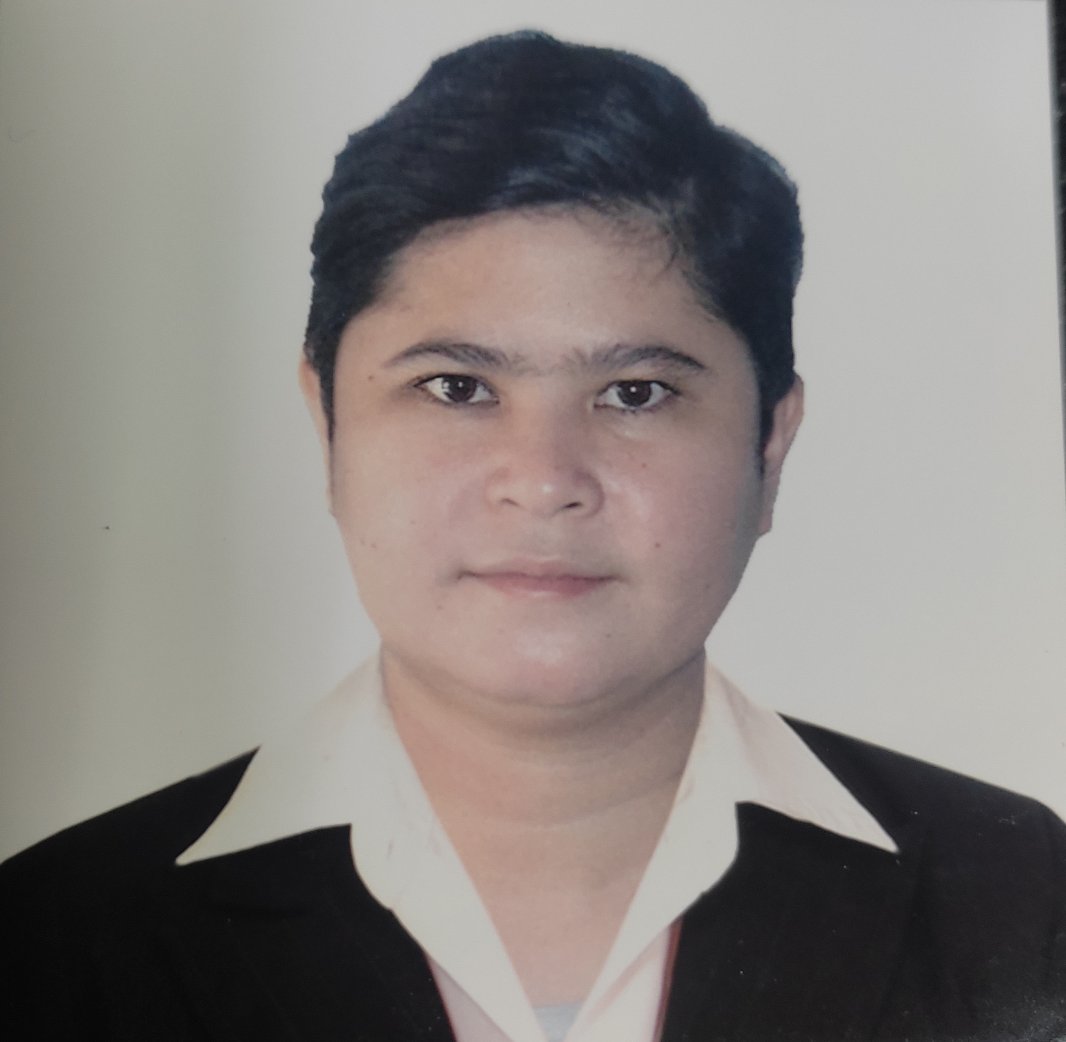
CHARMHEI ANNE C. BALINGIT
Purok 3, Concepcion, Cabiao, Nueva Ecija, Philippines
Contact numbers: 09683217742
Email Address: mheibalingit27@gmail.com

PERSONAL DATA:

Nickname: Mhei
Gender: Female
Civil Status: Single
Age: 31
Date of Birth: April 27, 1991
Place of Birth: Arayat, Pampanga
Citizenship: Filipino
Height: 152.4 cm
Weight: 60 kls.

EDUCATIONAL BACKROUND:

College

2007-2012 Bachelor of Science in Nursing Graduate
Wesleyan University-Philippines
Mabini Extension, Cabanatuan City

High School

2003-2007 Sta. Rita National High School Graduate
Sta. Rita, Cabiao, Nueva Ecija

Elementary

1997-2003 Cabiao Central School Graduate
Cabiao, Nueva Ecija

SKILLS

- Data Encoder
- Caregiving
- ECG Technician
- Phlebotomist

LANGUAGE SPOKEN

- English
- Tagalog

WORK EXPERIENCE

Company Date
- Trajector Medical (Costumer Service Representative) July 6, 2022 up to present

- Private Nurse Doha Qatar Oct. 22, 2018 -Jan 10, 2021

- Nurse Lingap Gen. Hospital Sept. 20, 2018- July 16, 2016

- Nurse Healthwise Specialty Clinic January 2016
& Diagnostic Center June 9, 2014

DUTIES AND RESPONSIBILITIES

- Primarily take good care of the patient
- Orient and guide patients about doctor’s prescription
- Blood Extraction for Chemistry
- Documents control and safety

CHARACTER REFERENCE:

Michele Cranefield
Site Director
Cabanatuan City, Nueva Ecija

Hon. Ramil B. Rivera
Municipal Mayor
Cabiao, Nueva Ecija

Dr. Crispin C. Eustaquio M.D.
Lingap General Hospital
Arayat, Pampanga

Feliciano C. Supan
Brgy. Chairman
Concepcion, Cabiao Nueva Ecija

