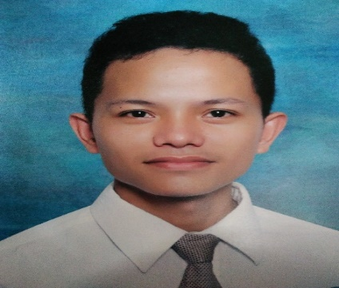
DELFIN L. ARCHIVAL
Address: Cambaro, Mandaue City, 6014
Contact #: 09275505479
Email Address: darchivaljr@gmail.com

Career Objective:
To work in a mass oriented and competitive company for a position that would offer a great challenge and better opportunity, and to apply and contribute my learnings from previous work experiences for the betterment of the company.

Educational Attainment:
Tertiary:
Center for Industrial Technology and Enterprise
Electromechanics Technology
San Jose, Cebu City
SY: 2014-2017

Secondary:
Talamban National (Night) High School
Talamban Cebu City, 6001
SY: 2007-2011

Elementary:
Adlaon Integrated School
Proper Adlaon Cebu City, 6001
SY: 2001-2007

Areas of Competencies:
Mechanical Technology:
- Perform basic benchwork operations such as filing.
- Operate and maintain standard tools such as lathe, drill press and milling machine.

Electrical Technology:
- Install service pneumatics and electro-mechanics.
- Install building wiring circuit.
- Install motor control circuit.

Electronics Technology:
- Knowledgeable in soldering and desoldering.
- Able to use electronics equipment.
- Able to lay-out in PCB (Printed Circuit Board).
Information Technology:
- Proficient in MS office programs such as MS Word and Excel.
- Computer Hardware Servicing.
- Able to troubleshoot basic computer problems.

Building/Facilities Maintenance:
- Working day to day maintenance and operation to ensure that all required tasks are carried out on time and satisfactory results.
- Ensure facility preserves a high-level maintenance and appearance.
- Ensure all preventive maintenance and corrective maintenance are completed on time and in professional manner.
- Cooperate the energy saving project and monitor energy consumption of the site.
- Provided daily report to supervisor.

Personal Skills
- Good in oral and written communications skill that includes email responding for client concern or request.
- Computer literate.
- Can handle multi-tasking jobs.
- Works effectively in a fast-paced environment.
- Possess excellent interpersonal skills.
- Good team player.
- Being a proactive in looking for improvement of the operation.
- Willing to be trained and considers self as a fast learner.
- Initiative and gives full attention to every minute detail.
- Good in mind games.
- Excellent punctuality and attendance record.

Work Experience:
- Dual Training System at Visayan Electric Company (VECO)
Materials Management Department
June 2015 to October 2016

- Technical Support (R&D) at RNM Dynamics
Repair and Design
December 2016 to July 2017

- Machine Operator at Monde Nissin Corporation (MNC)
Machine Operator
August 2017 to January 2018

- Facilities and Machine Technician at Gemphil Technologies Inc.
Facilities and Machine Technician
February 2018 to January 2020

- Sodexo Onsite Services Phils., Inc.
Multi-skilled Technician
January 2019 to March 2022

Teradyne Philippines Limited
Assembler
June 2022 to Present
Seminars and other affiliations:
Leadership Seminar - Center for Industrial Technology and Enterprise
Fire Prevention Month Seminar - Visayan Electric Company
NC II passer of MECHATRONICS TECHNOLOGY

Character References:

Aldrin Acedo
Facilities Engineer
Sodexo Onsite Services Phils., Inc.
Paseo de Roxas, Makati City
09260814823

Jeson Arreglado
Housekeeping Supervisor
Sodexo Onsite Services Phils., Inc.
Paseo de Roxas, Makati City
09472274085

Jay Capangpangan
Engineering Department - Supervisor
Cebu Light Industrial park, Basak, Lapu-Lapu City
09124500476

