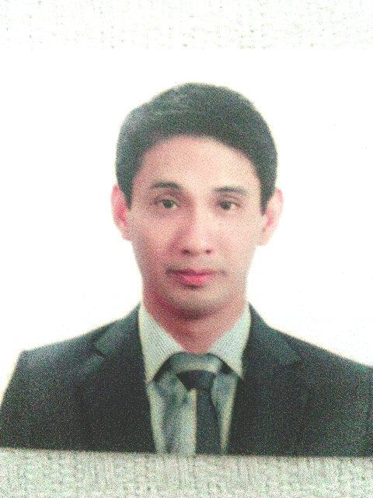
ERWIN MISA MARTINEZ
#130 Apo Esquivel Imelda Poblacion,
Jaen Nueva Ecija.
Contact No. {09324370995} _ (09975715693)

Email: young3image@yahoo.com

OBJECTIVES/MAJOR INTEREST:

Willing to undergo comprehensive trainings connected to job assignments, work under pressures, and support and contribute to the company in the pursuit of its objectives ideas, visions and gain professional growth within the company.

PERSONAL INFORMATION:

NATIONALITY : Filipino
AGE : 39 years old
PLACE OF BIRTH : Quezon City
DATE OF BIRTH : July 08, 1983
CIVIL STATUS : Married
HEIGHT : 5'10
WEIGHT : 175 lbs.
RELIGION : Iglesia Ni Cristo
FATHER'S NAME : Ignacio C. Martinez
OCCUPATION : (Deceased)
MOTHER'S NAME : Patricia M. Martinez
OCCUPATION : (Deceased)
WIFES NAME : Rimadel C. Martinez

WORK EXPERIENCE:

- EUROMED LABORATORIES PHIL, INC.
Designation: Medical Sales Representative June 2022 - Present

Duties and Responsibilities: Selling Small Volumes Parentals & Pharma Division to
Hospitals & Drugstore.

- GRAB A CAR December 2015 - June 2018
Designation: Personal Driver

Duties and Responsibilities: Grab a car & Personal Driver.

- CITIBANK EASTWOOD LIBIS. August 2015 - December 2015
Designation: Citi Sales Officer

Duties and Responsibilities: Selling Credit Cards & Loans to the Clients.

TAMAH ENTERPRISES April 2010 - August 2015
Designation: Sales Executive & Admin assistant

Duties and Responsibilities: Talking & Selling products to the clients (Architect,
Contructor & Engineers & Hardwares.)
delivering products to the clients. (ppr- materials
waterline pipes, paints & Phillips lightning) doing marketing, office wotks.

- KRESICS FITNESS PTE LTD (Singapore) March 2009 - March 2010
Designation: Fitness Consultant & Marketing Assistant

Duties and Responsibilities:Talking clients about Fitness & Doing Marketing duties.
Give guidance & instructions to the client to help them
attain the said fitness goals. Able to ensure that the client is performing exercises correctly. Follow-up the clients for their renewals of membership & services enrolled.
(Promoting Fitness)

- ATENEO DE MANILA UNIVERSITY February 2008 - September 2008
Designation: Textbook Office & Data Encoder

Duties and Responsibilities: Distributing and assisting textbooks to the students
and encoding the resume of the employees.

- MERCURY DRUG CORPORATION October 2006 - July 2007 Designation: Filling Clerk & Office Clerk

` Duties and Responsibilities: Filling the documents, form 206 (Barcode) and
distribute to different departments

- BANCO DE ORO October 2005 - March 2006
Designation: Money Sorter & Travelling Teller

Duties and Responsibilities: Sorting the Bills in a machine & in manual process to
determine if the money is fake or not.
- SM MART INC.
Designation: Counter Checker April 2005 - August 2005

Duties and Responsibilities: Checking the receipts (Bagger).

EDUCATIONAL BACKGROUND:

COLLEGE: Philippine School Business Administration Quezon City

COURSE: BSBA Management
College Graduate

HIGH SCHOOL: Roosevelt College Cainta
High school Diploma

ELEMENTARY: Marist School Marikina Heights
Elementary Diploma

SKILLS:

- Knowledge of various Computer Software (MS DOS, Microsoft Excel, Microsoft word, Microsoft Power Point)

- 23 Years Driving Experience.with Professional drivers license.

SEMINAR & TRAINING ATTENDED:

- Alumni Hotel, University of The Seminar Workshop about
Philippines, Diliman Quezon City Writing Business Report

- Alumni Hotel, University of The Seminar Workshop about
Philippines, Diliman Quezon City Speaking & Writing English

- Junior Bankers Association Seminar on Credit Banking Facilities

- Cafe Americana Seminar & Training Dealing
with the customer
- Jong Phil. Language Korean Language
Center, Inc.

- Fellus Pte Ltd. Trainee on Loan & Credit
Singapore Call Center Representative

CHARACTER REFERENCE:

- Gilda Paredes
4 St. Francis St. Maries Village 1
Antipolo City
+639184871556

- Krescenthia David
11 Japanese Garden Road
Singapore 619229
(65) 93486468

- Vincent Tobias
#8 St. Agnes St. Maries Village 1
Antipolo City
+639175904770

I HEREBY CERTIFY that all information written above are true and correct to the best of my knowledge.

ERWIN MISA MARTINEZ
Applicant's Signature

