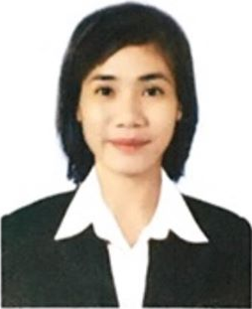

DIANE JOY D. BEJERANO-BROCA, R.N, M.N
Email: dianeyang070390@gmail.com
09982319028

Objectives and Goals:

To land a career opportunity where I could apply and practice my skills and enhance my knowledge and capabilities as a clinical nurse.

Work Experiences:

- Staff Nurse
Neuro-Ortho Ward (December 2020-Present)
COVID HOLDING AREA (November 2020- December 2020)
General Private Ward (June 2019-November 2020)
Davao Regional Medical Center
Apokon, Tagum City, Davao Del Norte, Philippines 8100

- Science and Health Teacher
Anuban Phetchaburi School
Amphoe Meuang, Phetchaburi, Thailand 76000
July 16, 2014-November 7, 2016
May 1, 2018- May 2019

- Staff Nurse
Bishop Joseph Regan Memorial Hospital
Apokon Road, Tagum City, Davao Del Norte
November 8, 2016 – March 31, 2018

- Private Duty Nurse
Bumrungrad International Hospital
Under: Kronus (Thailand) Co.,Ltd.
33 Sukhumvit 3 (Soi Nana Nua), Sukhumvit Road,
Klongtoey Nua, Wattana, Bangkok, Thailand 10110
October 7, 2014- October 31, 2016

- Volunteer Nurse:
Davao Prison and Penal Farm Hospital
Department of Justice
Bureau of Correction
B.E Dujali, Carmen, Davao Del Norte
July 15, 2013- June 20, 2013

- Volunteer Nurse:
Haiyan Medical Mission
Filipino Canadian Medical Association (FCMA)
Tacloban, Samar, and Leyte
January 10-17, 2014

Trainings/Seminars Attended:

Orthopedic Nursing
April 11, 2023
Davao Regional Medical Center
Apokon, Tagum City, Davao Del Norte, Philippines 8100

Handling of Rabies Patient
February 28, 2023
Davao Regional Medical Center
Apokon, Tagum City, Davao Del Norte, Philippines 8100

Seminar-Workshop on Wound Assessment and Management
September 8, 2022
Davao Regional Medical Center
Apokon, Tagum City, Davao Del Norte, Philippines 8100

Seminar Workshop on Basic ECG Interpretation
and Interventions by Nurses
December 2, 2021
Davao Regional Medical Center
Apokon, Tagum City, Davao Del Norte, Philippines 8100

20-Hour Breastfeeding and Lactation Management Training With
Mentoring, Coaching, and Evaluation
August 7-9, 2019
Davao Regional Medical Center
Apokon, Tagum City, Davao Del Norte, Philippines 8100

Evidence-Based Practice Seminar
Graduate School of Nursing
Ateneo De Davao University
Davao City
April 6, 2018

Teenage Pregnancy and Substance Abuse Seminar
“Fifty Shades Darker No Lies No Secrets Stop”
Graduate School of Nursing
Ateneo de Davao University
March 4, 2017

Nurses’ Health Forum: Resilient Nurses Facing HIV-AIDS
And Diabetes with a Heart Seminar
Graduate School of Nursing
Ateneo de Davao University
February 4, 2017

Intravenous Training Program
ASSOCIATION OF NURSING SERVICE ADMINISTRATORS OF THE PHILIPPINES, INC. (ANSAP): Certificate of Training- Regular IV Training Program
Davao Regional Hospital
Apokon, Tagum City, Philippines
February 26-28, 2014

Basic Life Support Training and Seminar
American Heart Association
Primus Training Center
FTC Tower, Davao City, Philippines
February 22, 2014

Educational Background:

Post Graduate Study : Ateneo De Davao University
Master of Arts in Nursing
June 2020-Present
On-going Thesis Paper II (Data Analysis)

Ateneo De Davao University
Master’s Degree in Nursing
2016-2018
Graduate

Tertiary : Saint Mary’s College of Tagum, Inc.
Bachelor of Science in Nursing
Graduated May 12, 2011

Secondary : Nuevo Iloco National High School
Nuevo Iloco, Mawab, Compostela Valley
Graduated 2006־2007

Elementary : Bawani Elementary School
Bawani, Mawab, Compostela Valley
Graduated 2003־2004
Character References:

- Rudolph Derick Millan, R.N
Nursing Coordinator
Davao Regional Medical Center
Apokon, Tagum City, Philippines, 8100
09208614716

- Romel P. Hiavia, R.N, MAN
Supervisor
Davao Regional Medical Center
Apokon, Tagum City, Philippines, 8100
+63 917 306 6719

- Ann Therese L. Usaraga, RN
Assistant Chief Nurse and Ward Head Nurse
Bishop Joseph Regan Memorial Hospital
Apokon Road, Tagum City, Philippines, 8100
+639228023384

Personal Background:

Date of Birth: July 3, 1990
Place of Birth: Purok 7 Nuevo Iloco, Mawab, Davao De Oro, Philippines 8802
Civil Status: Married
Nationality: Filipino
Height: 156cm
Weight: 68kg
Spouse’s Name: Marc Kenneith B. Broca

--------------------------------------------------------------------------------------------------------------------------------------
I hereby certify the correctness of the above-mentioned information to the best of my knowledge.
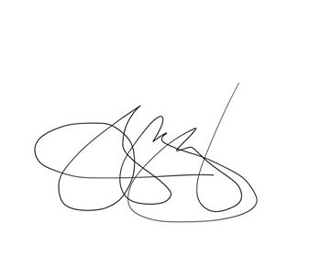

DIANE JOY D. BEJERANO-BROCA, R.N, M.N
Applicant

