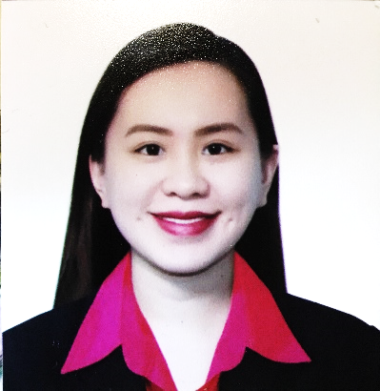

Mari Louise S. Dagum – Floresca, R.N
Address: Unit D #11 Dona Segundina Townhomes, National Road, Brgy. Putatan, Muntinlupa City
E-mail: marilouisedagum1227@gmail.com
Contact no.: +639176660371

Objective:
To render services in my full capacity as a compassionate nurse and be an asset to my prospective healthcare institution.

Qualifications:

- Strong work ethics and interpersonal skills
- Caring, dedicated nurse with a reputation for providing quality care and ensuring patient satisfaction.
- Knowledgeable of monitoring, assessing, addressing document and reporting symptoms and changes in patients’ conditions.
- Keen attention to details and enthusiasm.

Personal Background:
Born on 27th of December, 1993 to Lawrence Dagum and Myra Dagum in Batangas City. Fluent in oral and written English and Filipino languages. Knowledgeable in MS Office, and in the Internet. Enjoys travelling, interacting with people, cooking, dancing, and learning new skills. A registered nurse since 2014.

Responsible, resourceful, hardworking, fast learner, and has a good working relationship.

Employment History:
I was a senior staff nurse at the Emergency Department of the Perpetual Help Medical Center, Las Pinas from November 15, 2015 to June 21, 2018. The Emergency Department is divided into three (3) units, Primary Care, Acute Care and the Critical Area. I handle patients of any ages at the critical care unit that experience life-threatening cases. I administer medications, apply contraptions (IV insertion, Indwelling Foley Catheter insertion, Nasogastric tube insertion), facilitates resuscitation and ensure the patient’s safety during their stay at the emergency room.
I am currently a staff nurse in the General Nursing Unit in my present institution that handles

Education:
Tertiary:
University of Perpetual Help System-DALTA, Las Pinas City 2010-2014
Alabang – Zapote Road, Pamplona 3, Las Piñas City
News Editor, Nurture Sectoral Organization S.Y 2013-2014

Secondary:
Christ the King School of Muntinlupa Foundation, Inc. 2006-2010
Graduated, 1st Honorable Mention S.Y 2009-2010

Elementary:
Christ the King School of Muntinlupa Foundation, Inc. 2000-2006
Graduated, 1st Honorable Mention S.Y 2005-2006

Trainings:
March 2011 Reserve Officer Training Corps (ROTC)
Department of Air Sciences and Tactics
University of Perpetual System DALTA, Las Piñas City

September 10, 2015 Bundles of Care to Prevent Healthcare Associated Infections
UPHDMC, Infection and Control Unit
University of Perpetual Help Medical Center

June 25, 2016 6th Annual Post Graduate Course: “intERactive”
University of Perpetual Help Medical Center
Salle Entremont Hall Quartier 1, Crosswinds, Tagaytay

June 28, 2016 Train the Trainers Program on Diabetes
Eli Lilly Philippine, Inc.
University of Perpetual Help Medical Center, Las Pinas

December 22-23, 2017 Basic Life Support Course
Largado Training Center
Tamayo Tower, Las Pias City

January 26-27, 2018 Advanced Care Life Support Course
Largardo Training Center
Tamayo Tower, Las PiÑas City

Awards:
May 12, 2016 1st Placer Research Presentation
6th Grand Annual Nursing Case Presentation
Perpetual Help Medical Center
Tamayo Tower, Las Pinas City

May 12, 2016 Best Presentor
6th Grand Annual Nursing Case Presentation
Perpetual Help Medical Center
Tamayo Tower, Las Pinas City

