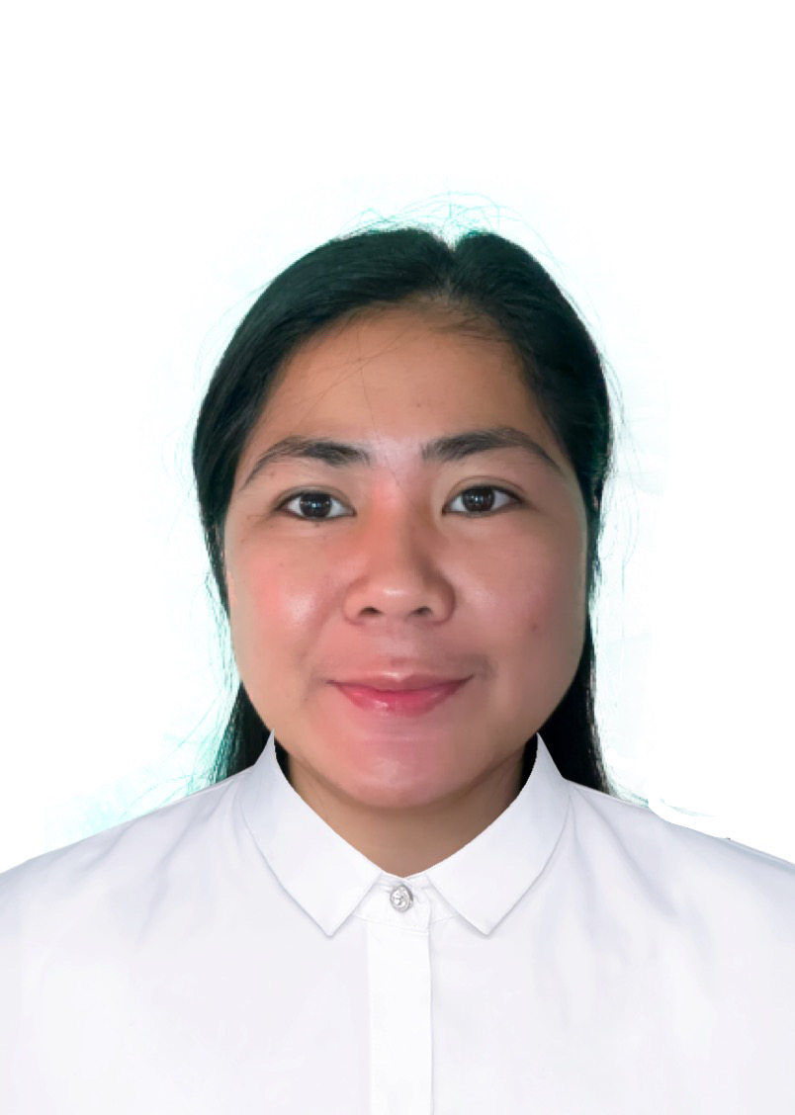
ERANA JEANNEZA SERRANO

Permanent address with zip code:
San Nicolas East , Agoo La Union 2504
Contact no:
+639-664013018
Email address:
hygelac_08@yahoo.com

Objective
To seek a position in your company that will enable me to use my strong organizational skills, educational background and ability to work well with people in achieving the company’s goals.

Personal data

Birthday: March 18,987
Birthplace: La Union
Age: 35
Civil Status: Married
No. of children: 1
Religion: Christian

Work experience

1. Position (specific area):
Nurse Assistant
Company name:
Sree Narayana Mission Home for the Aged Sick
Date:
May 2011- May 2018

Job description:

- Monitor patient’s condition by taking temperature,blood pressure,pulse rate, respiratory rate and weight
- Serve meals and feed the patient
- Bathe and groom the patients
- Assist supervisors in giving oral medication
- Accompany patient to hospital for medical appointment
- Reposition bed bound patients every two hours
- Report any unusual abnormality to supervisors
- Accompany patient to their exercise routine
- Monitor intake and output and record
- Lastly, always listen to patients concern

Cases Handled:

- Stroke and bed ridden
- Geriatric patients with dementia
- Palliative care for cancer patient
- Patient with Alzheimer’s Disease
- Patient with colostomy care

Equipment used:

- Thermometer
- Pulse oximeter
- Blood pressure app
- Personal protective Equipment (PPE)
- Oxygen Concentrator

2. Position (specific area):
Nurse
Company name:
La Union Medical Center
Agoo, La Union, Philippines
Date:
April 2009 - September 2009

Job description:

- Render general nursing care to patients within the assigned area/unit.
- Carries out therapeutic nursing procedures.
- Monitoring patients' conditions like vital signs monitoring, intake and
output monitoring.
- Administers intravenous and oral medications as ordered by the physicians.
- Ensures proper regulation of intravenous fluids, blood transfusion.
- Prepares patients for diagnostic and surgical procedures.
- Completes records of nursing observations/patients charts.
- Assists doctors during rounds/physical examination.
- Carries out admission and discharge orders accordingly.
- Conducts health teachings to patients considering the specific illness.

Educational background

College:
University of Luzon
​Course:
Bachelor of Science in Nursing
​Date Graduated:
March 2008

Secondary:
President Elpidio Quirino National High School
Date Graduated:
March 2004

Elementary:
Ambitacay Elementary School
Date Graduated:
March 2000

Training acquired

Topic:
Basic Cardiac Life Support with AED
Venue/address:
Lentor Training Center/ 33 Ubi Ave 3, Vertex Tower B
#03-11 Singapore 408868
Date started:
November 27, 2017

Topic:
Continuing Professional Development
Program Titled Medico-Legal Response
To Weapon of Mass Destruction Terror Incidents
Venue/Address:
Online
Date:
July 19-21, 2021

Qualifications

PHILIPPINE NURSING LICENSURE EXAM PASSED

Character reference

Name:
Karen Acebes
Position:
Senior Staff Nurse
Company:
Sree Narayana Mission home for the Aged Sick
Contact details:
+65 90261442

