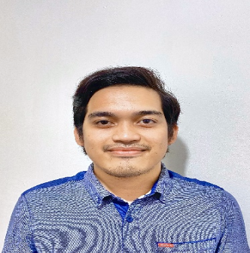
HARRY G. DAGONDON
#495 Barra Opol, Misamis Oriental
Mobile Phone Number: +639278503894
harrydagondon@gmail.com

PERSONAL BACKGROUND:
Age: 25
Height: 5’4”
Weight: 60 kgs.
Civil Status: Single
Birthdate: April 25, 1997
Birthplace: Cagayan de Oro City
Citizenship: Filipino
Languages: English, Filipino, Visayan

OBJECTIVE:
To obtain a job where I would apply my skills and develop more to be an asset to your company.

WORK QUALITIES:
I enjoy challenging and dynamic work environment, and getting along well with others. I am disciplined and resourceful. I deal with difficult tasks.

SKILLS:

- Computer Literate
- Team player
- Great interpersonal skills
- Ability and willingness to work long and extended hours
- Easy to get along with
- A keen eye for details
- Eager to learn new things
- Great people skills
- Flexible and adaptive to new environment

EXPERIENCE
Intern
TGI Fridays, Centrio Mall, Cagayan de Oro City
December 2016 – April 2017
Provided dining service for patrons at a fine dining establishment.
Took orders, served meals, set and cleared tables and dealt with the exchange of bills and money at fast-paced lunch restaurant.

Prep Cook / Food Expeditor
Espressini Café, Cagayan Town Center, Cagayan de Oro City
August 17, 2017 – December 2018
Maintained a prompt and efficiently run atmosphere concerning kitchen productivity; ensured that all kitchen orders were prepared in a timely manner and according to the menu and customer specifications. Prepare and stock the day’s ingredients for each station. Responsible for maintaining the stock inventory and purchasing the stock needed. Order supplies and ingredients as needed.

Marketing & Outside Sales Representative
Cerebro Diagnostic System, Alwana Business Park, Cagayan de Oro City
April 1, 2019 – March 9, 2020
Establishing and maintaining relationships with customers (Hospital Owners, Medical Directors). Take orders, solicit opinions, provide information about new products and services, keep records or complete progress reports. Introduce initiative to establish a laboratory machine with information system that would provide long – term monthly income. Meet and exceeding sales goals.

EDUCATIONAL BACKGROUND:
Tertiary: Associate in Hotel and Restaurant Management 2015 - 2017
Lourdes College
Capistrano-Hayes Streets, Cagayan De Oro City
Secondary: Blessed Mother College 2009- 2013
Iponan, Cagayan de Oro City

SEMINARS AND WORKSHOP ATTENDED:
“Workshop Basic Flair”
Bar Management

